Tour ID: 171038  
Tour Name: 8 day Self-drive tour | Ring Road Highlights

Tour destinations: ['Keflavik', 'Hveragerdi', 'Thingvellir National Park', 'Geysir', 'Gullfoss', 'Vik', 'Kirkjubaejarklaustur', 'Skaftafell', 'Jokulsarlon', 'Hofn', 'Stodvarfjordur', 'Egilsstadir', 'Husavik', 'Dettifoss', 'Myvatn', 'Akureyri', 'Saudarkrokur', 'Reykholt', 'Borgarnes', 'Reykjavik']

Tour destinations images:

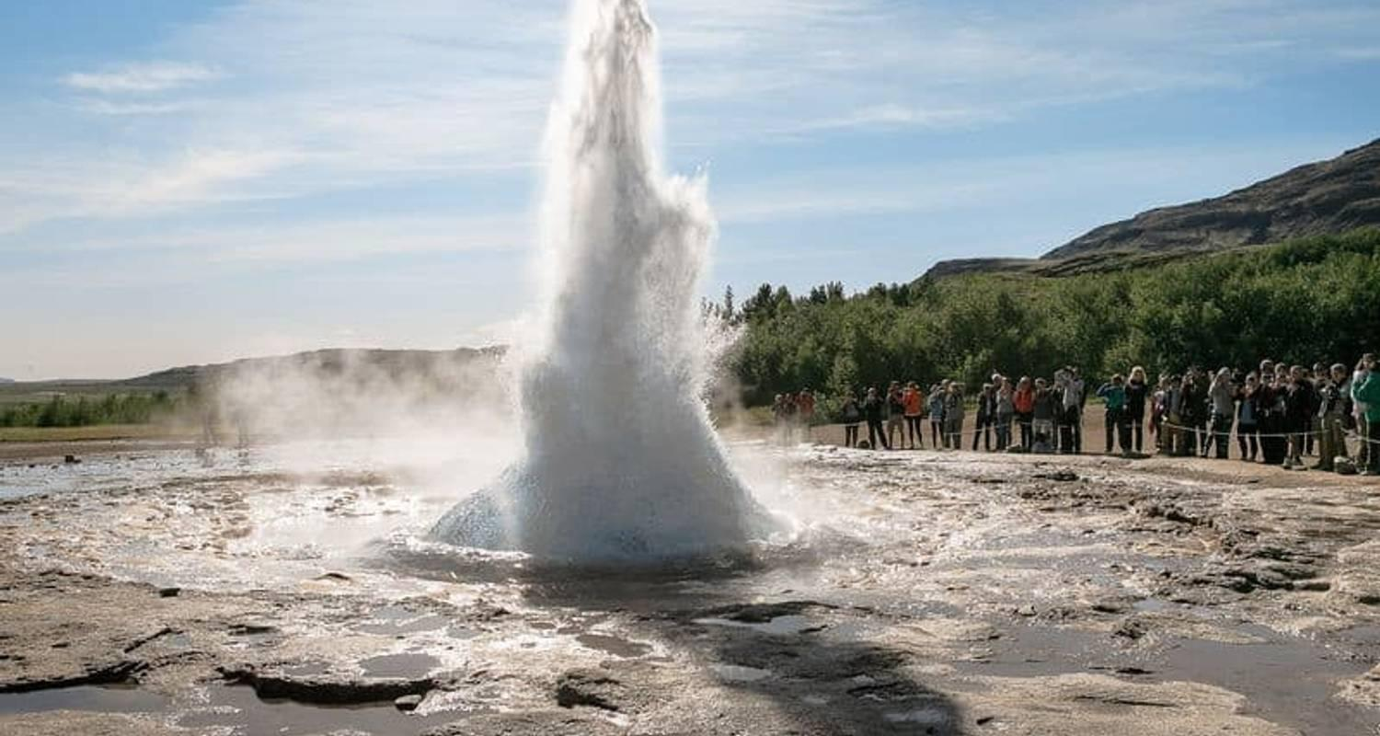

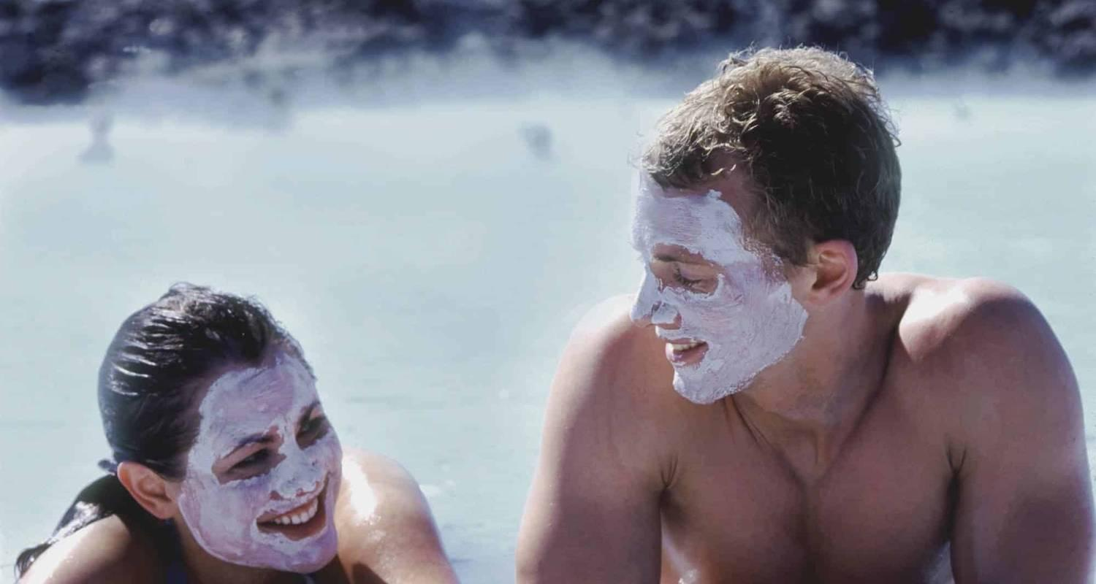

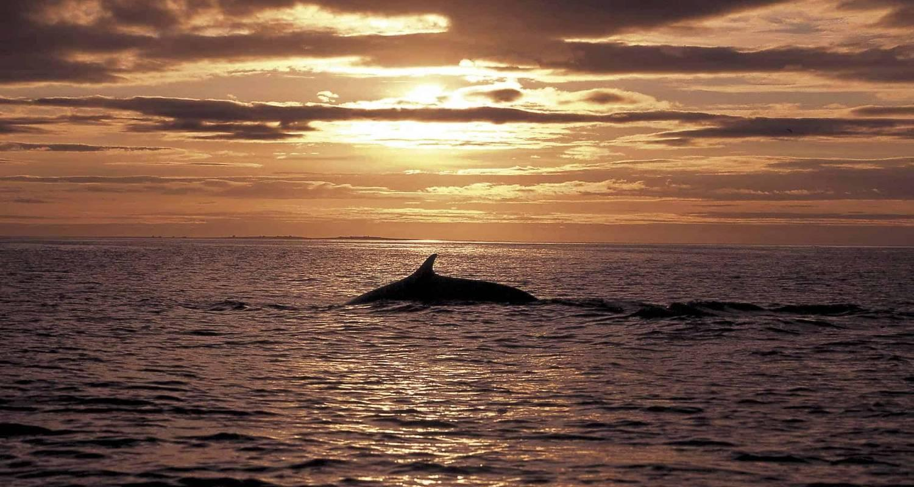

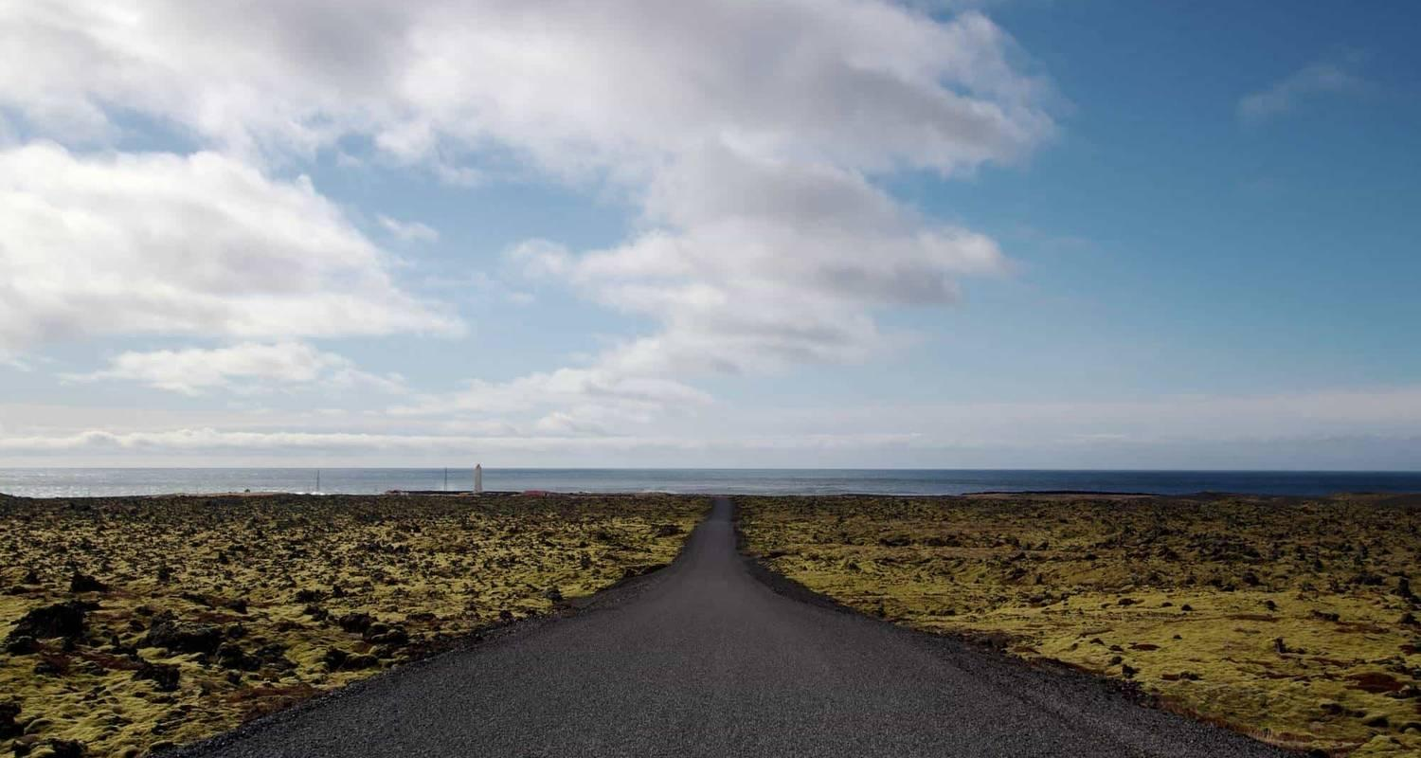

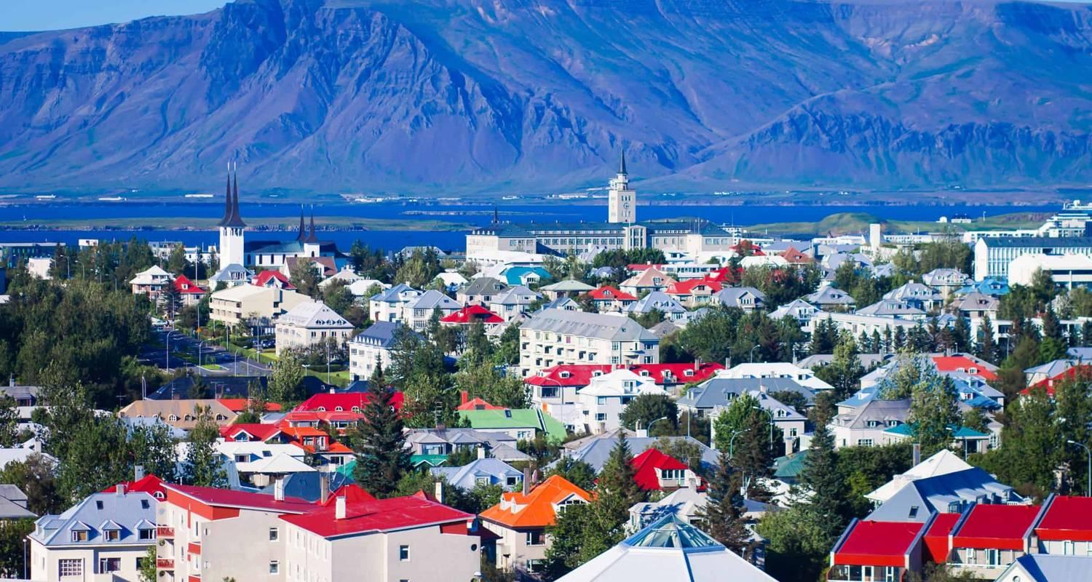

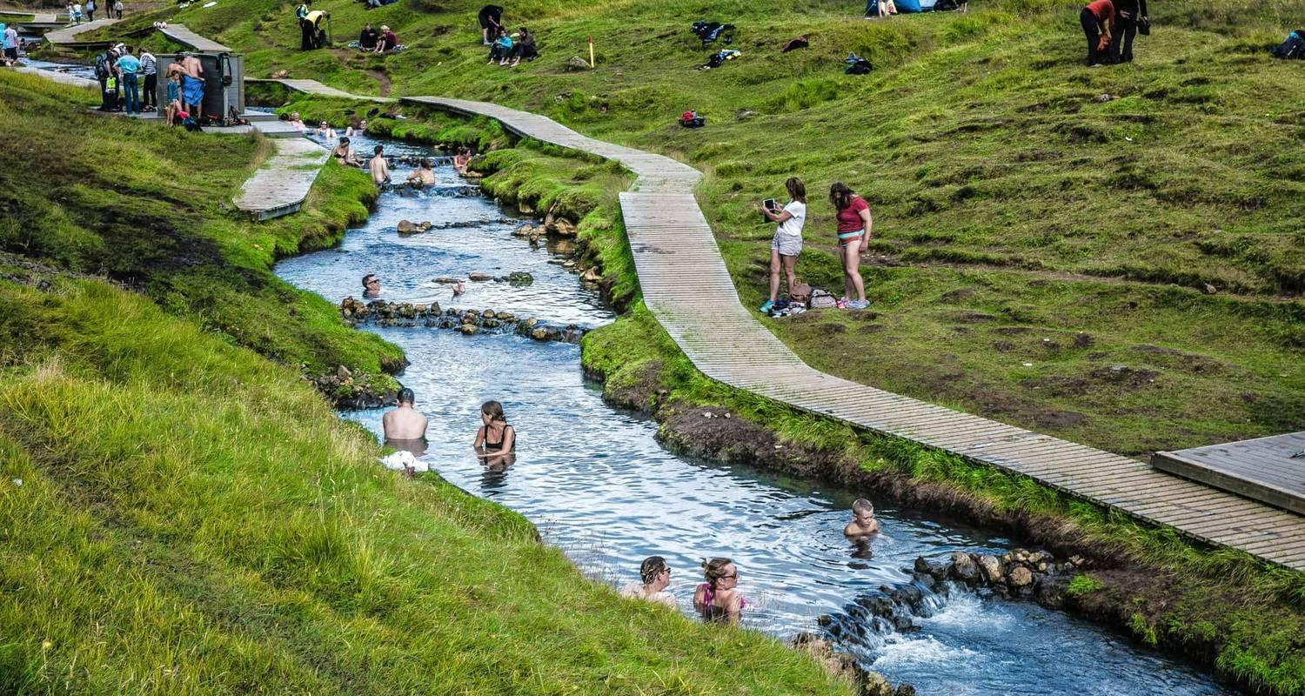

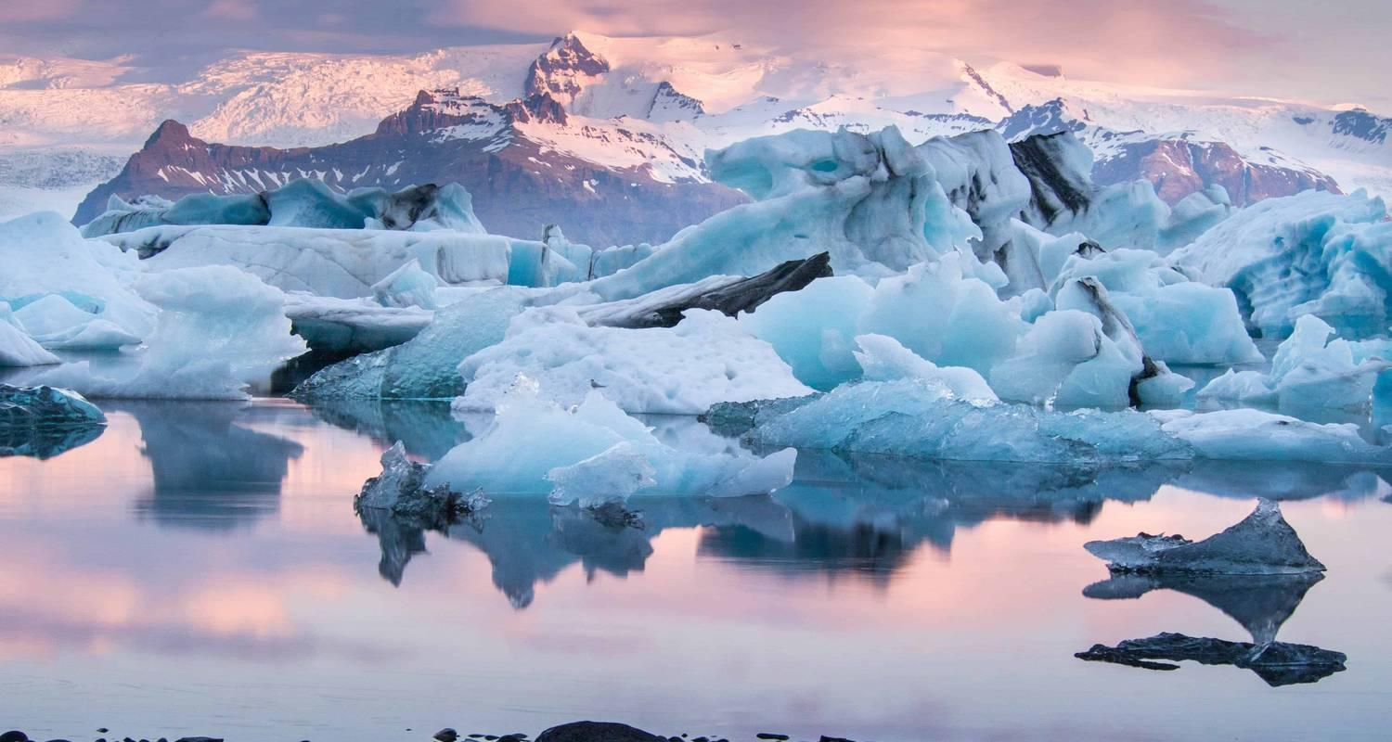

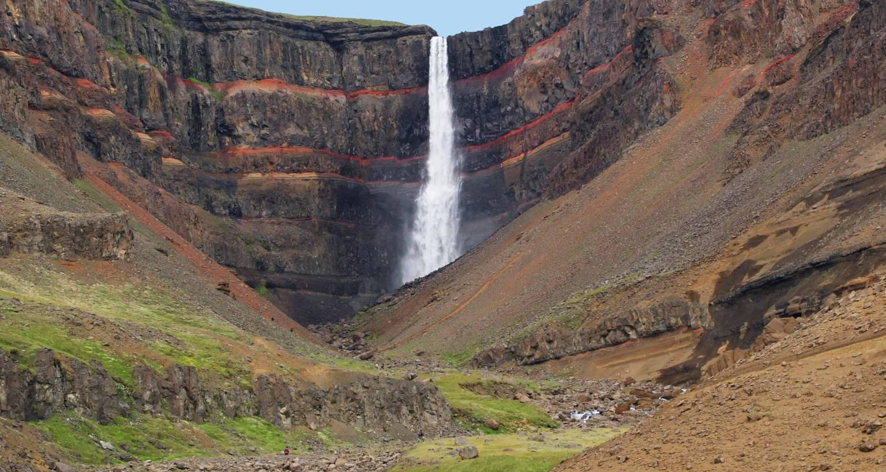

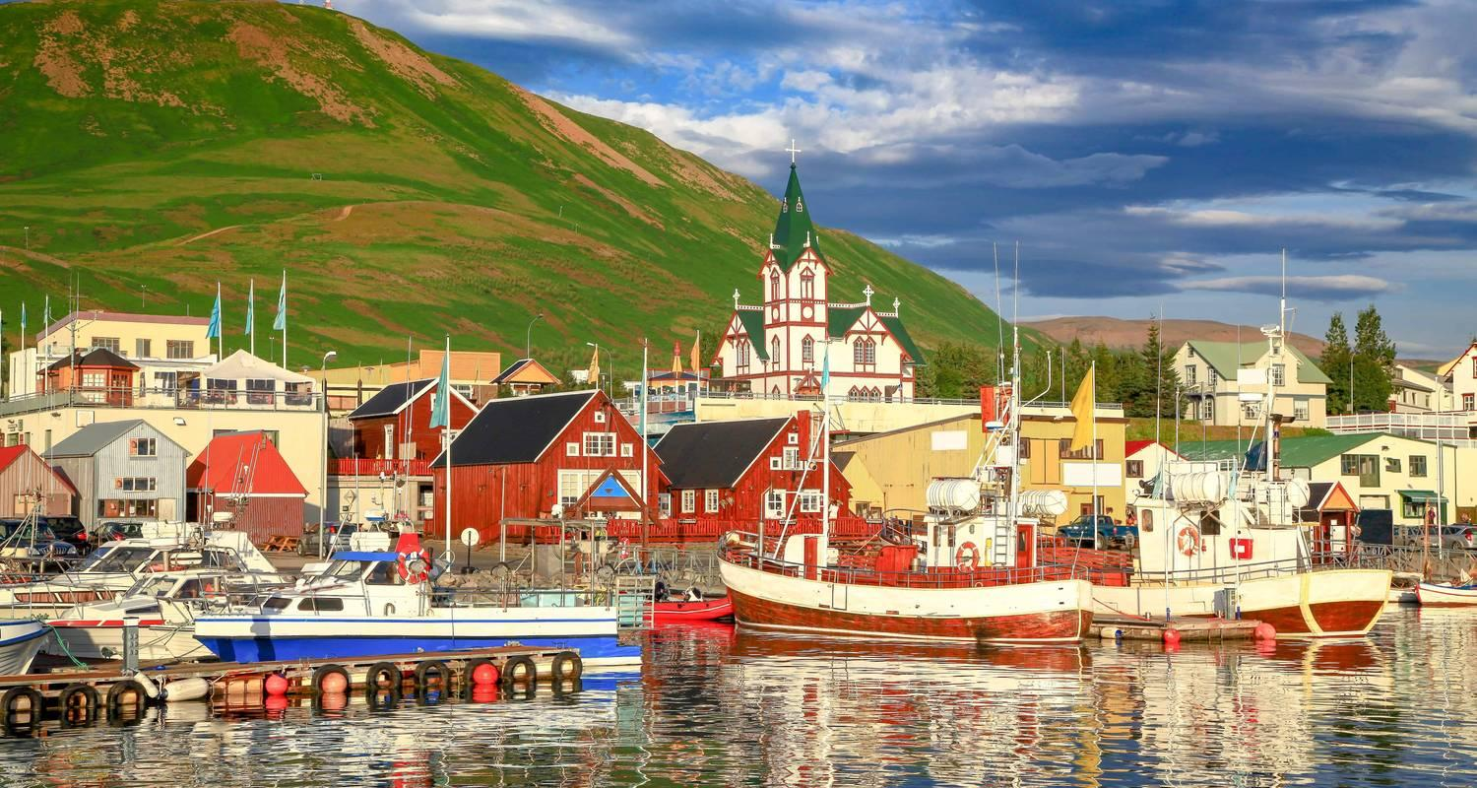

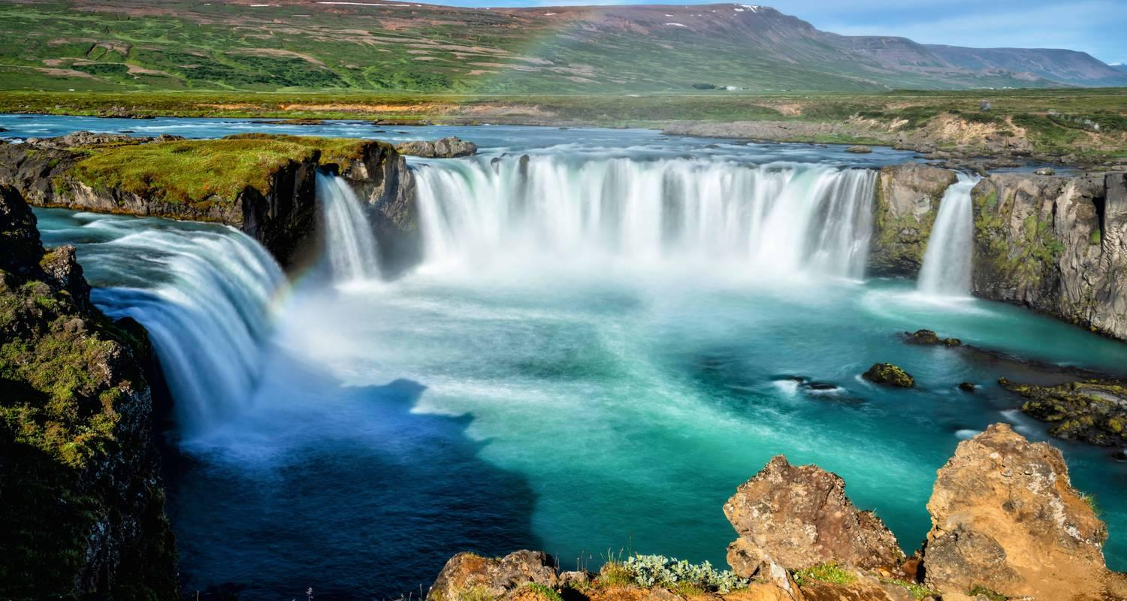

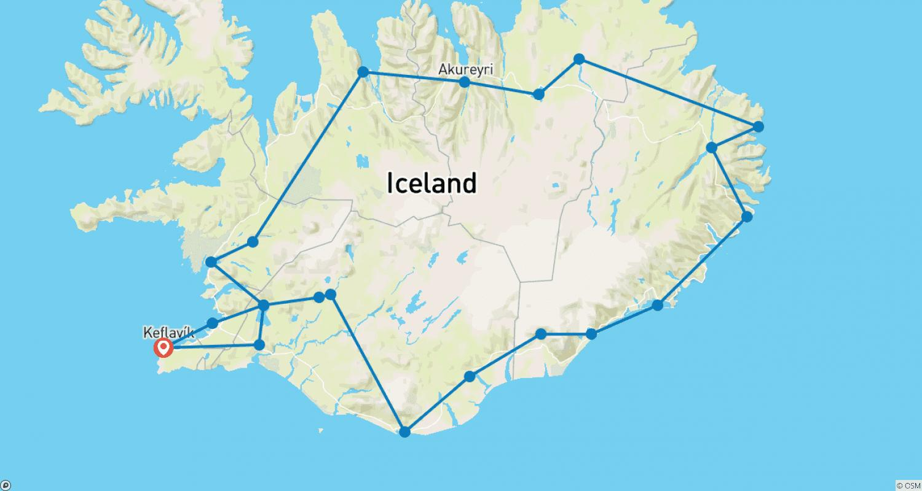

Tour ID: 171040  
Tour Name: 8 day Self-drive tour | Glorious Glaciers and Northern Lights

Tour destinations: ['Keflavik', 'Reykjavik', 'Borgarnes', 'Reykholt', 'Arnarstapi', 'Thingvellir National Park', 'Laugarvatn', 'Geysir', 'Gullfoss', 'Hvolsvollur', 'Skogafoss', 'Reynisdrangar Cliffs', 'Vik', 'Hofn', 'Jokulsarlon', 'Skaftafell', 'Kirkjubaejarklaustur', 'Seljaland', 'Selfoss', 'Hveragerdi']

Tour destinations images:

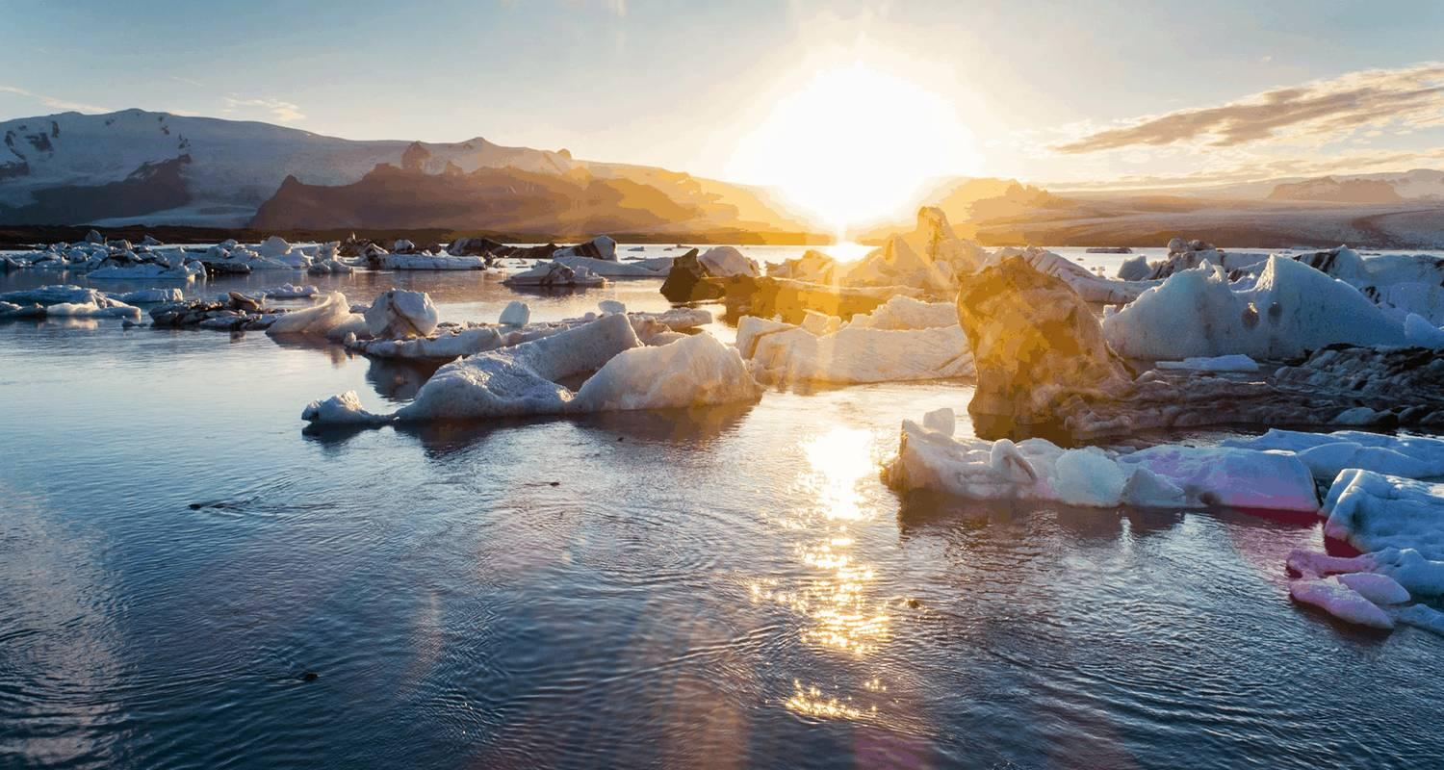

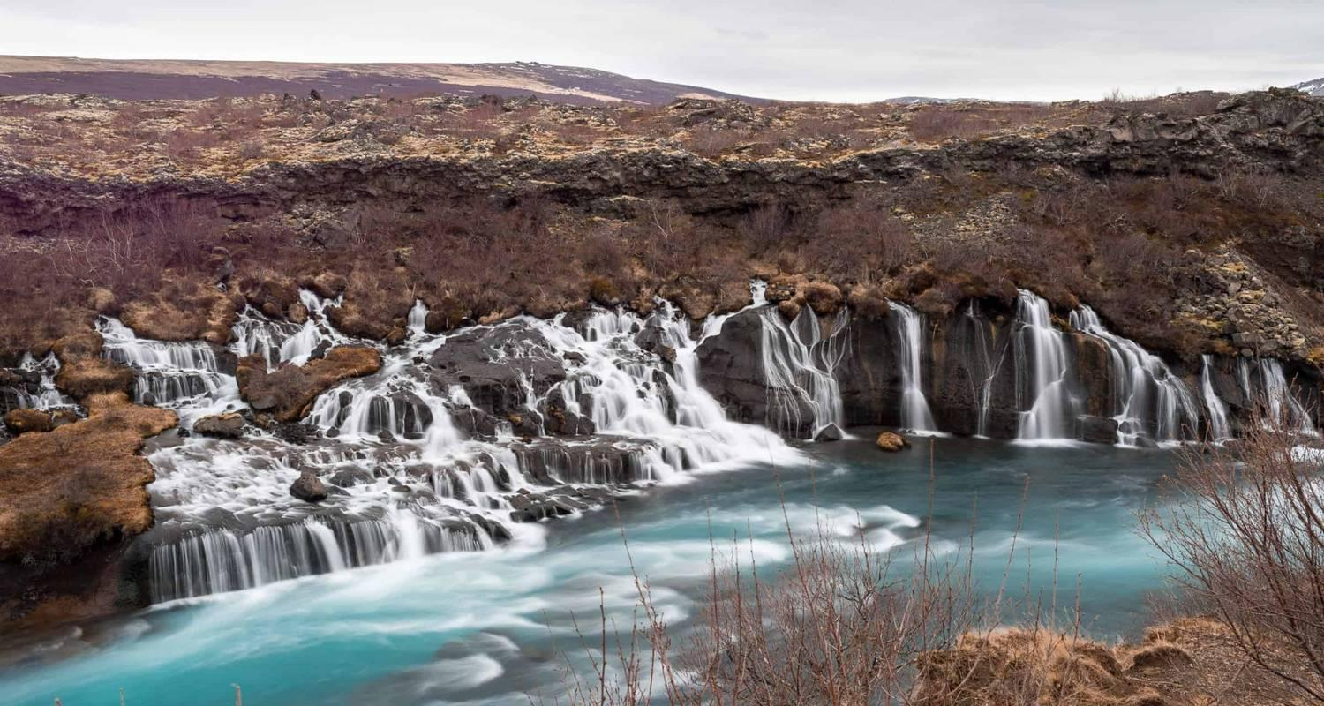

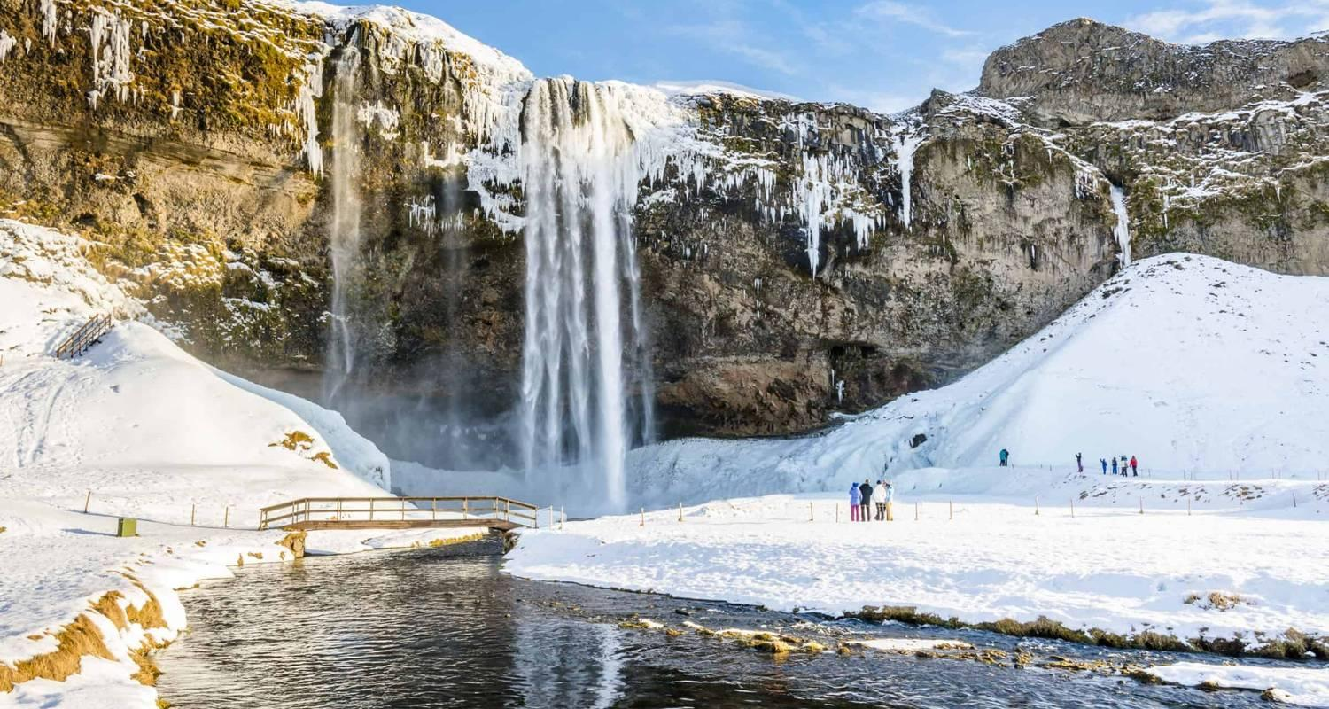

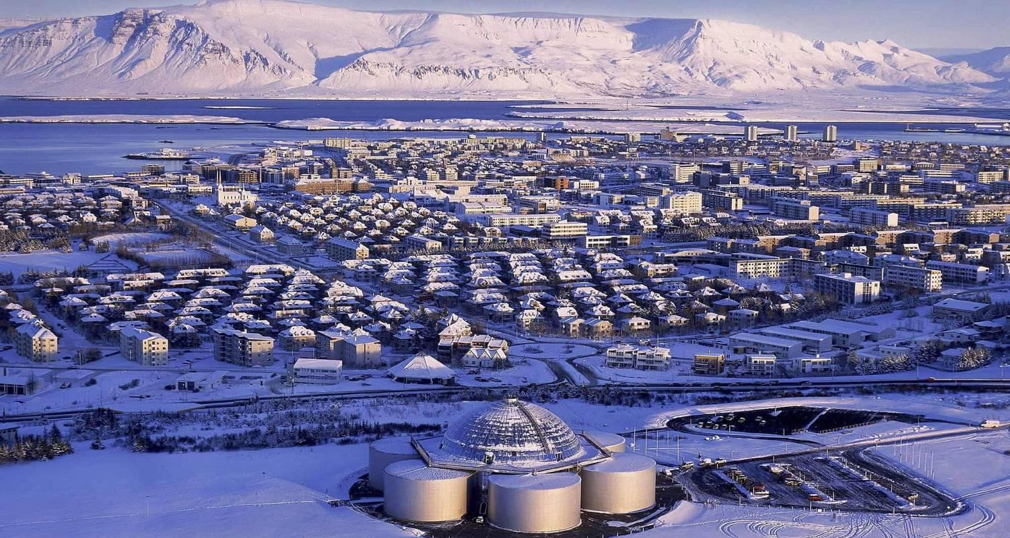

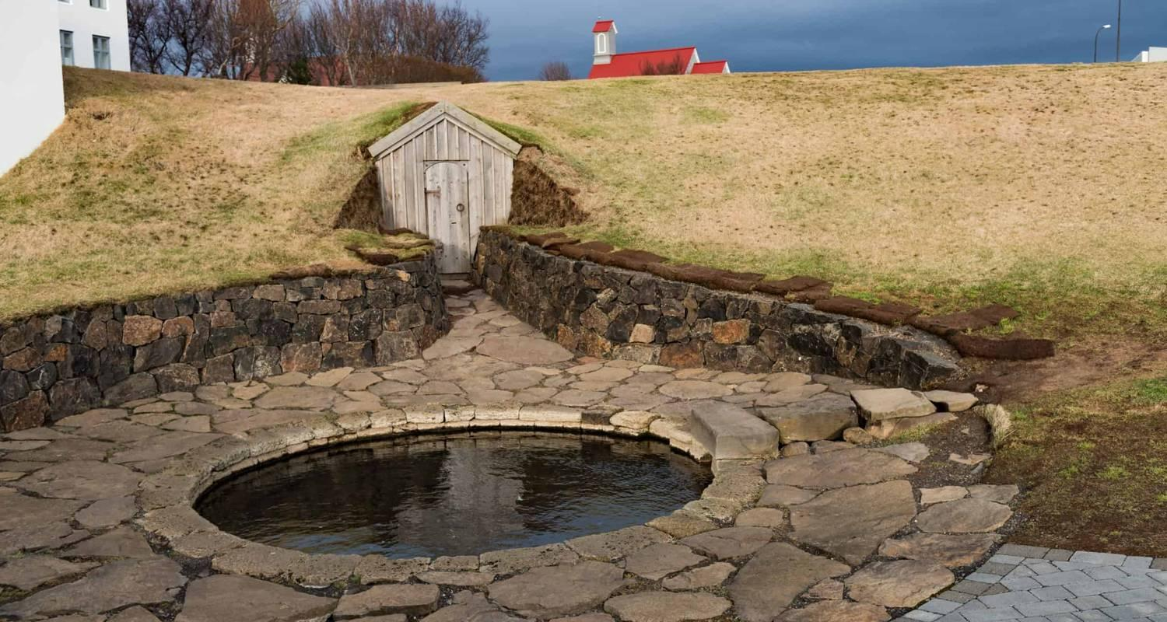

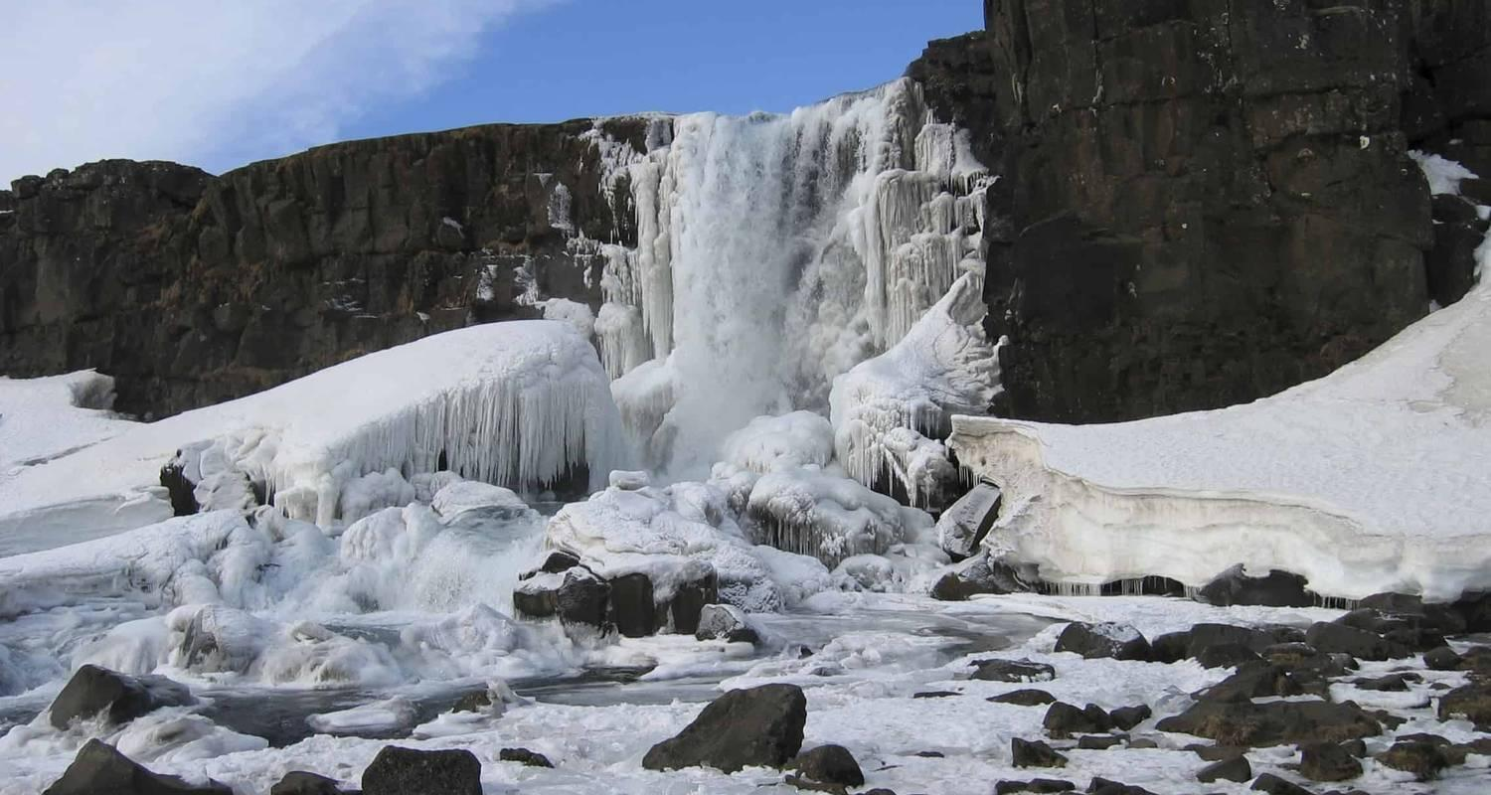

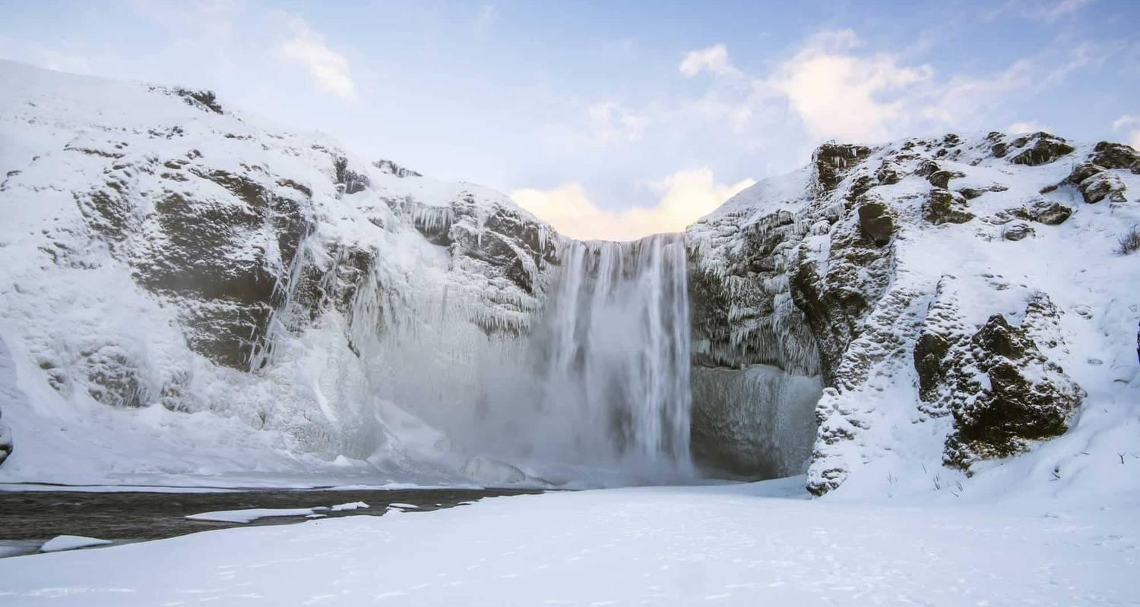

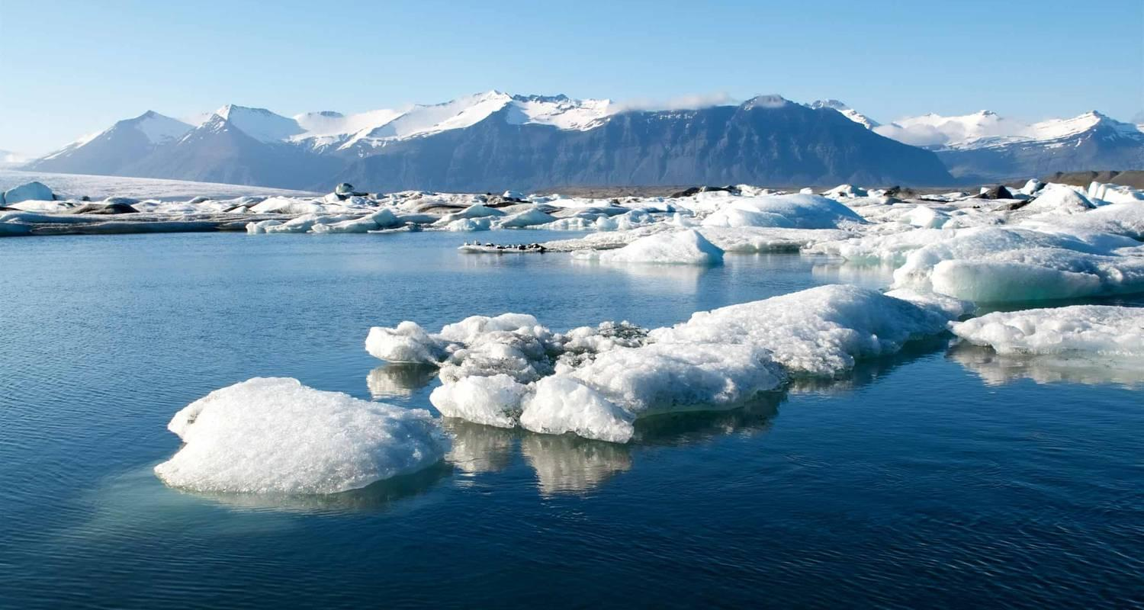

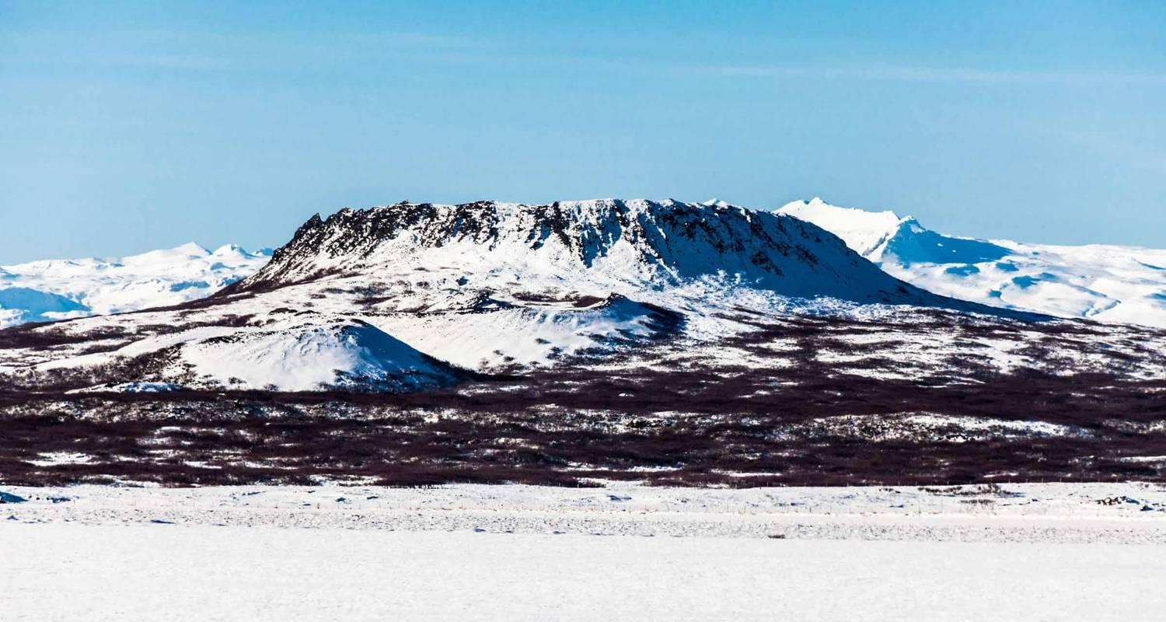

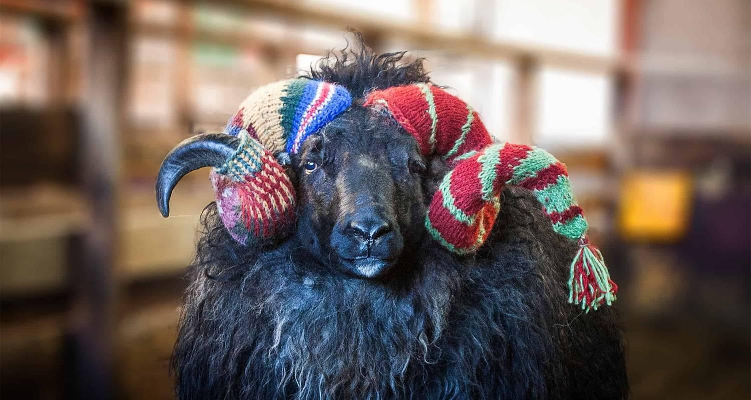

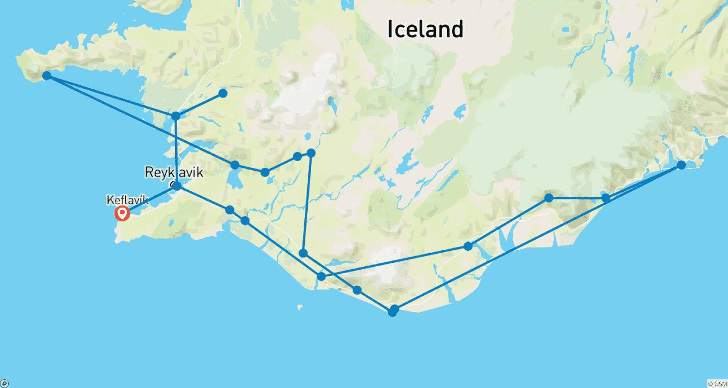

Tour ID: 171898  
Tour Name: Classic Iceland Adventure

Tour destinations: ['Reykjavik', 'Thingvellir National Park', 'Geysir', 'Gullfoss', 'Fludir', 'Heimaey Island', 'Seljaland', 'Skogafoss', 'Eyjafjallajokull', 'Vatnajokull National Park', 'Ingolfshofdi', 'Svartifoss', 'Jokulsarlon', 'Hofn']

Tour destinations images:

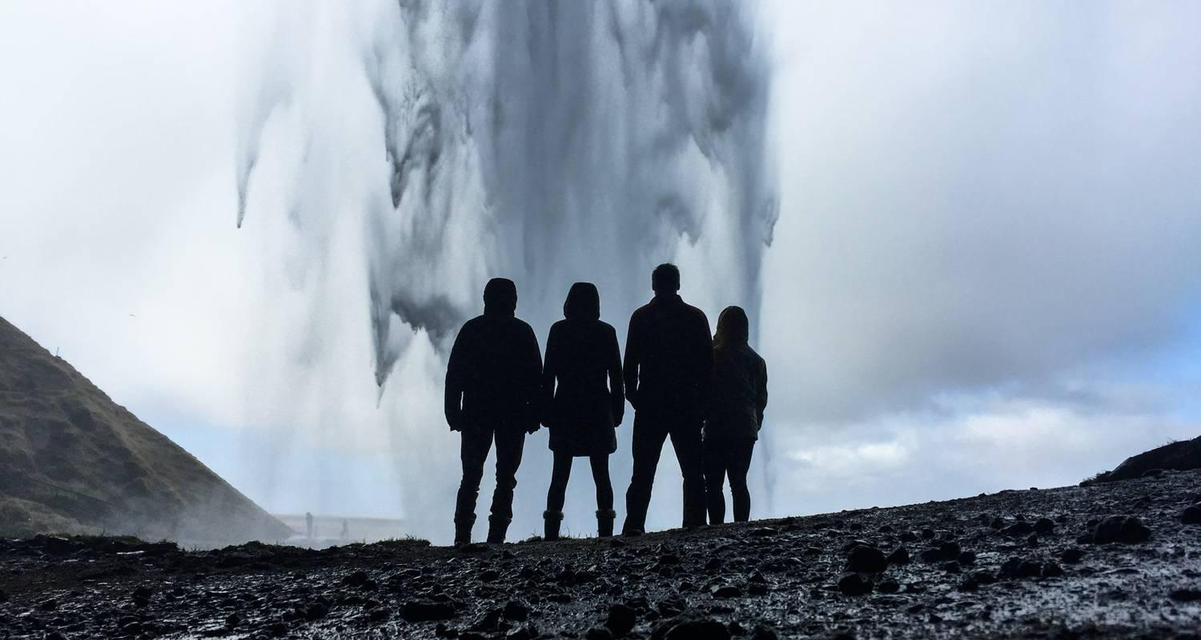

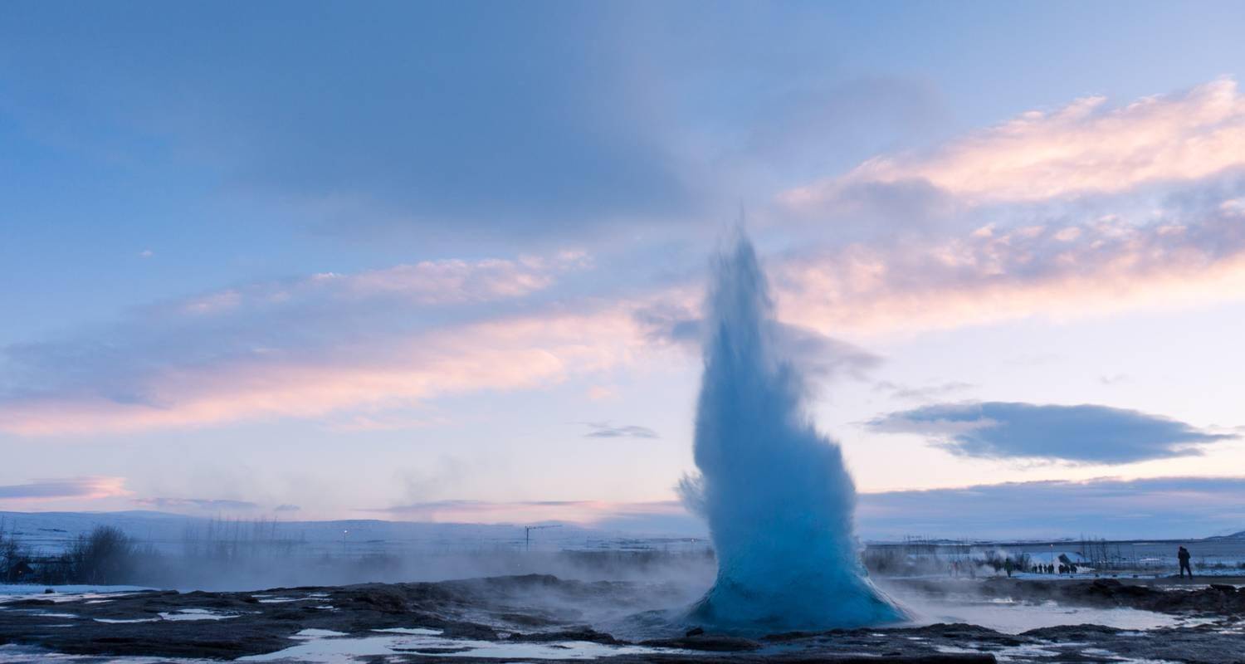

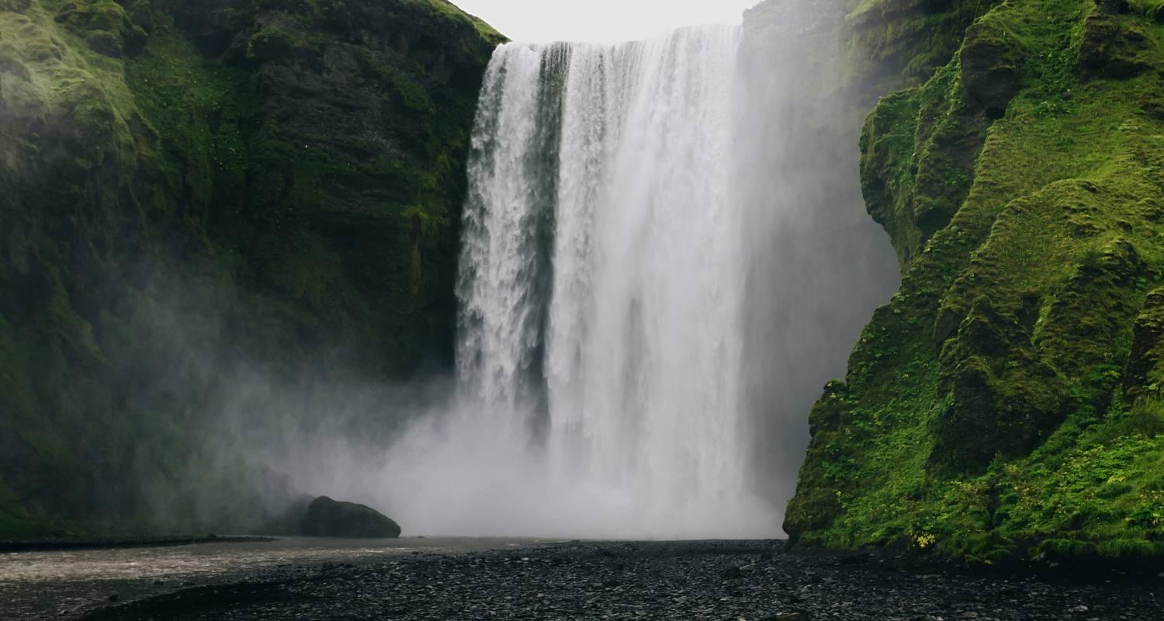

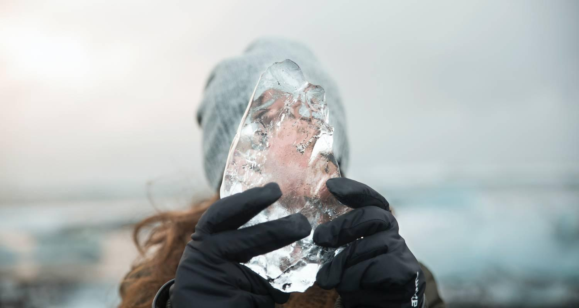

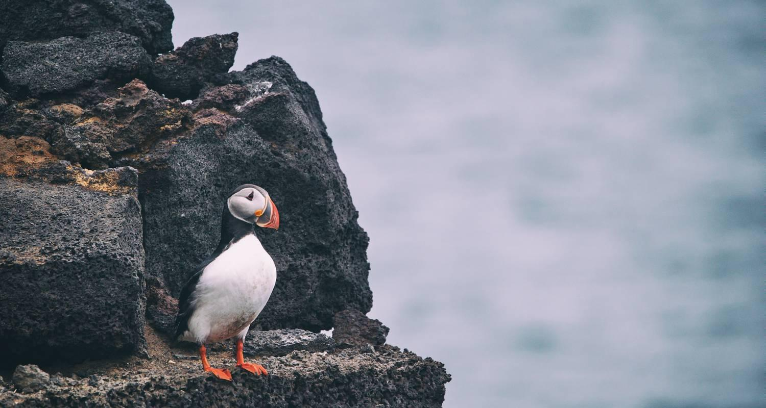

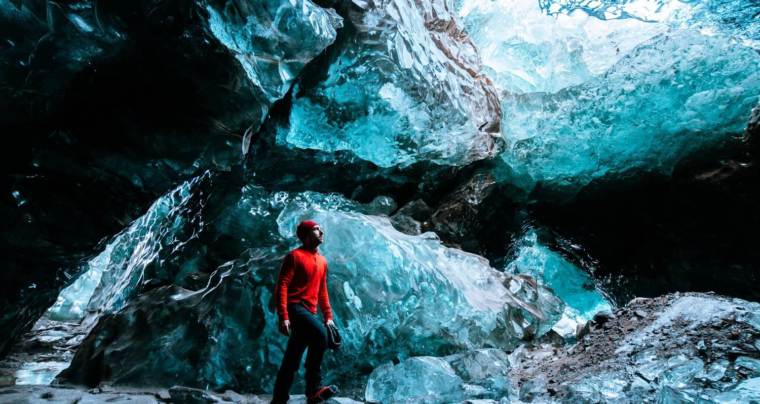

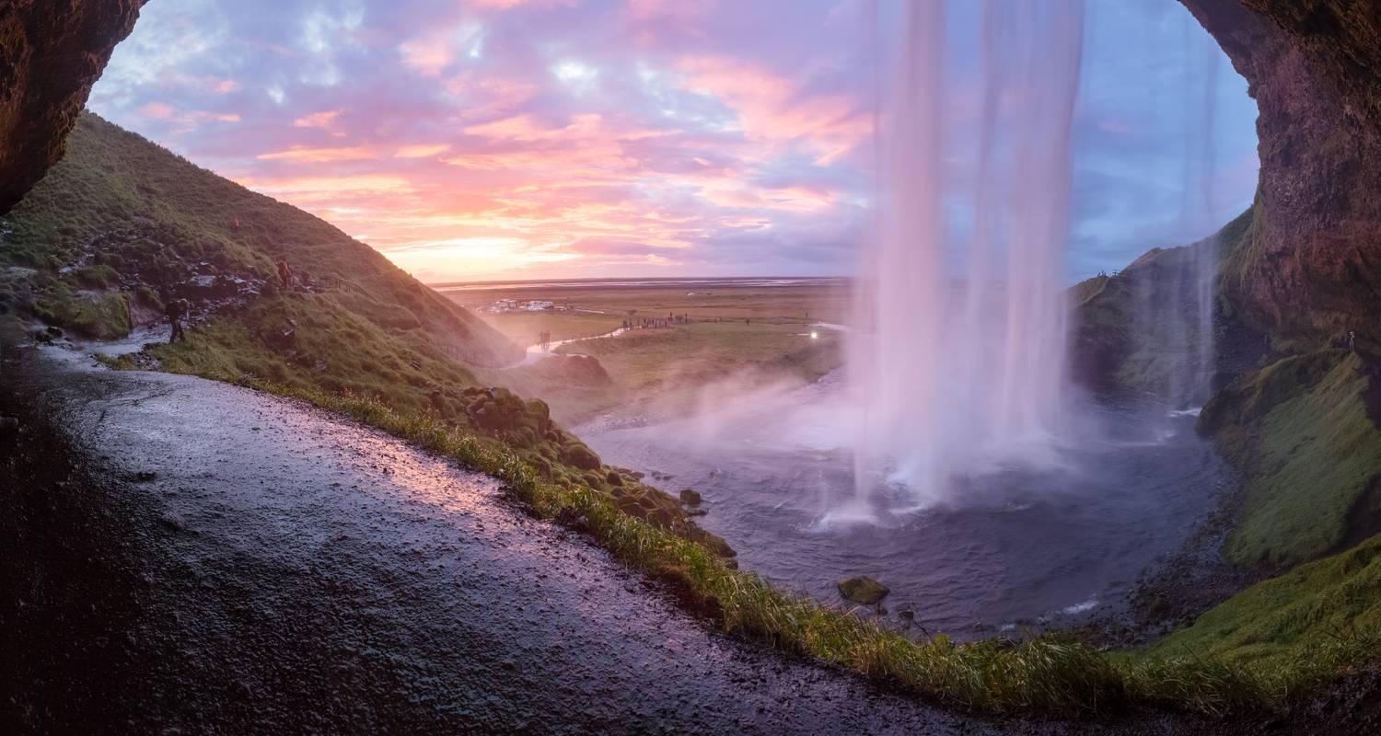

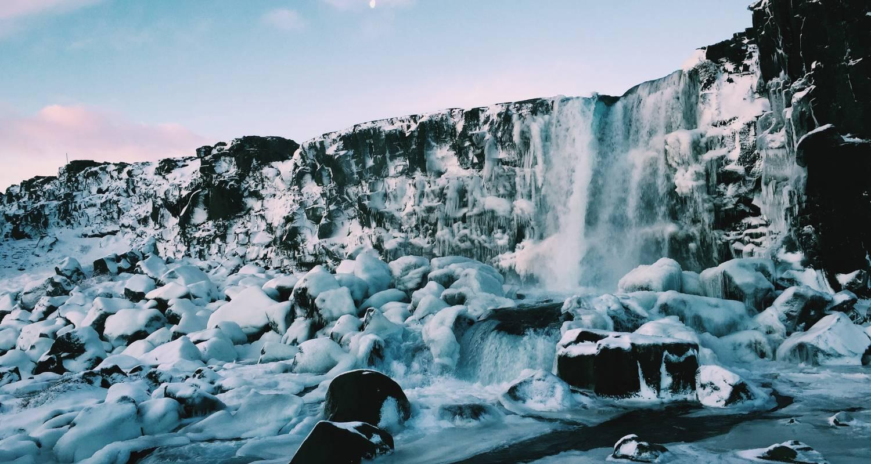

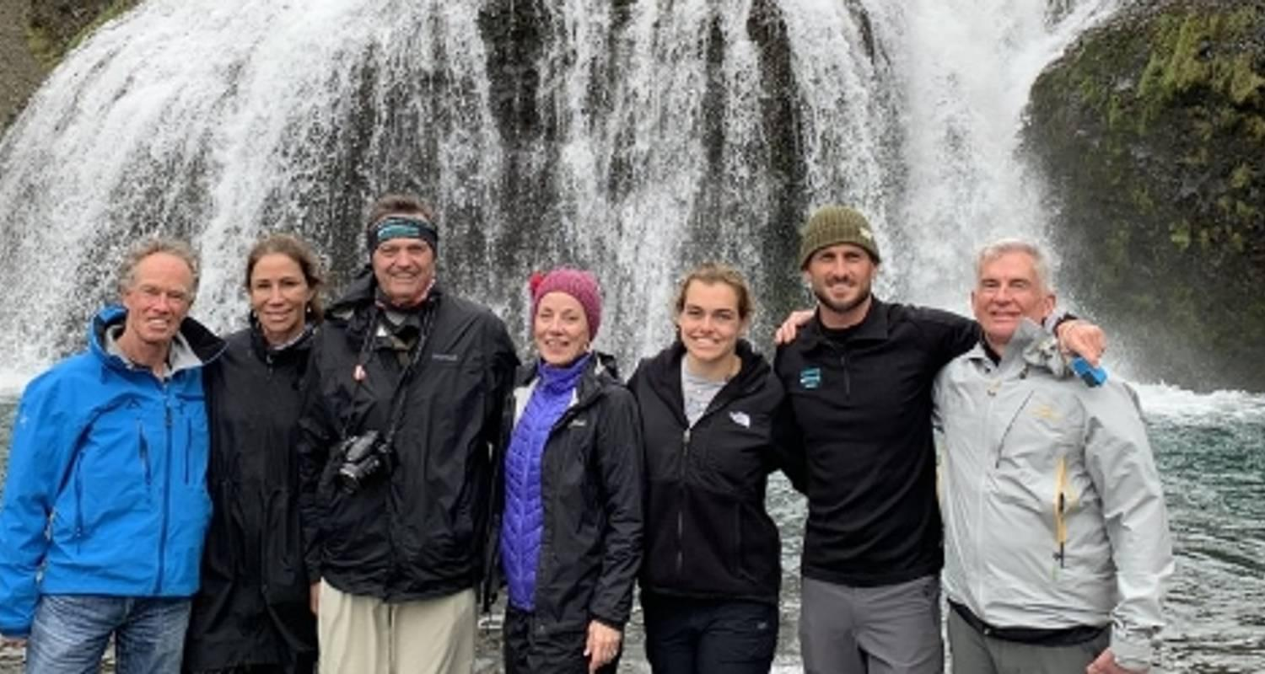

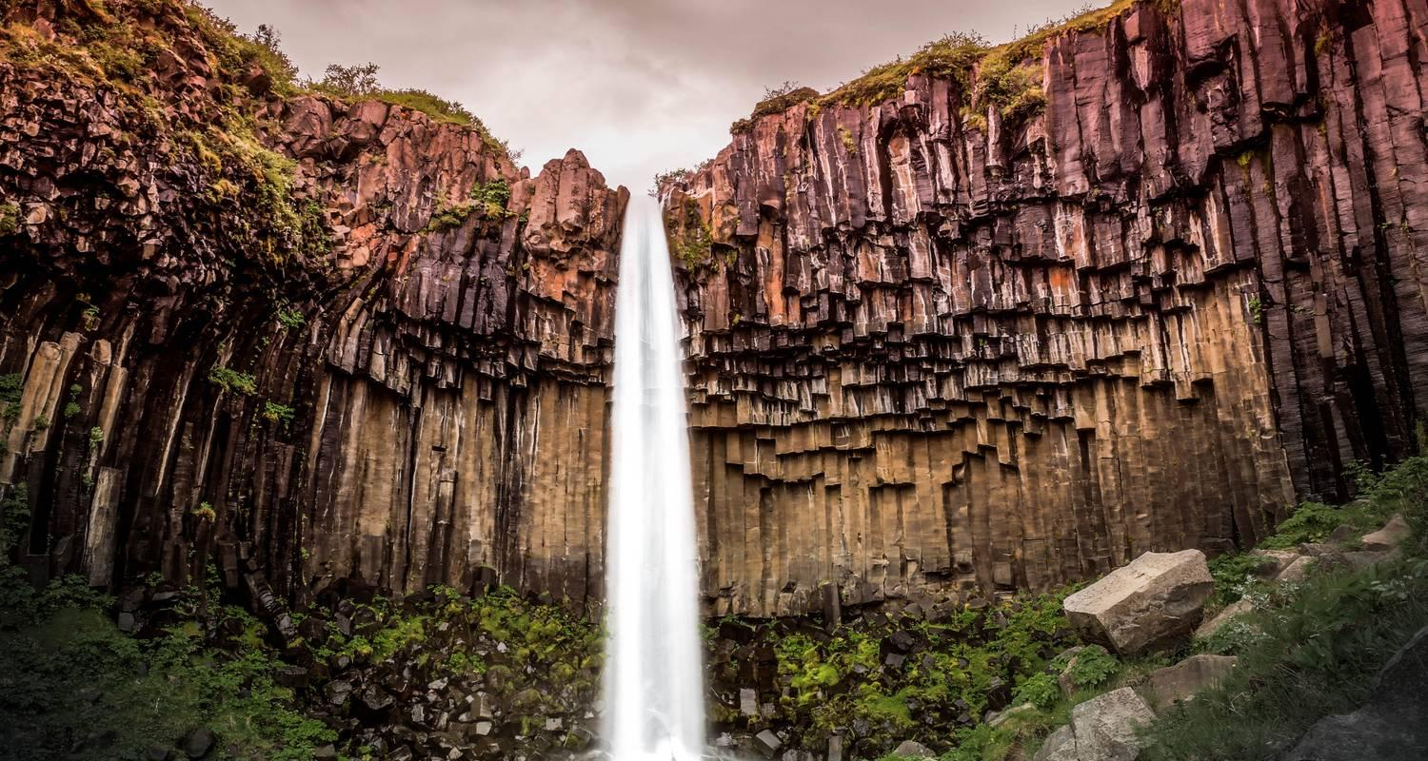

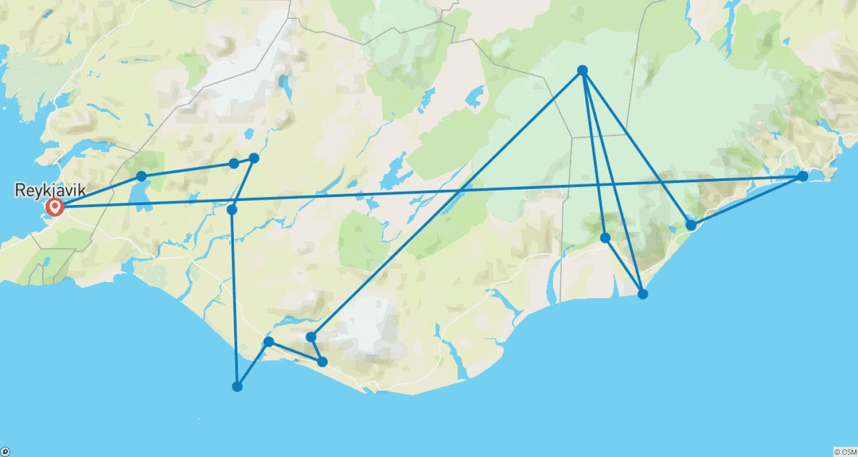

Tour ID: 171925  
Tour Name: Ultimate Iceland Adventure

Tour destinations: ['Reykjavik', 'Thingvellir National Park', 'Fludir', 'Heimaey Island', 'Seljaland', 'Skogafoss', 'Ingolfshofdi', 'Svartifoss', 'Vatnajokull National Park', 'Jokulsarlon', 'Hofn', 'Husavik']

Tour destinations images:

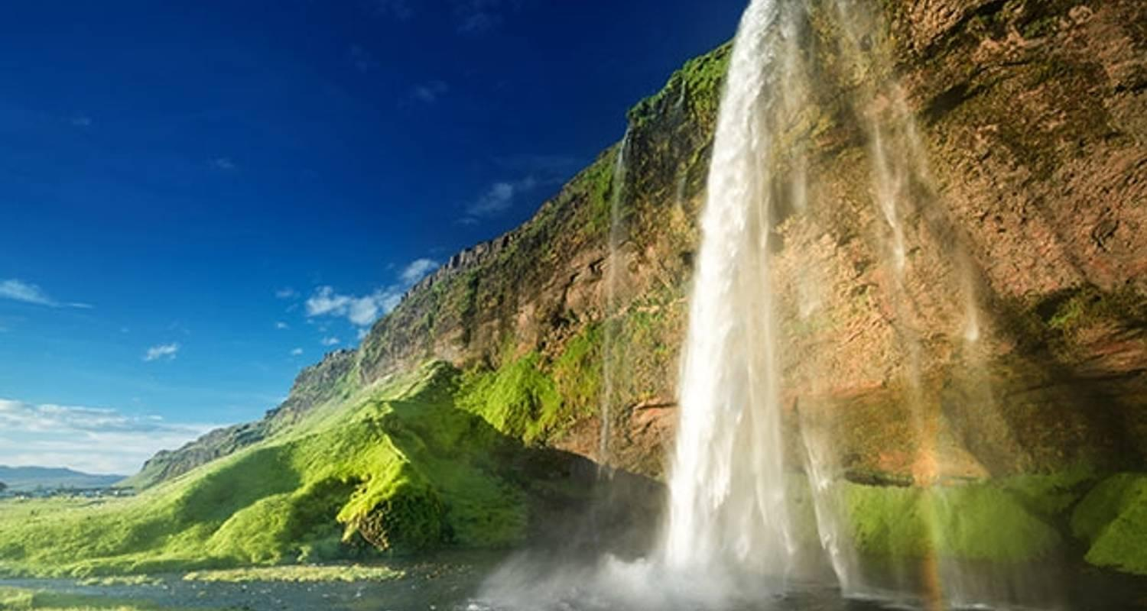

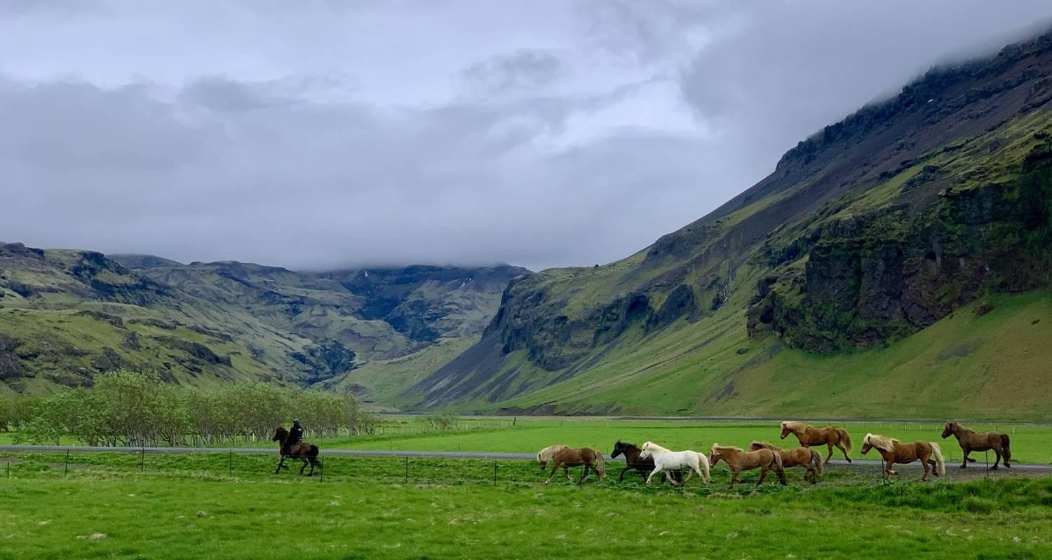

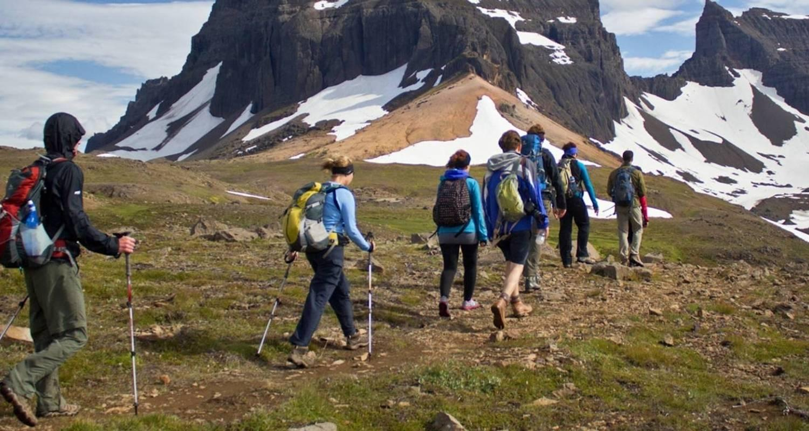

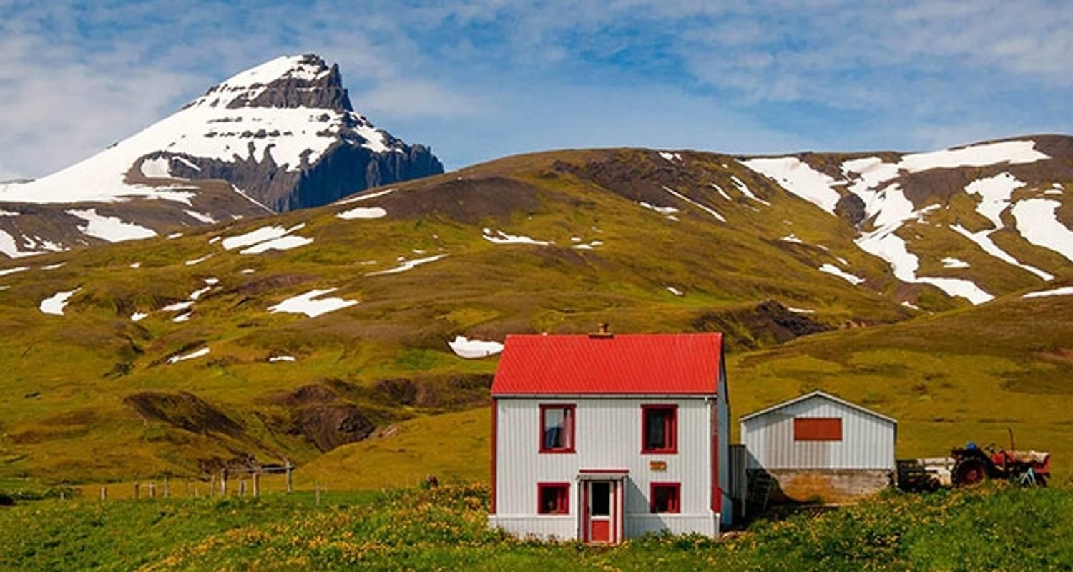

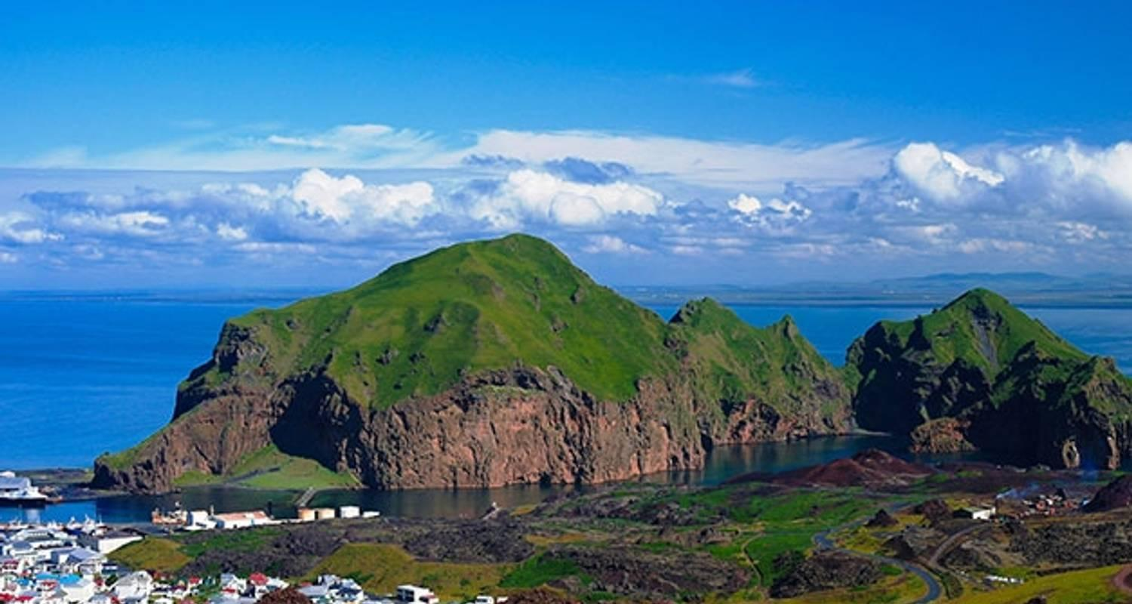

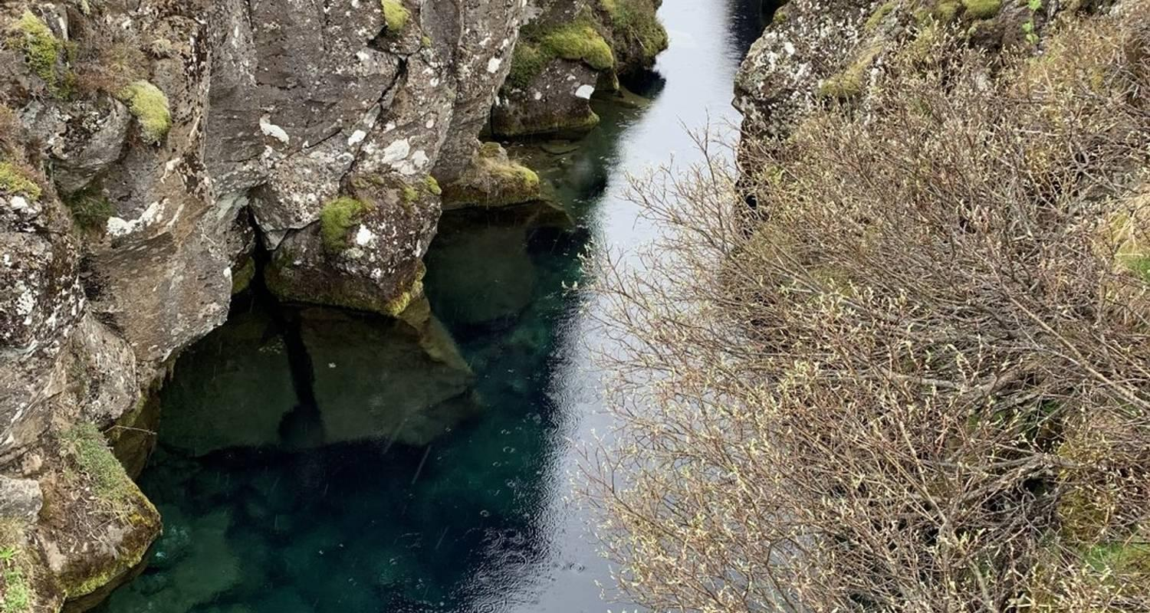

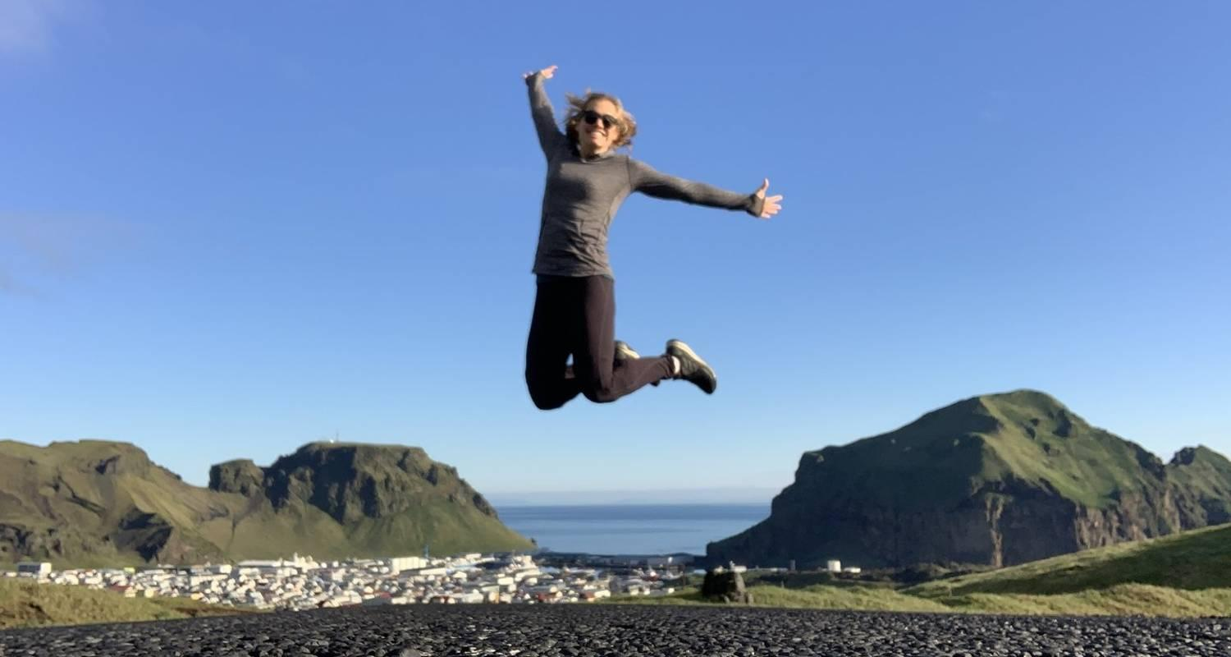

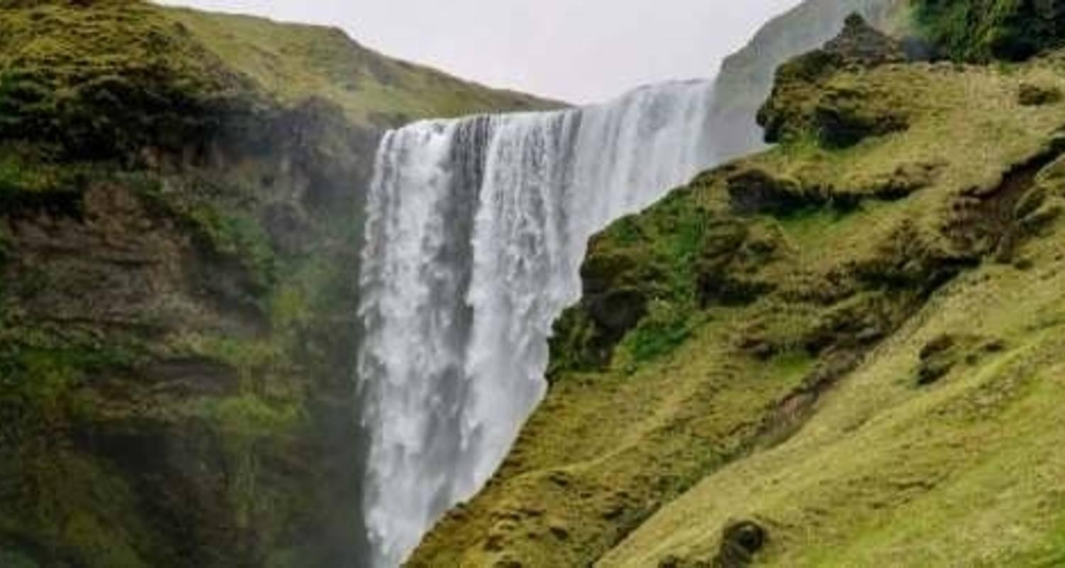

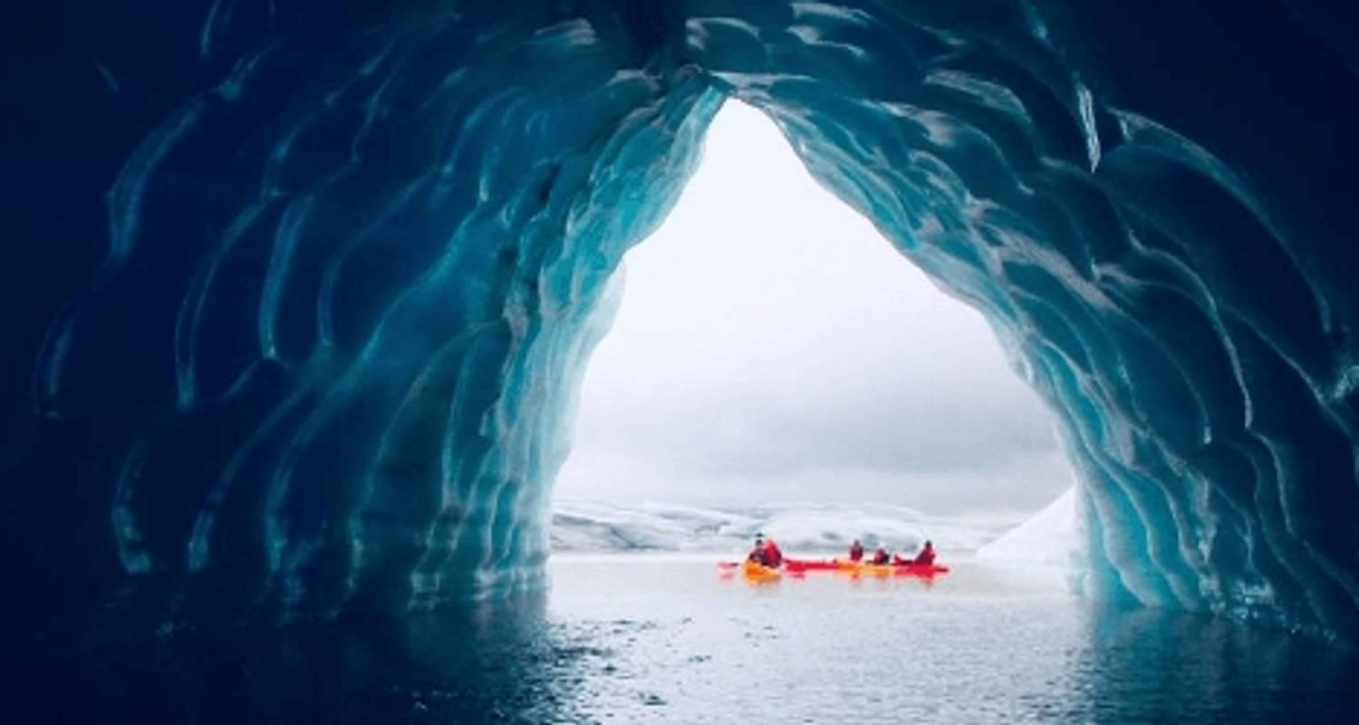

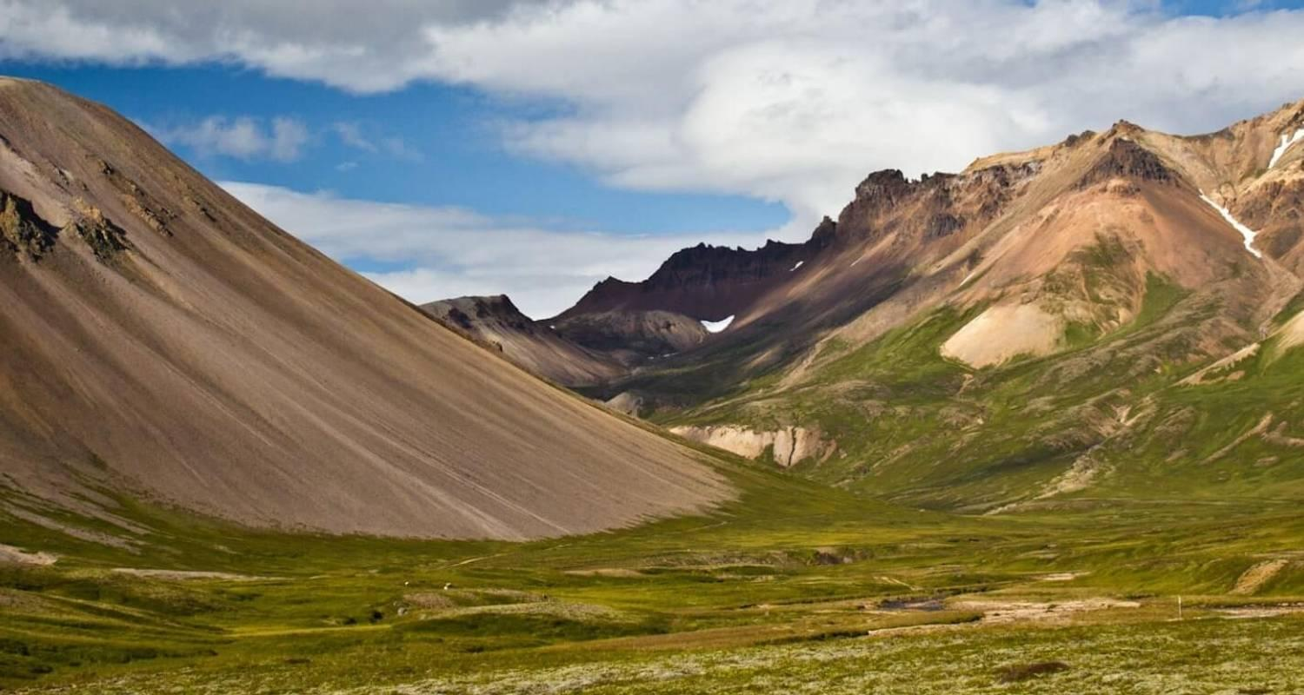

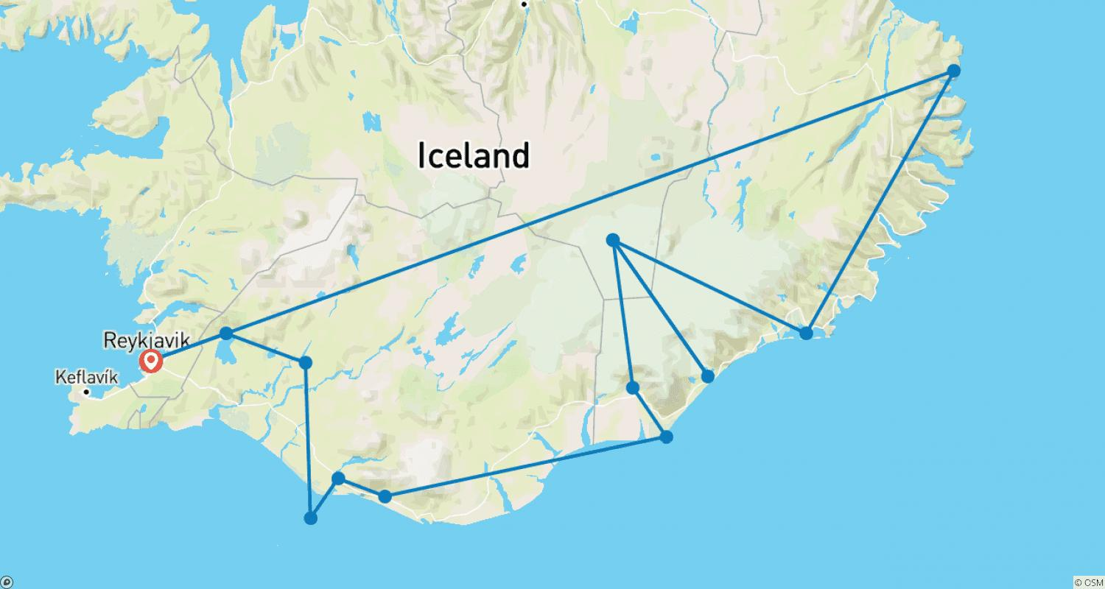

Tour ID: 172367  
Tour Name: 8 Day - Laugavegur trail, Golden Circle, south coast and glacier hike

Tour destinations: ['Reykjavik', 'Landmannalaugar', 'Hrafntinnusker Mountain', 'Emstrur', 'Thorsmork Nature Reserve', 'Fimmvorduhals Volcano', 'Hella', 'Seljaland', 'Skogafoss', 'Solheimajokull', 'Vik', 'Thingvellir National Park', 'Gullfoss', 'Dover', 'Secret Lagoon']

Tour destinations images:

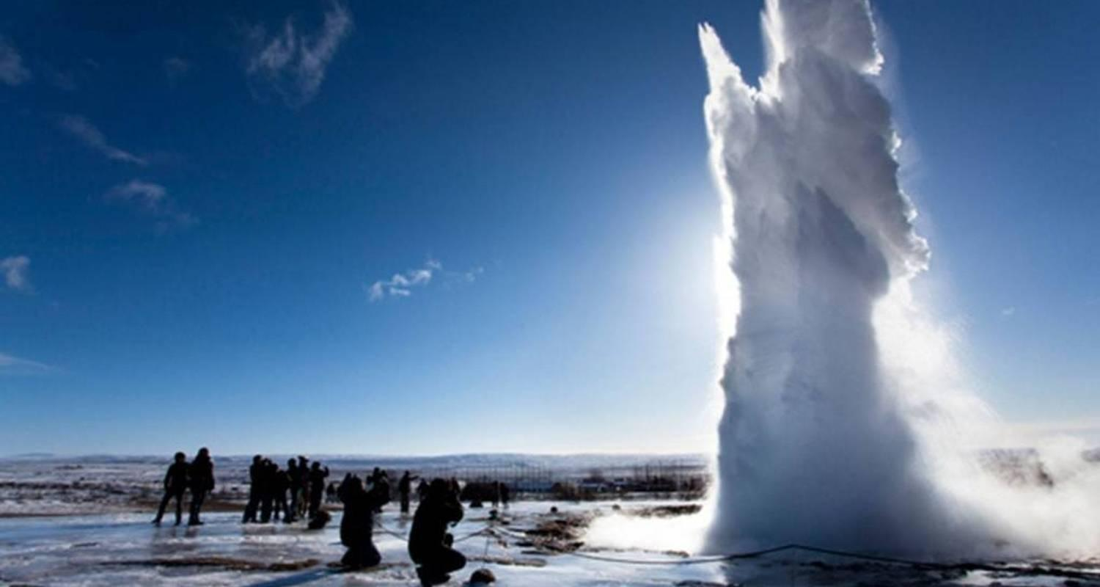

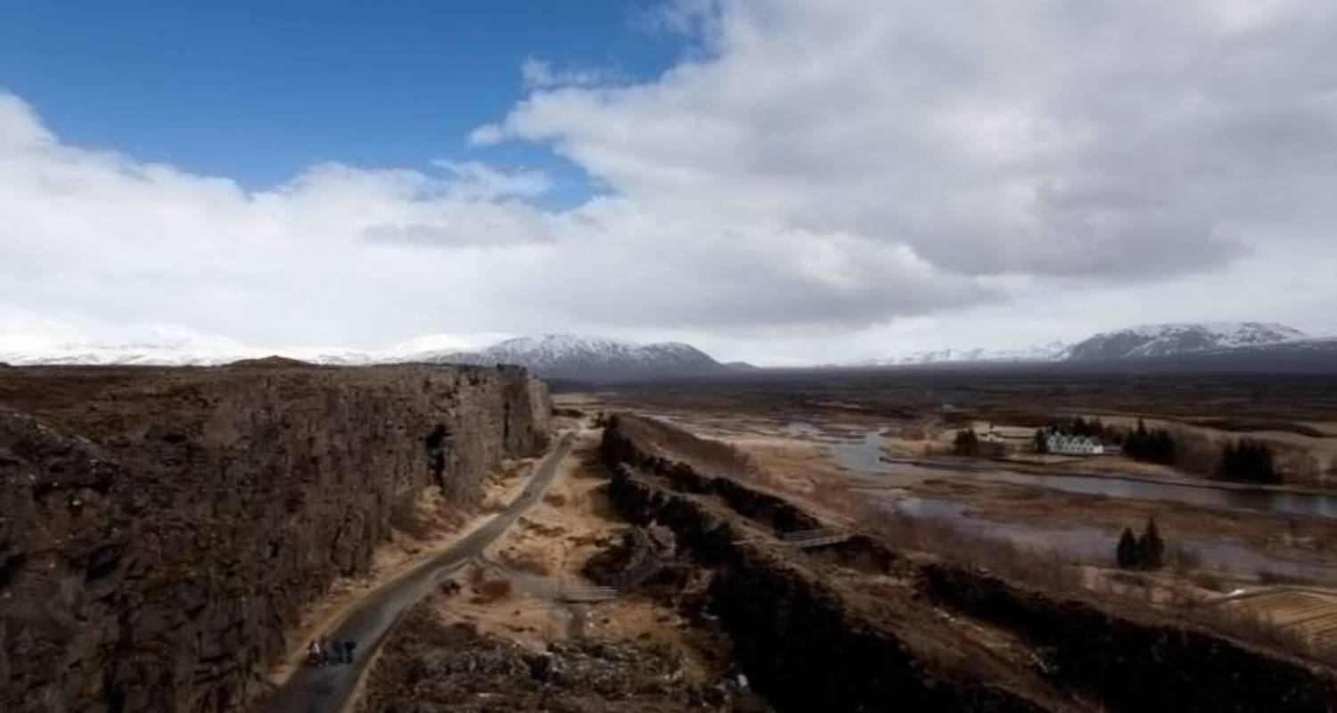

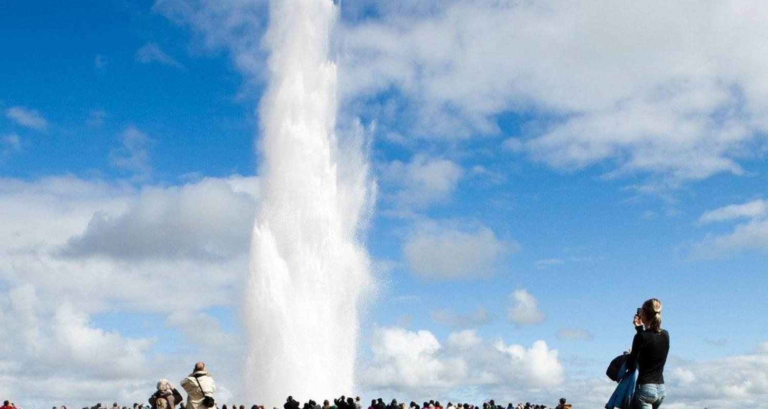

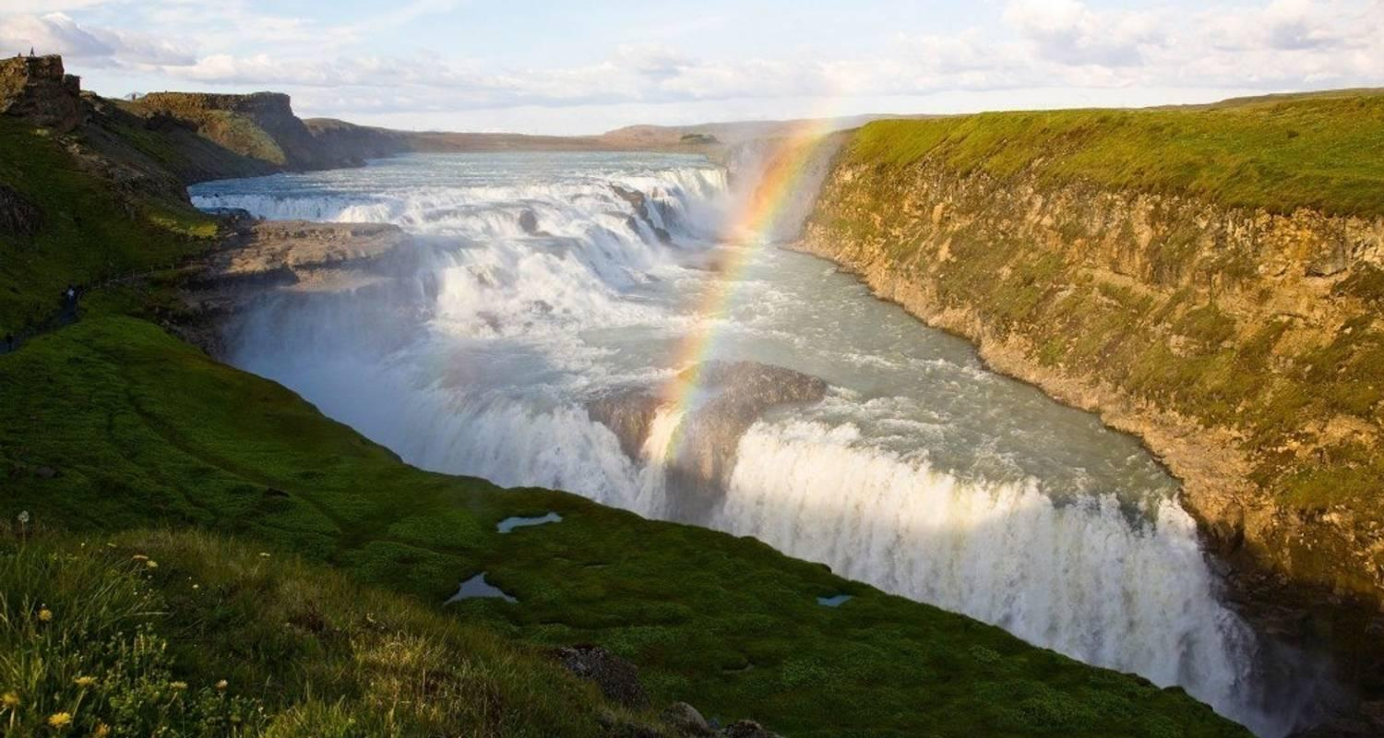

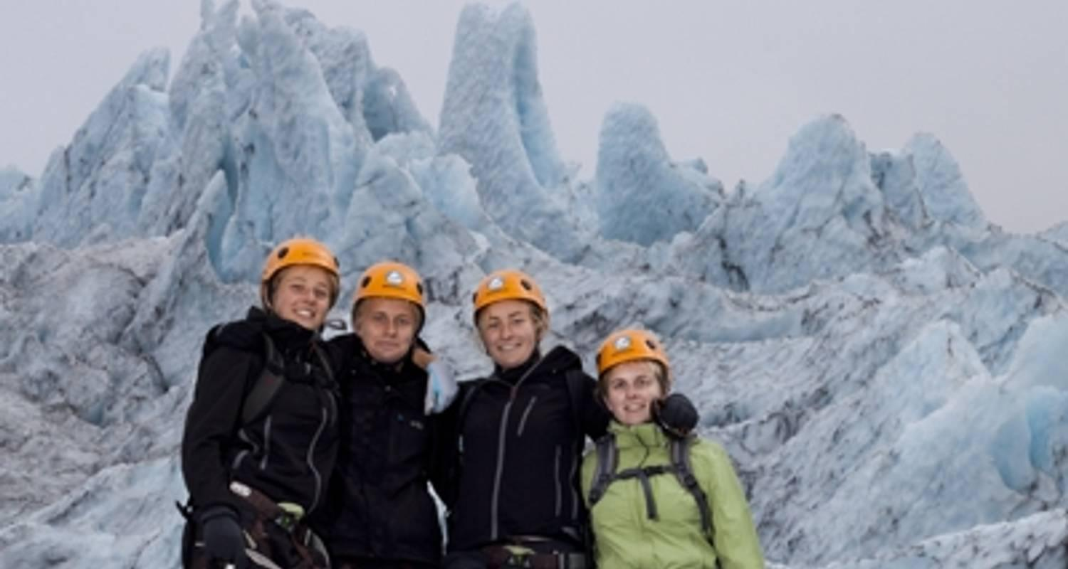

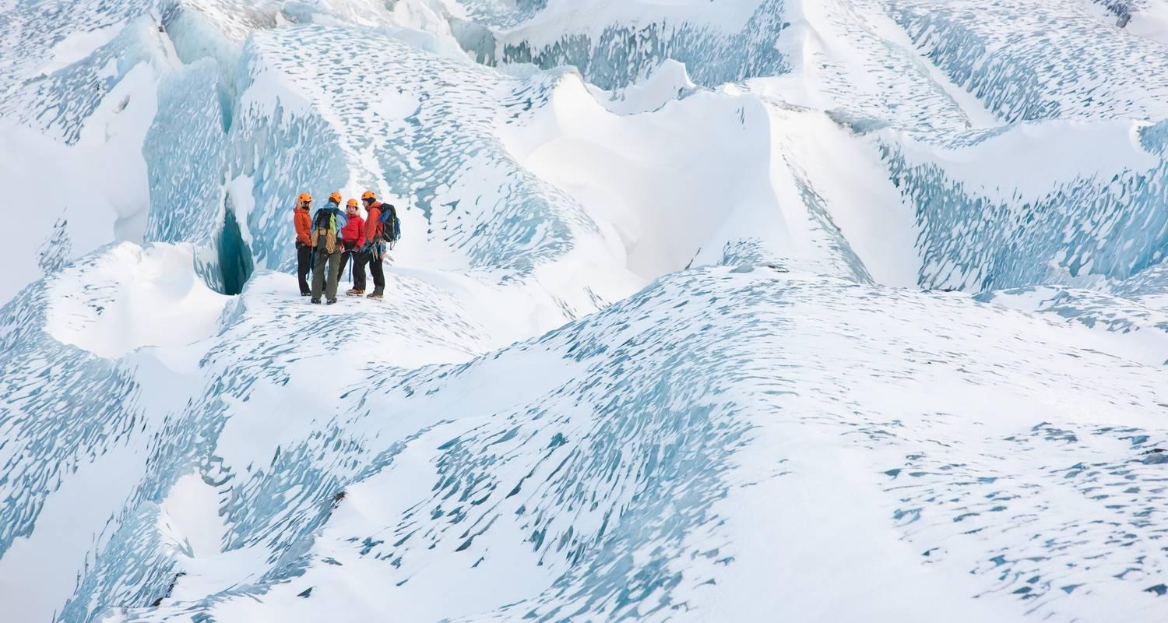

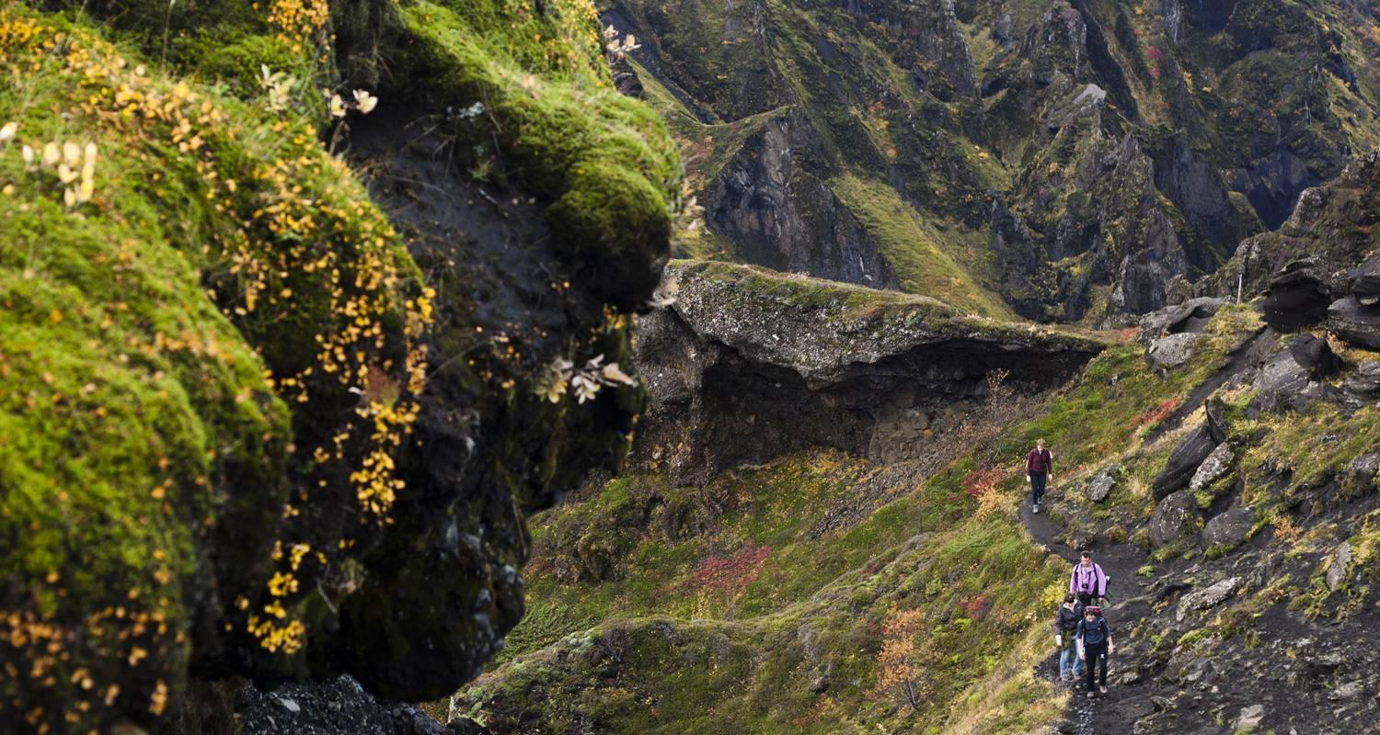

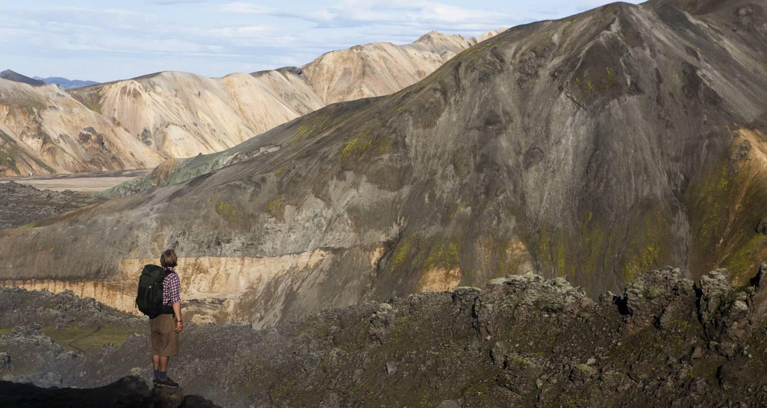

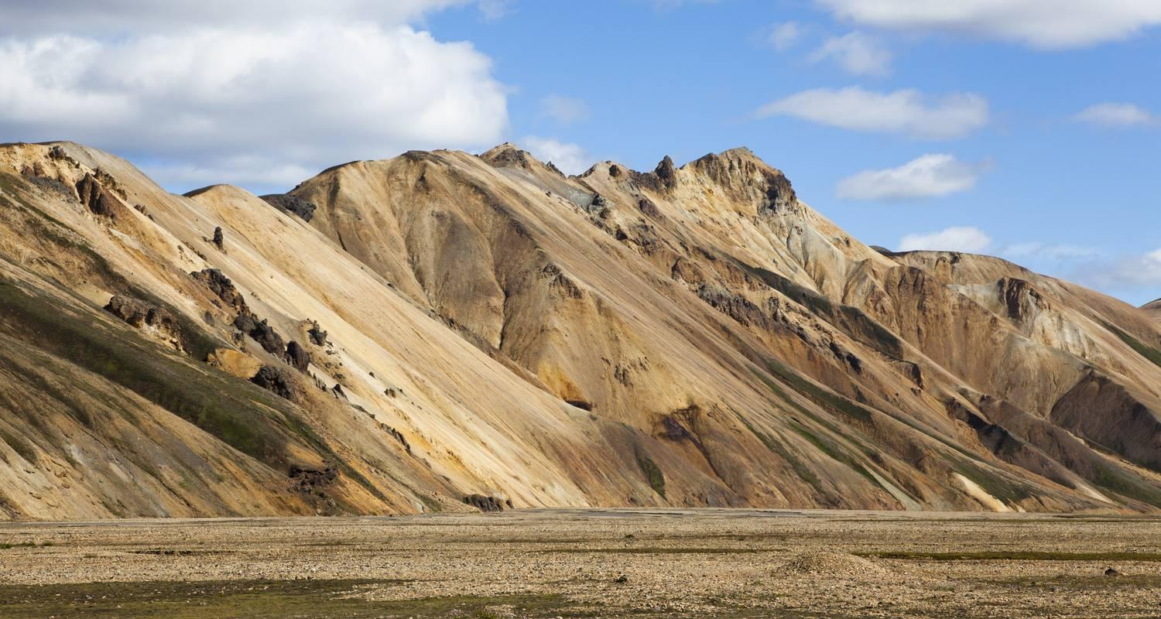

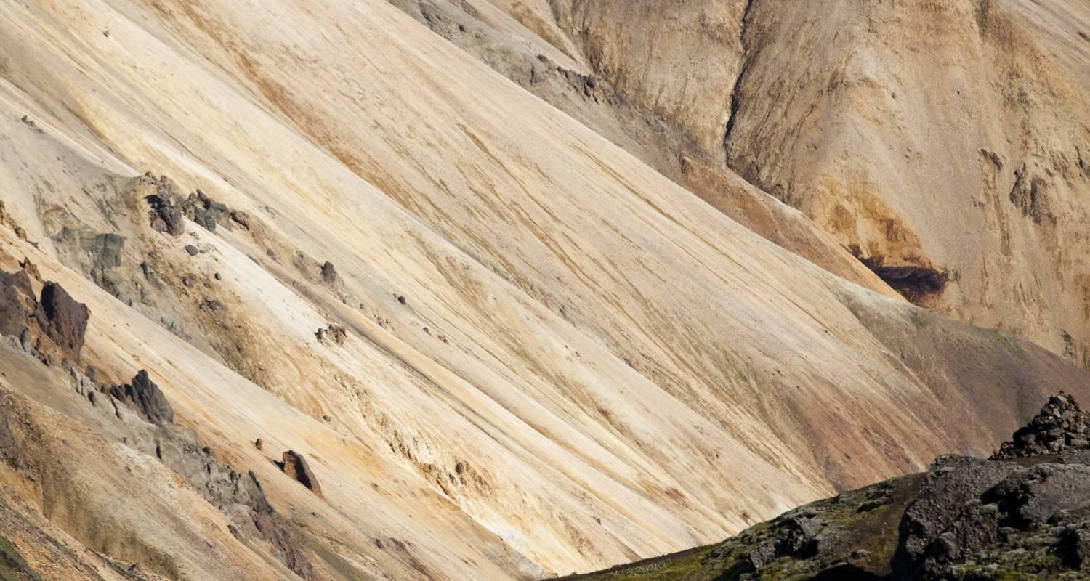

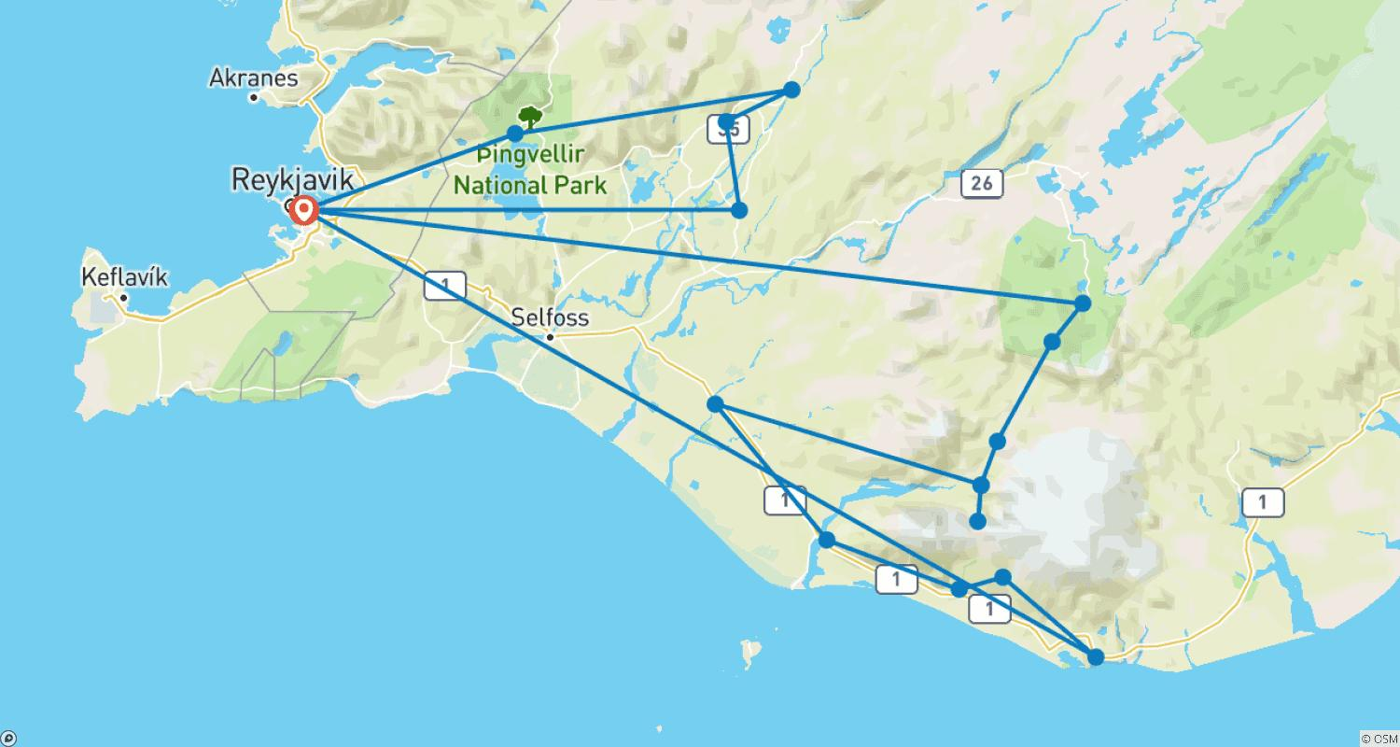

Tour ID: 172370  
Tour Name: Laugavegur Trek with glacier hike - 7 Day (Huts)

Tour destinations: ['Reykjavik', 'Landmannalaugar', 'Hrafntinnusker Mountain', 'Emstrur', 'Thorsmork Nature Reserve', 'Seljaland', 'Hella', 'Skogafoss', 'Solheimajokull']

Tour destinations images:

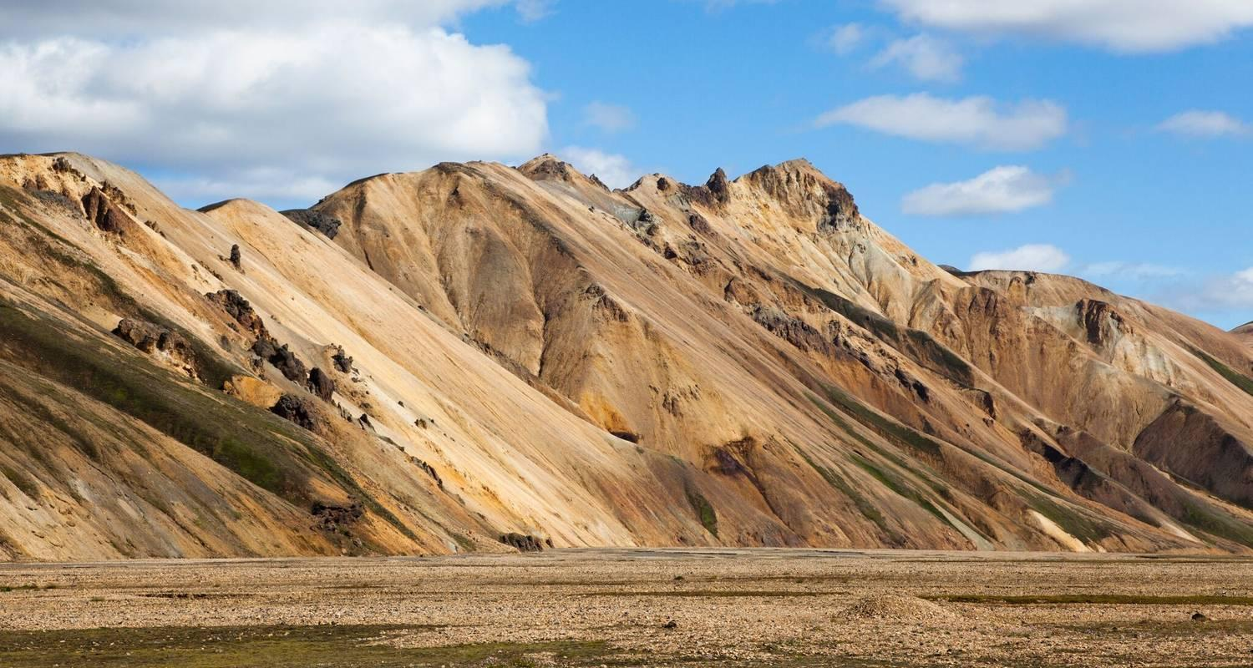

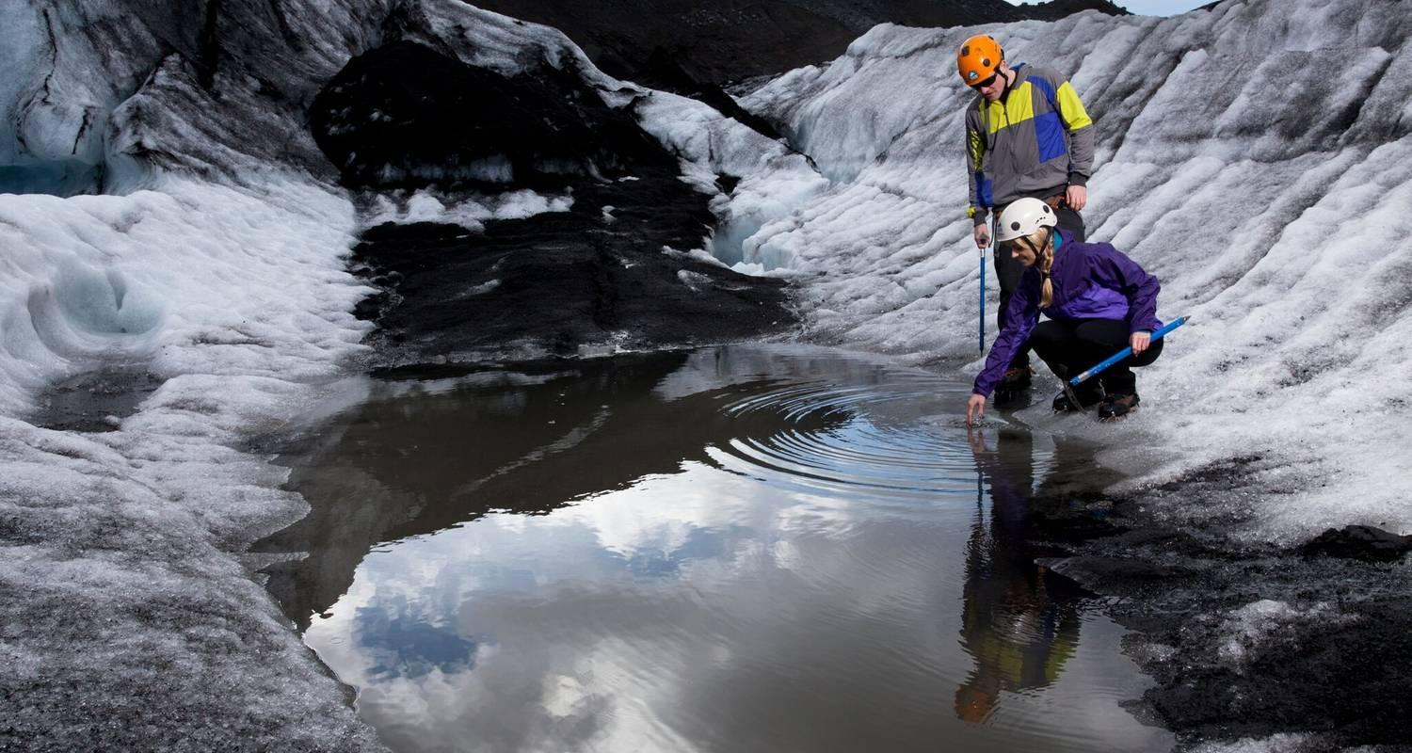

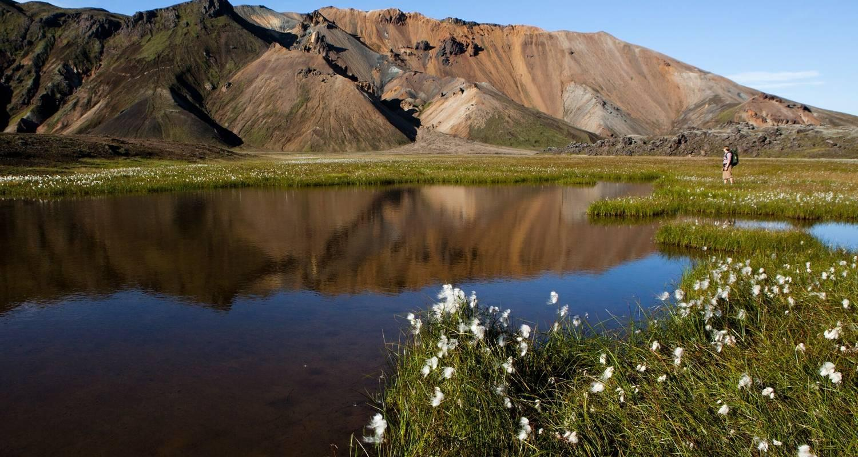

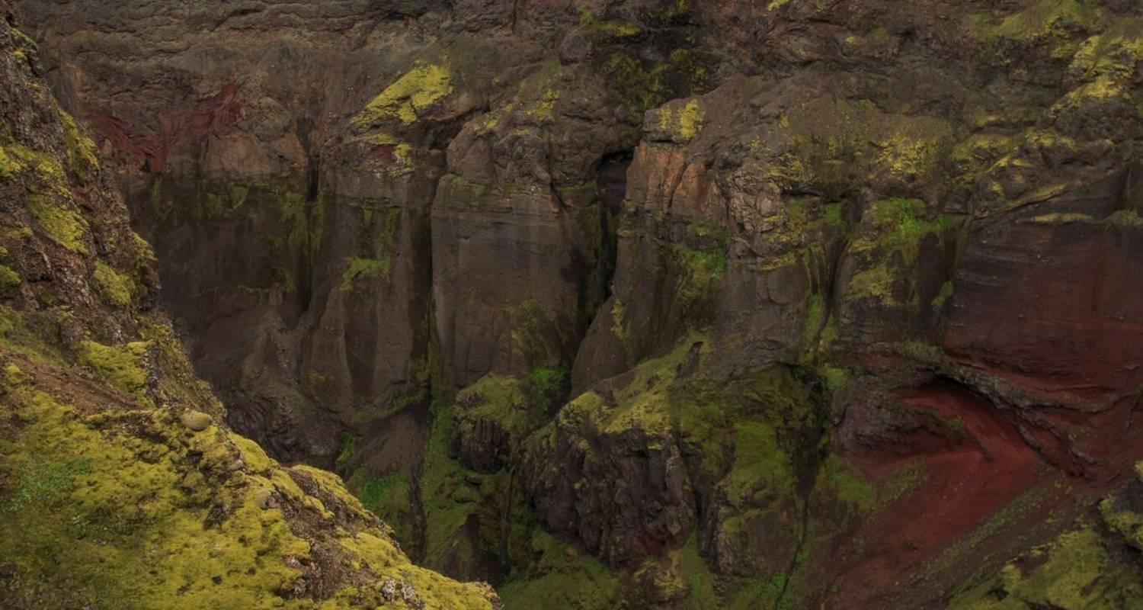

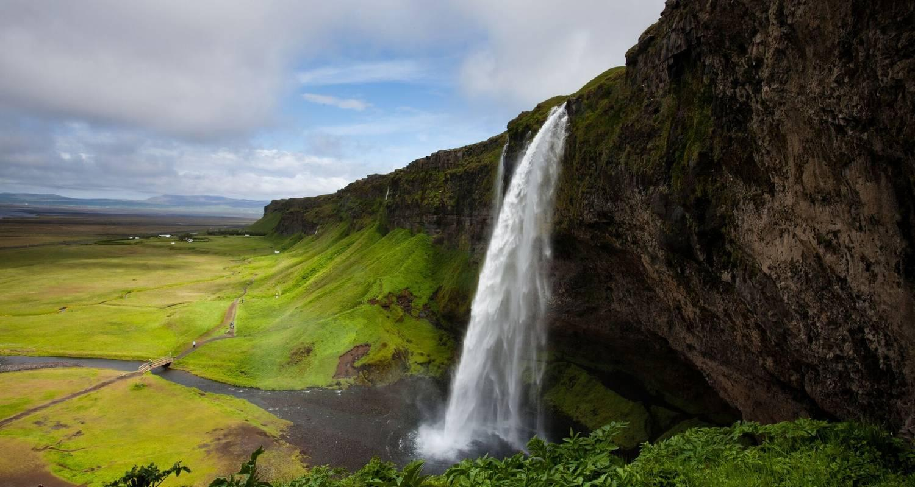

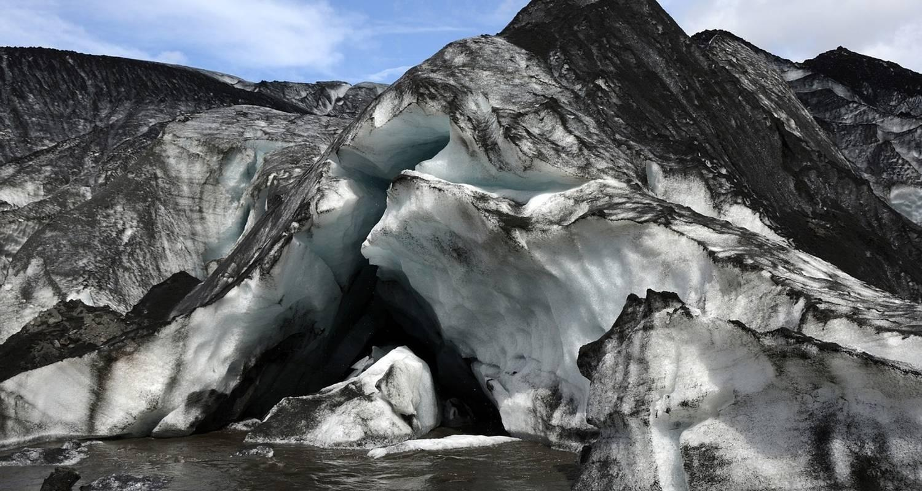

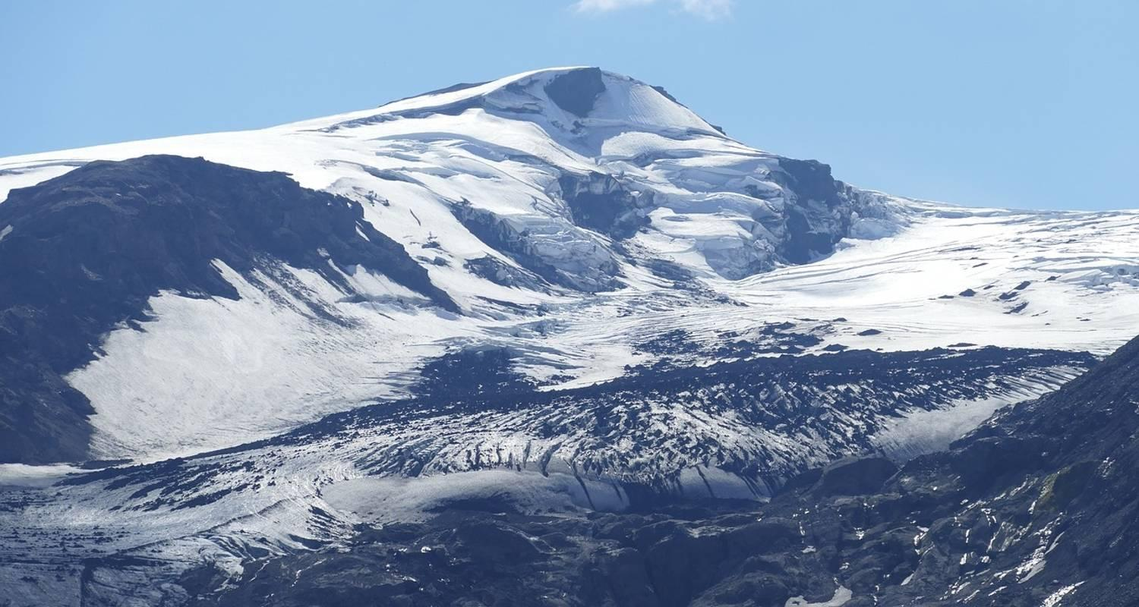

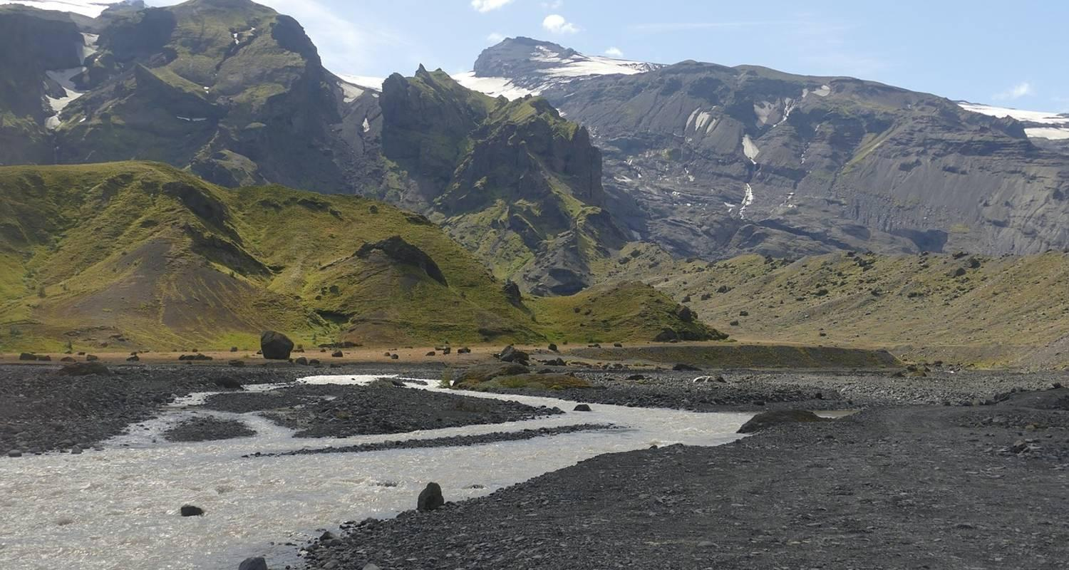

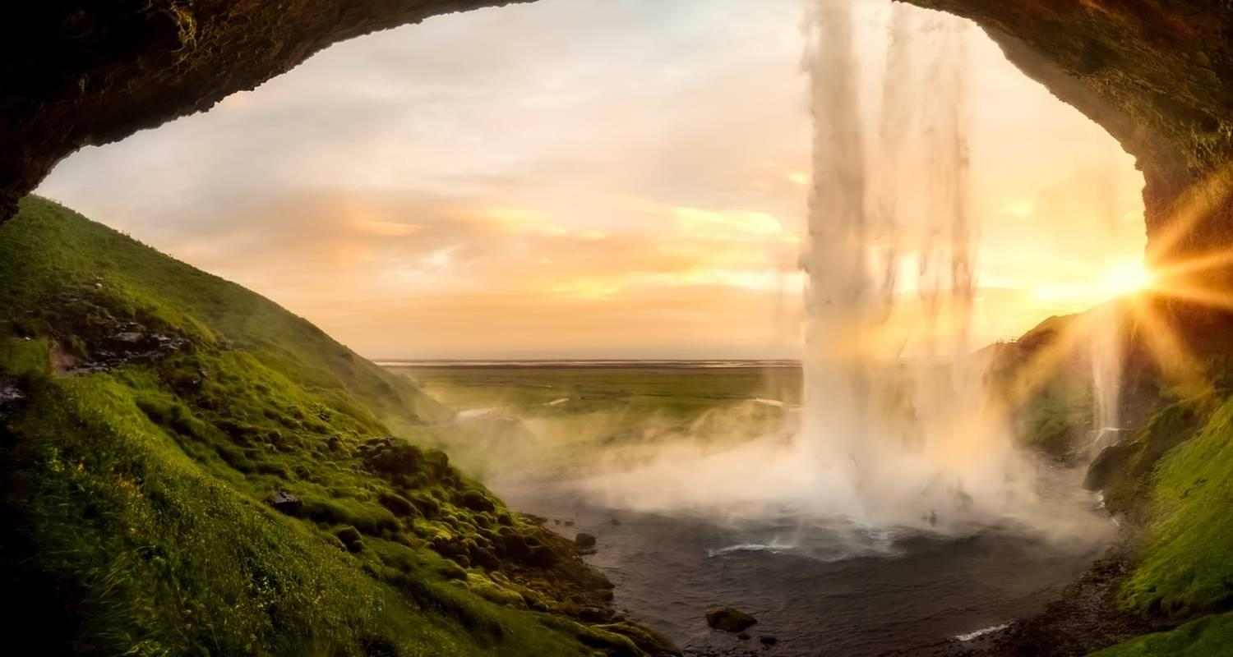

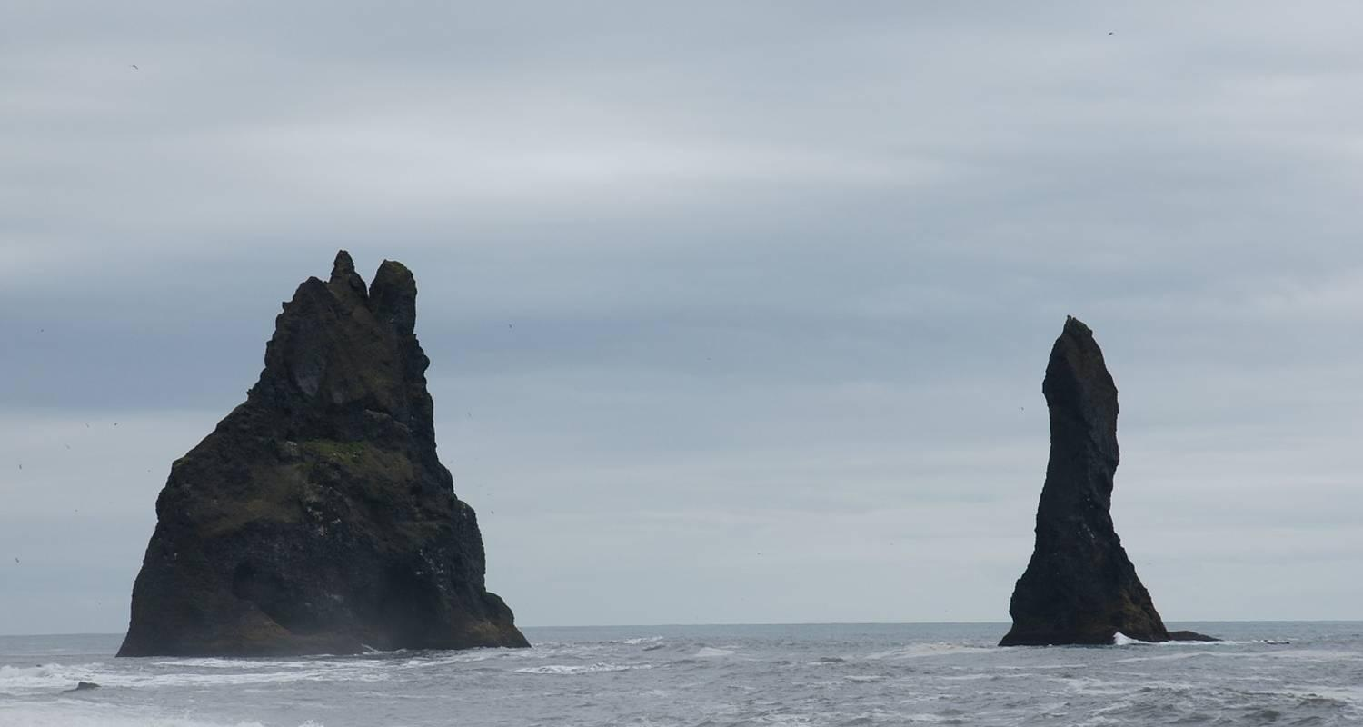

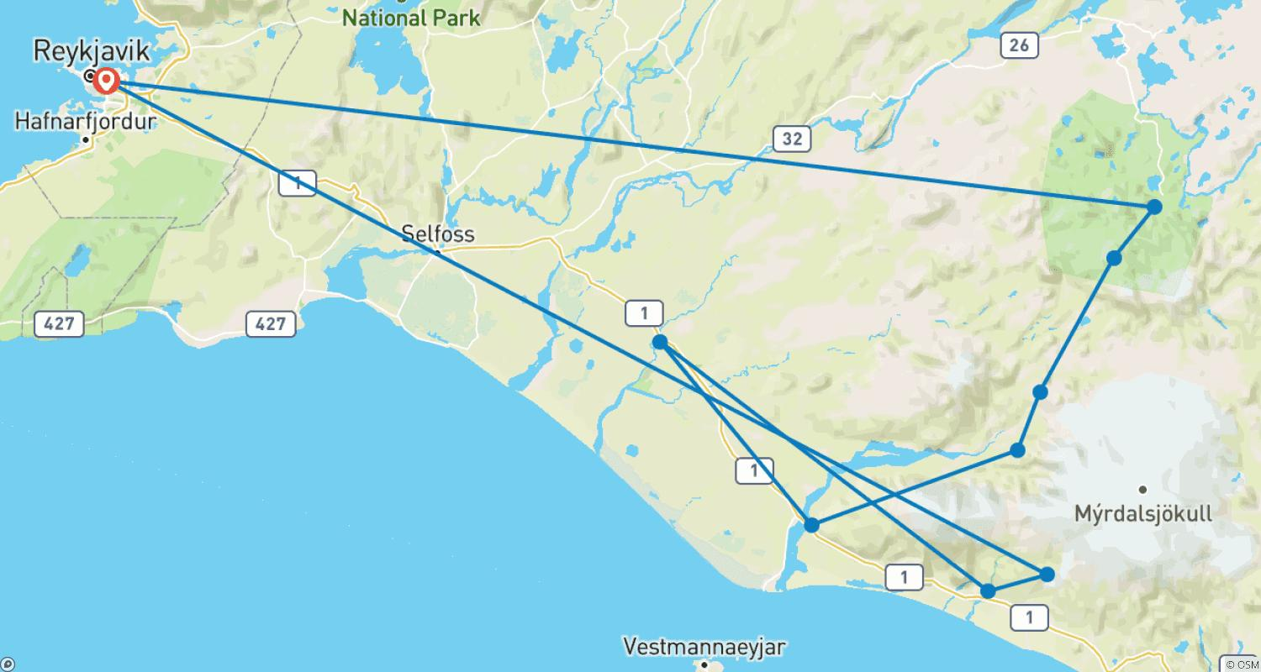

Tour ID: 173465  
Tour Name: 10 day Self-drive tour | Around Iceland

Tour destinations: ['Keflavik', 'Blue Lagoon', 'Reykjavik', 'Hveragerdi', 'Kerid Volcano', 'Gullfoss', 'Geysir', 'Thingvellir National Park', 'Borgarnes', 'Reykholt', 'Grábrók Volcano', 'Blonduos', 'Akureyri', 'Godafoss', 'Myvatn', 'Hverfjall Volcano', 'Krafla Volcano', 'Husavik', 'Asbyrgi Canyon', 'Dettifoss', 'Egilsstadir', 'Seydisfjordur', 'Stodvarfjordur', 'Djupivogur', 'Hofn', 'Jokulsarlon', 'Skaftafell', 'Kirkjubaejarklaustur', 'Vik', 'Reynisfjara', 'Skogafoss', 'Seljaland']

Tour destinations images:

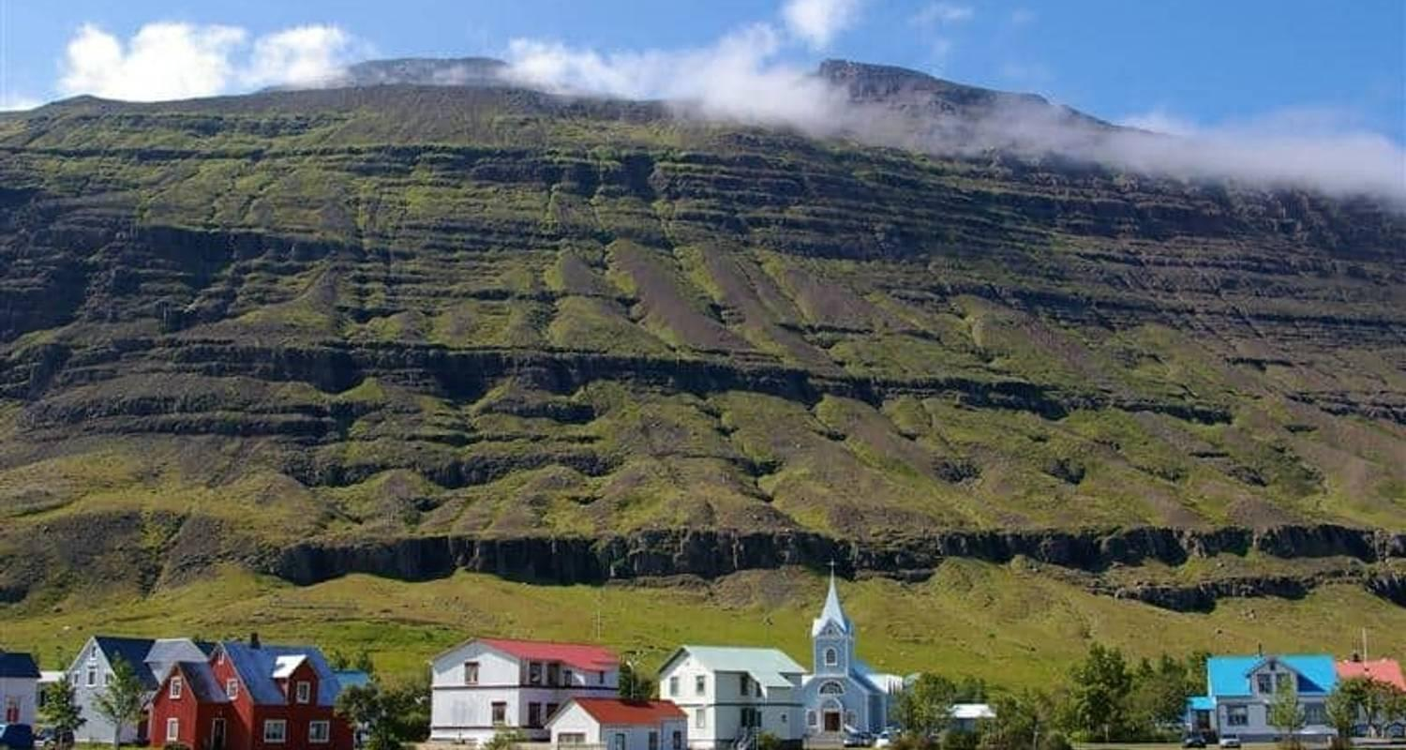

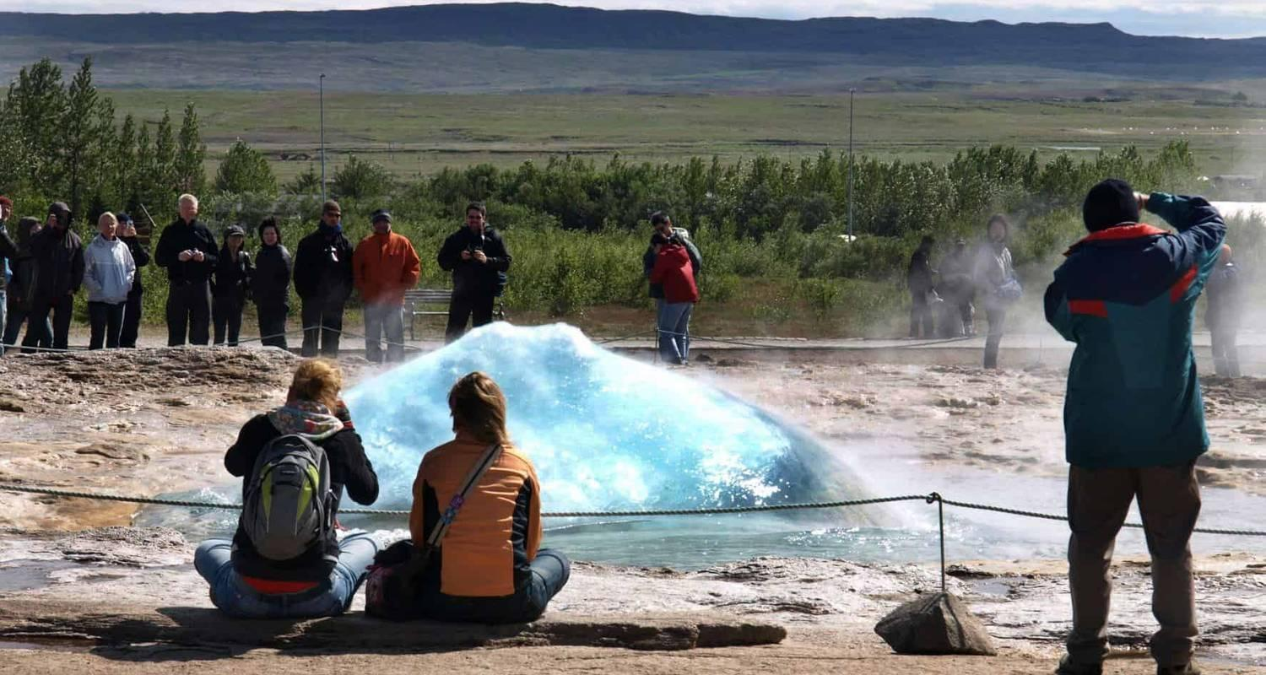

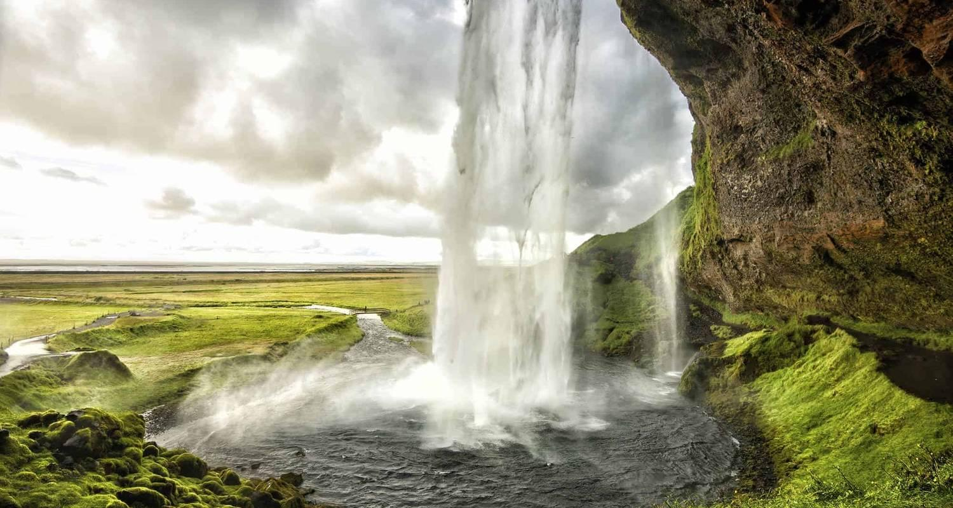

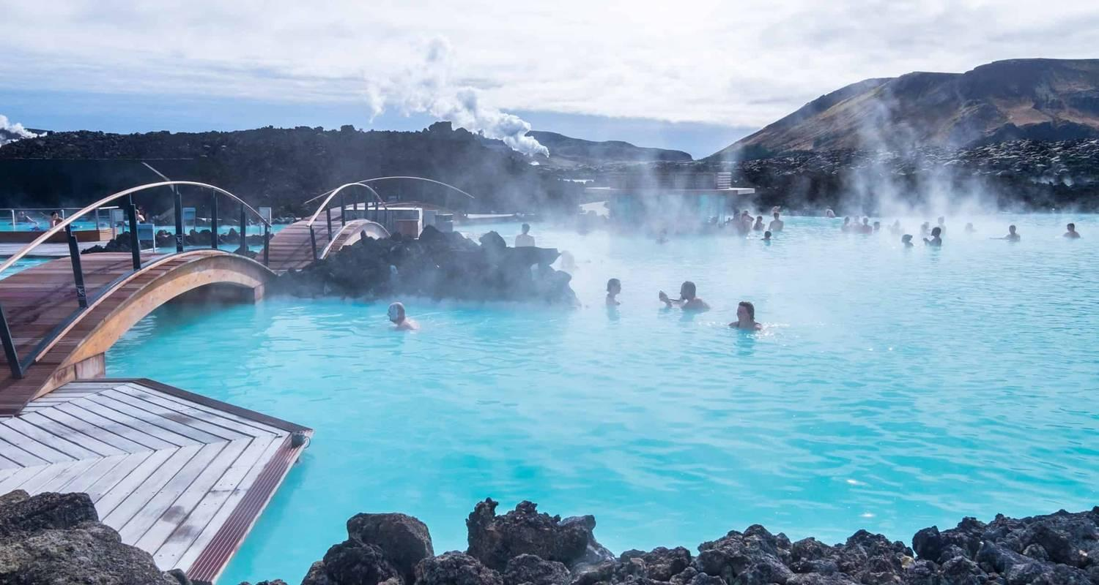

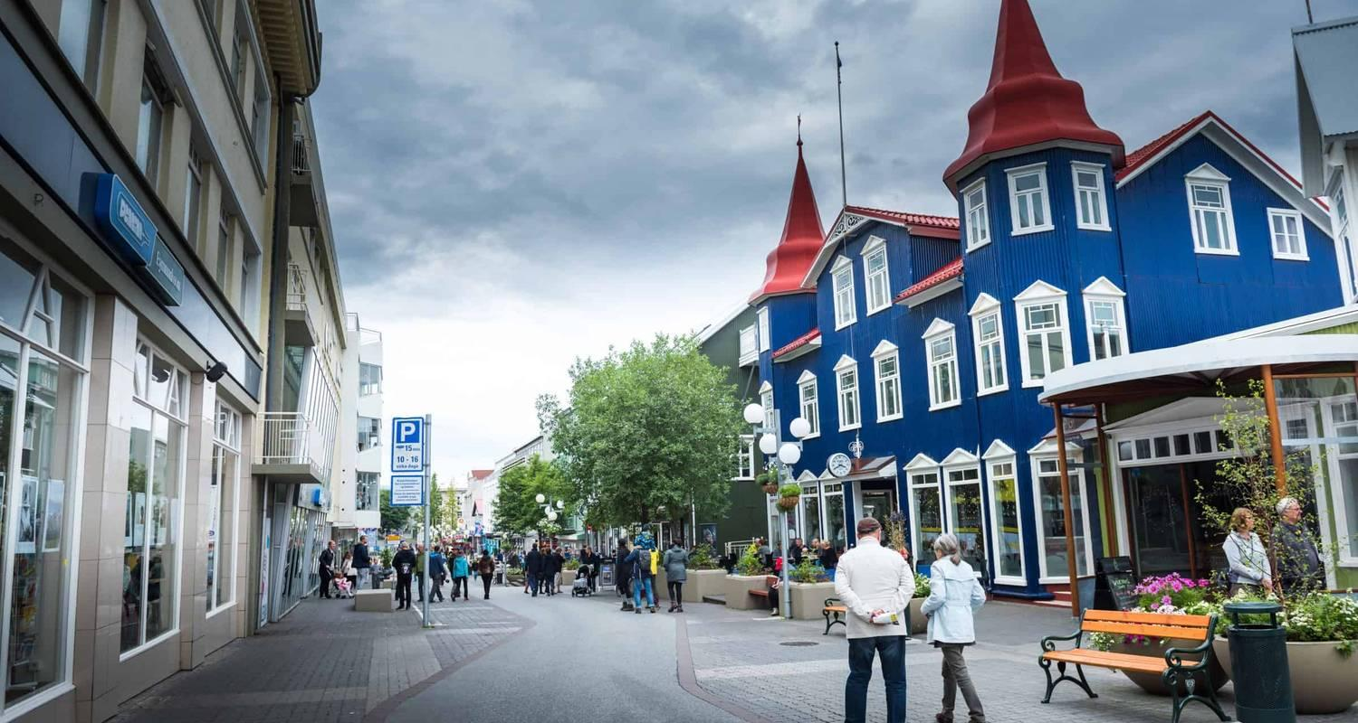

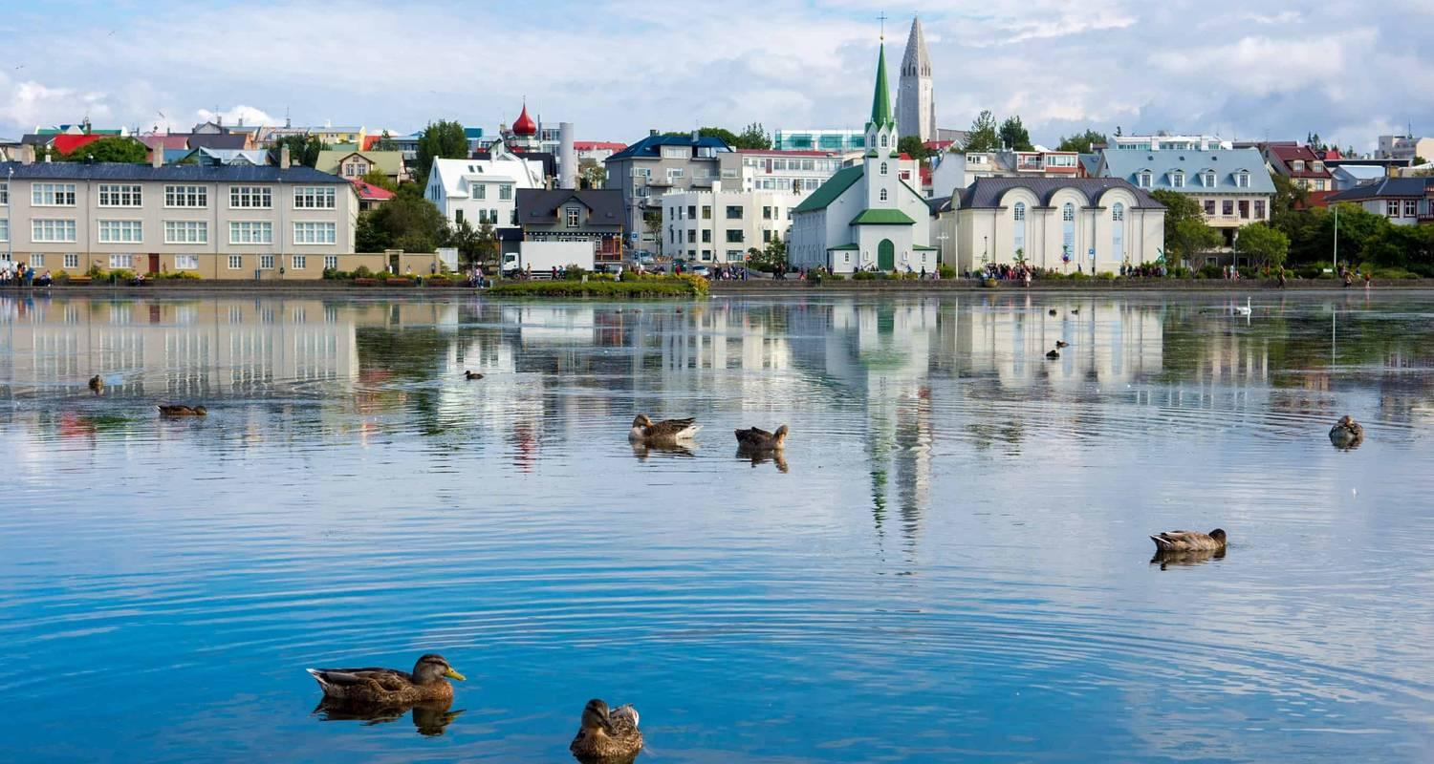

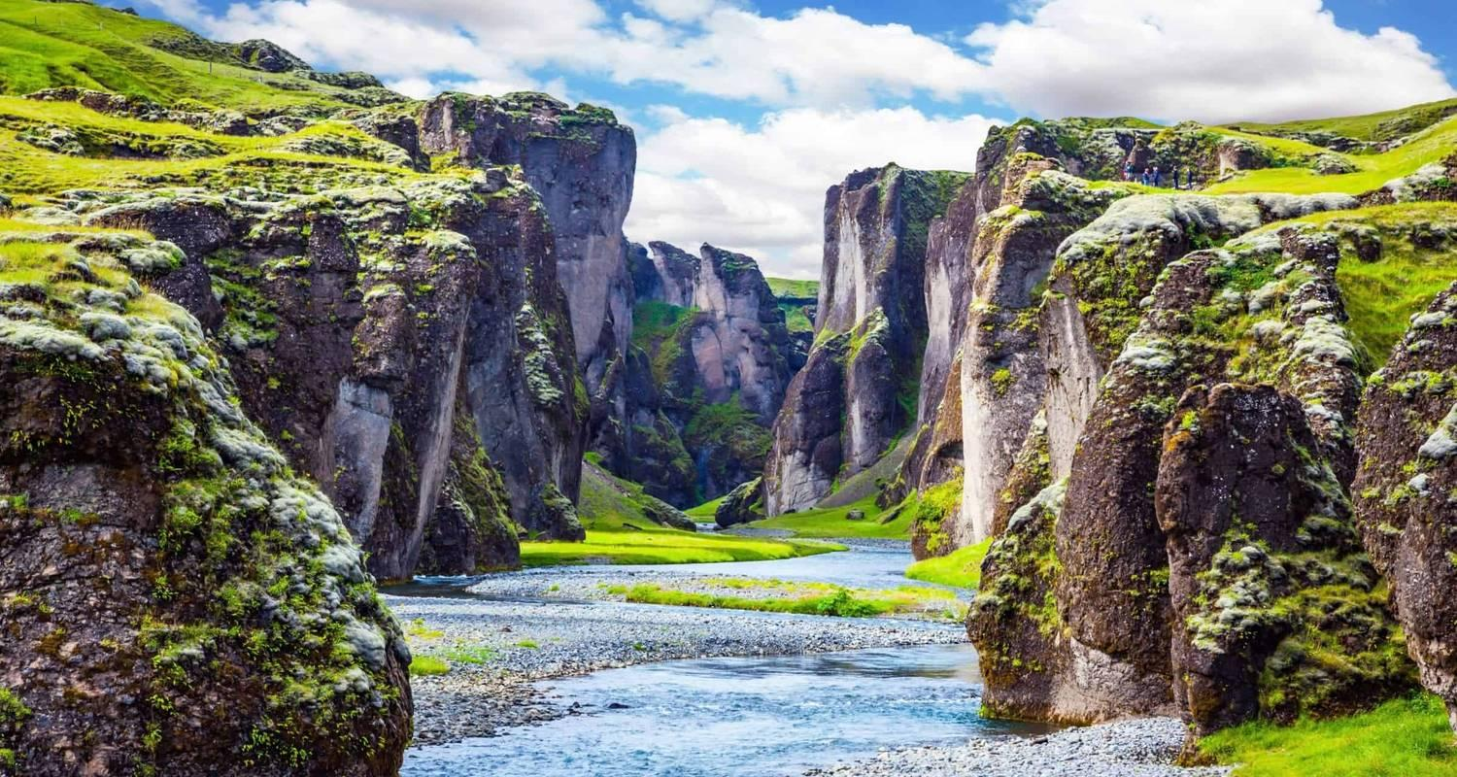

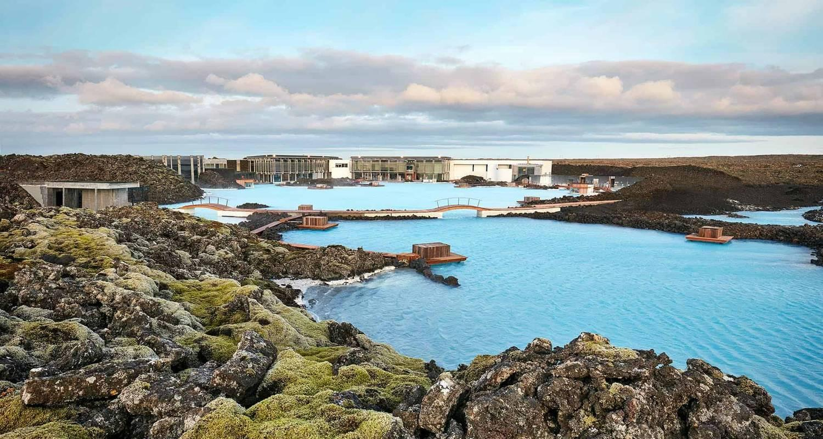

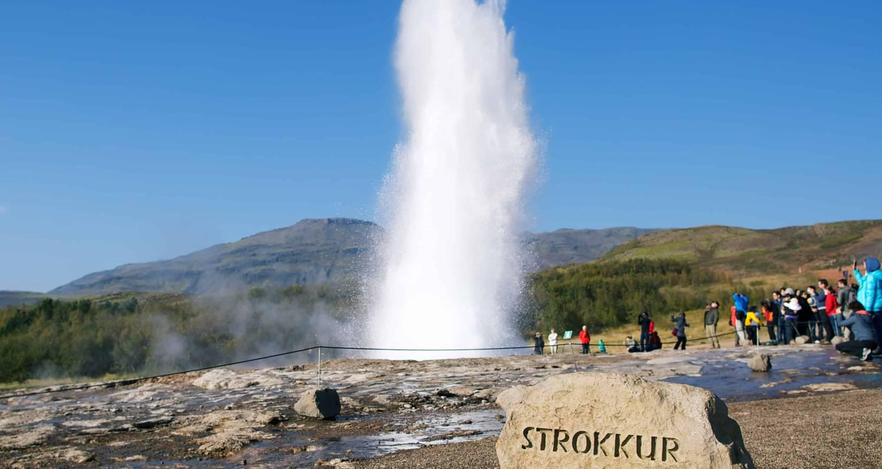

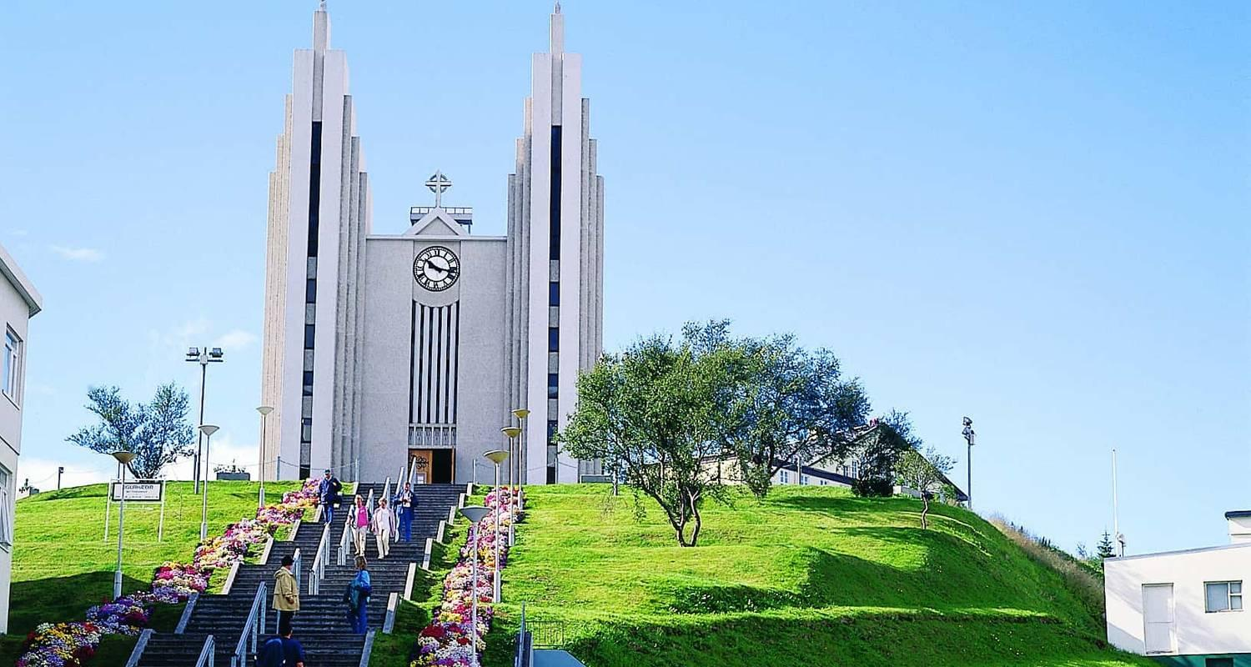

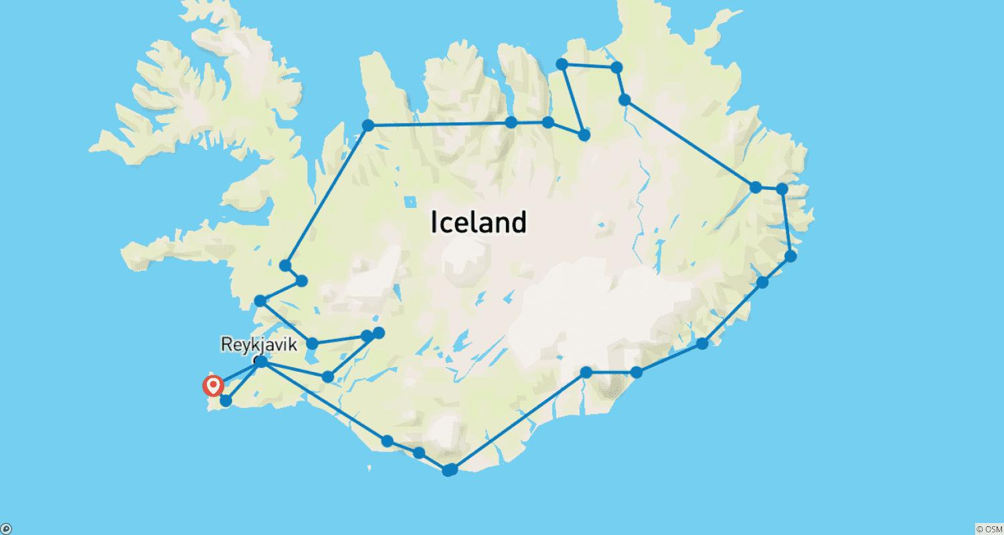

Tour ID: 173467  
Tour Name: 7 day Self-drive tour | Geysers, Glaciers and Waterfalls

Tour destinations: ['Keflavik', 'Hveragerdi', 'Thingvellir National Park', 'Laugarvatn', 'Geysir', 'Gullfoss', 'Kerid Volcano', 'Seljaland', 'Skogafoss', 'Eyjafjallajokull', 'Reynisfjara', 'Vik', 'Kirkjubaejarklaustur', 'Skaftafell', 'Jokulsarlon', 'Borgarnes', 'Reykholt', 'Snaefellsjokull National Park', 'Arnarstapi', 'Kirkjufell Mountain', 'Stykkisholmur', 'Reykjanesfólkvangur Reserve', 'Blue Lagoon', 'Grindavik', 'Reykjanesviti', 'Gunnuhver', 'Reykjavik']

Tour destinations images:

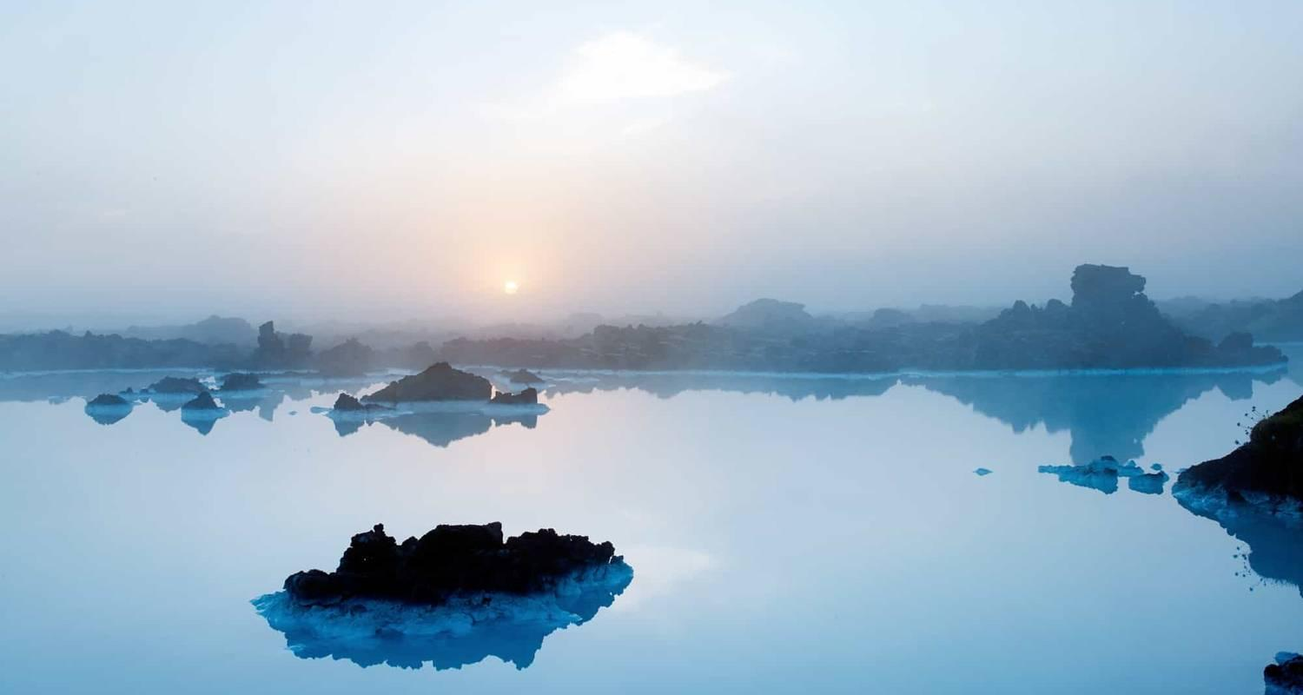

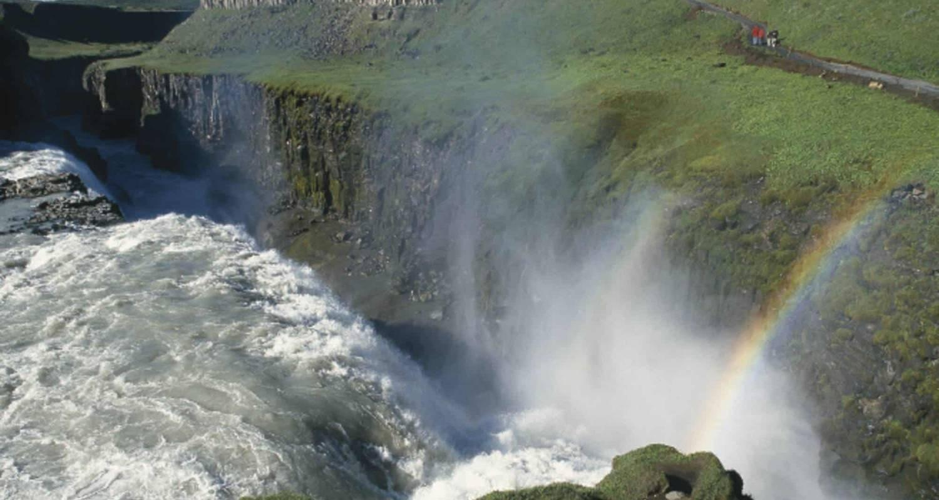

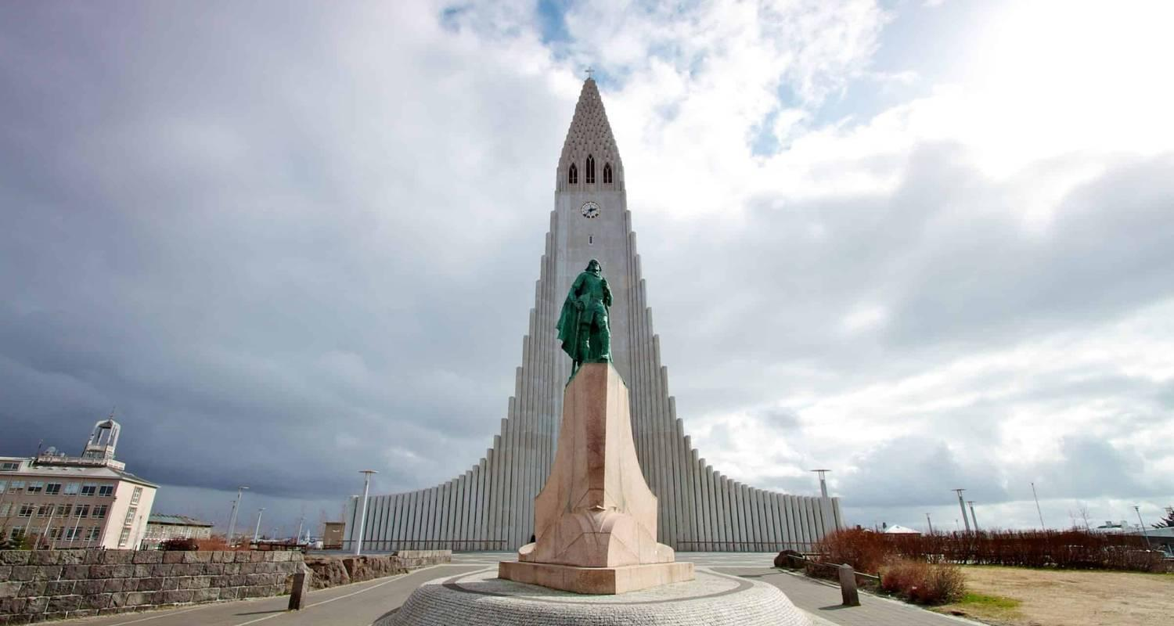

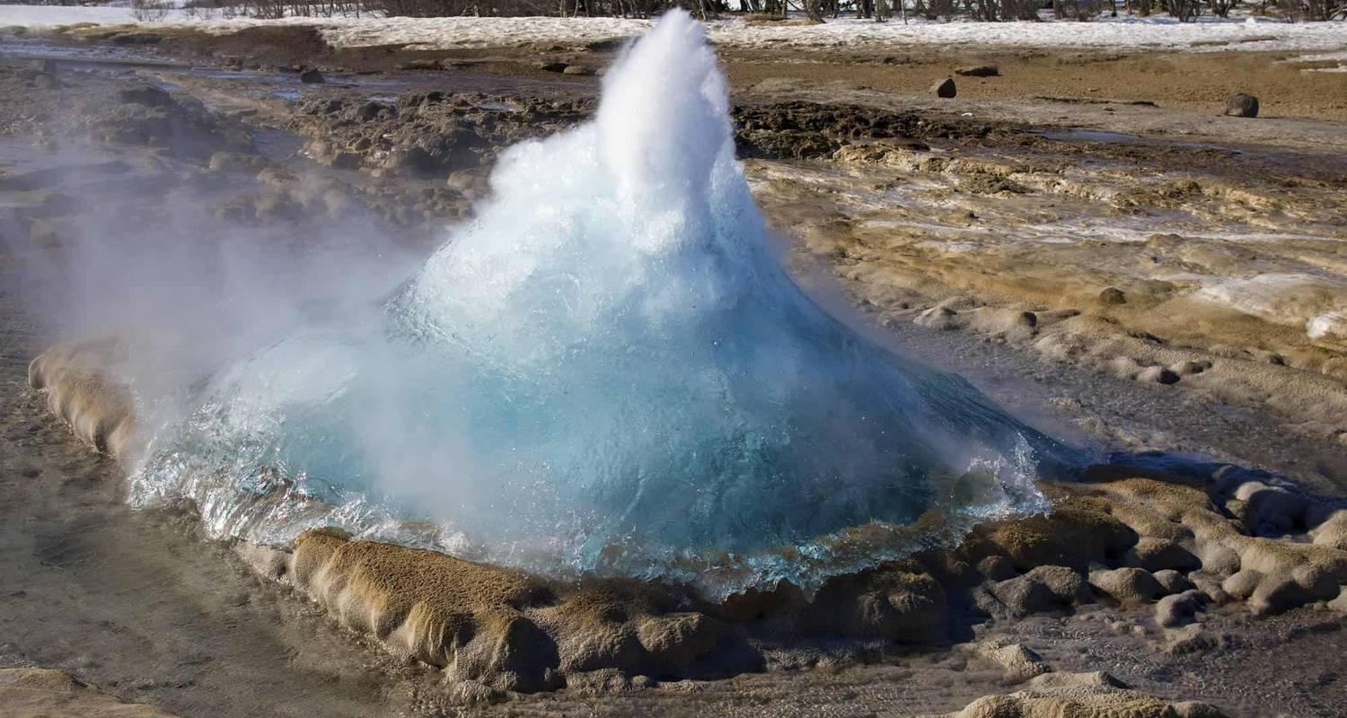

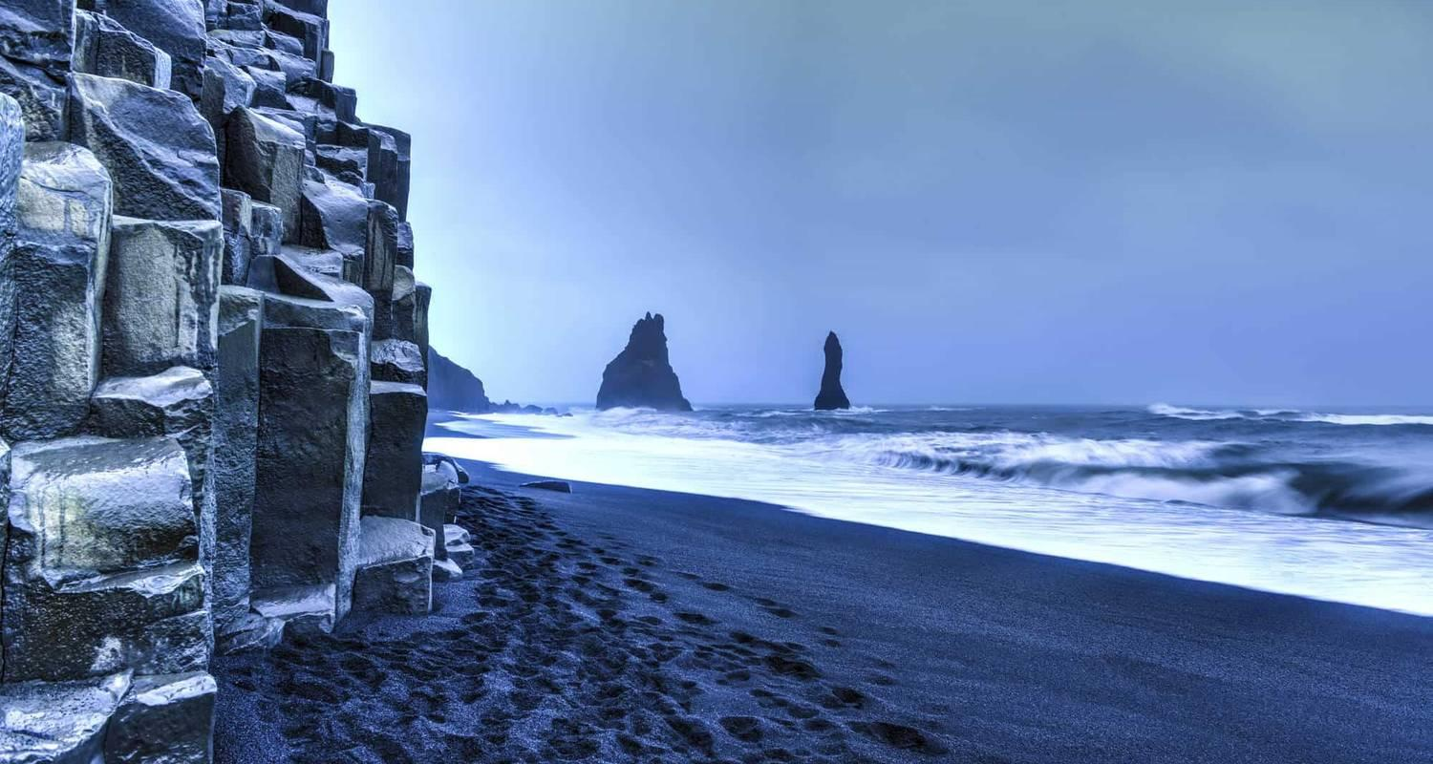

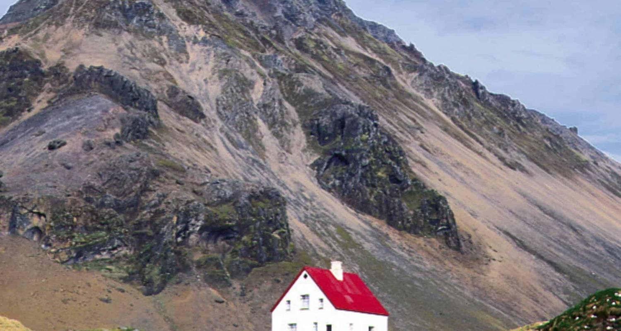

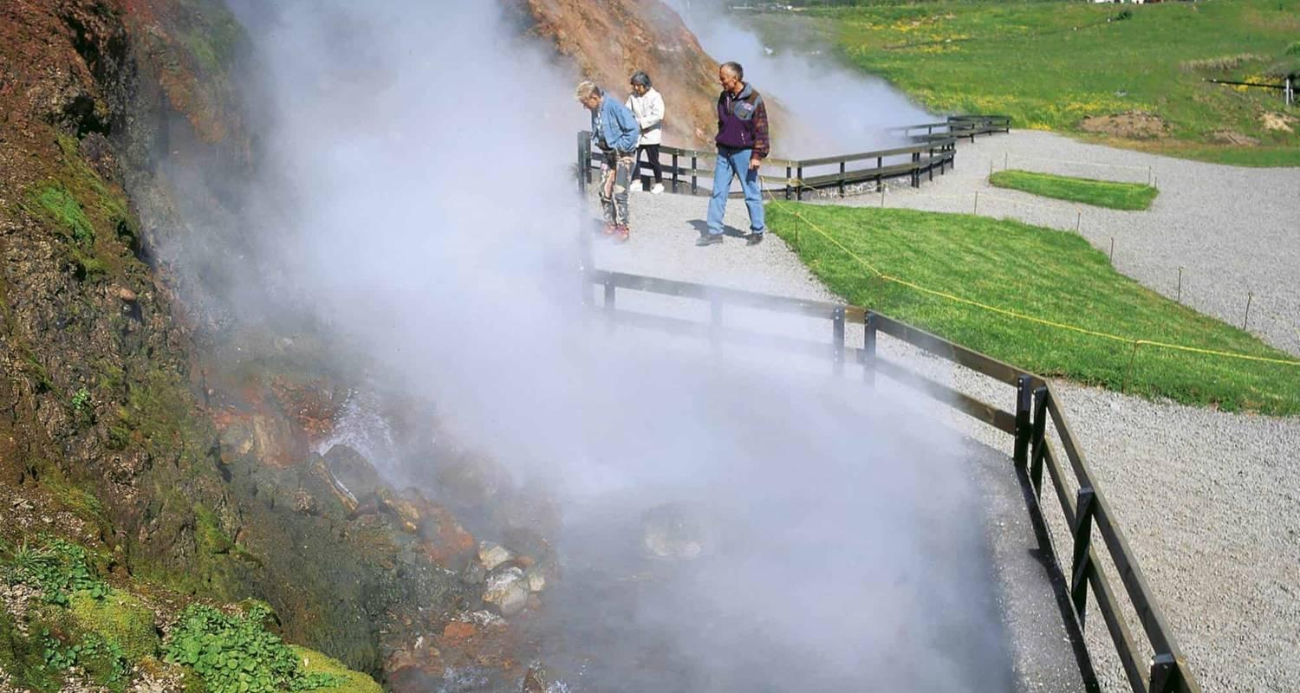

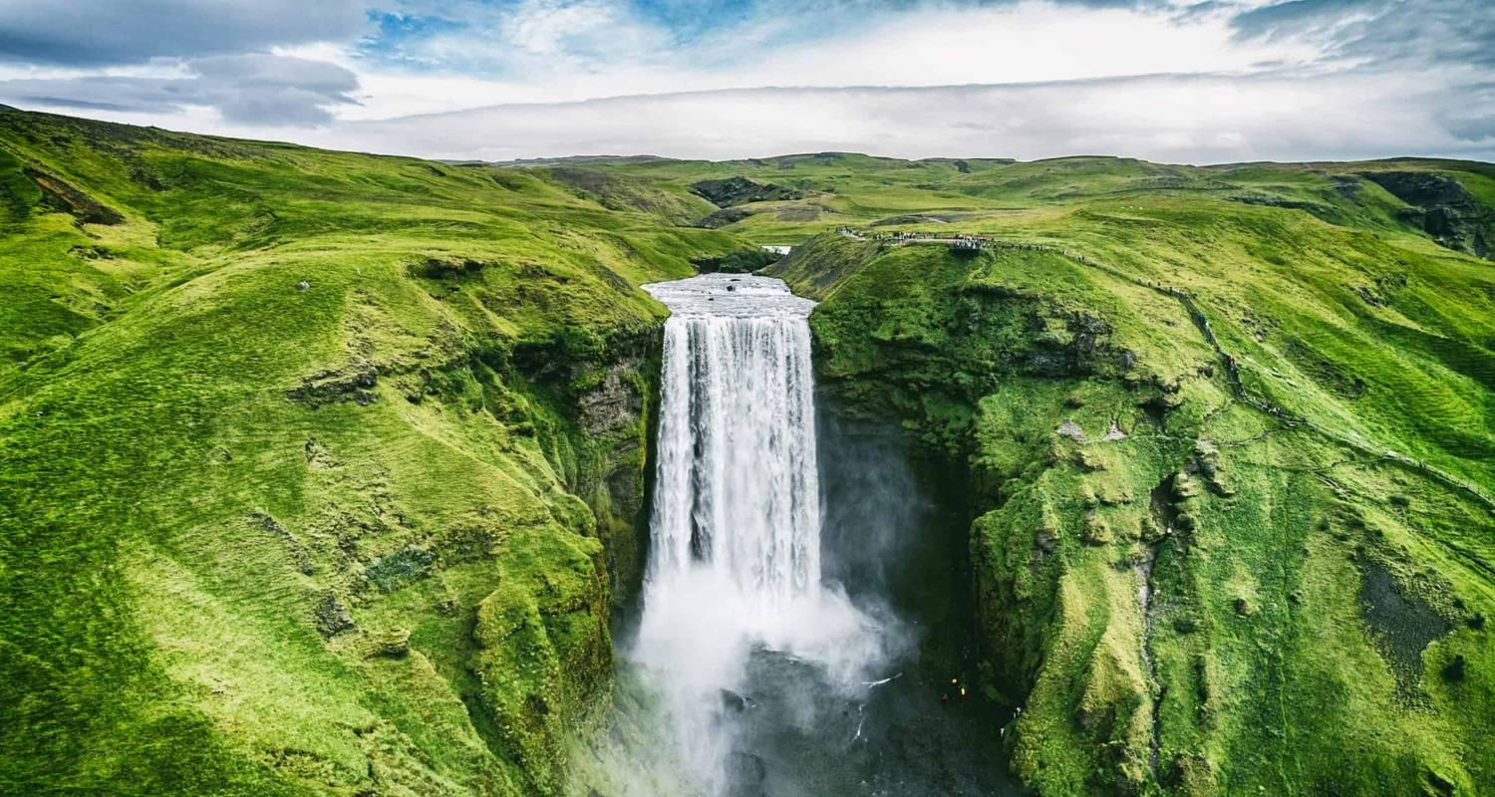

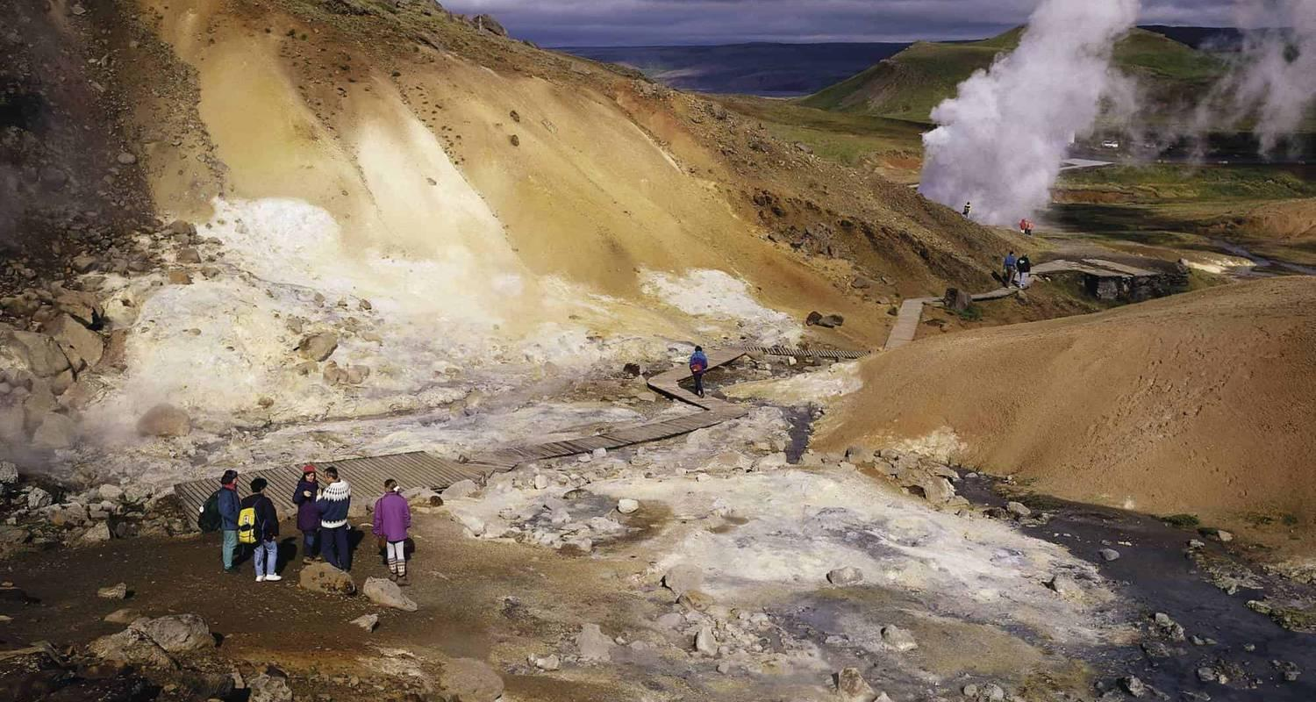

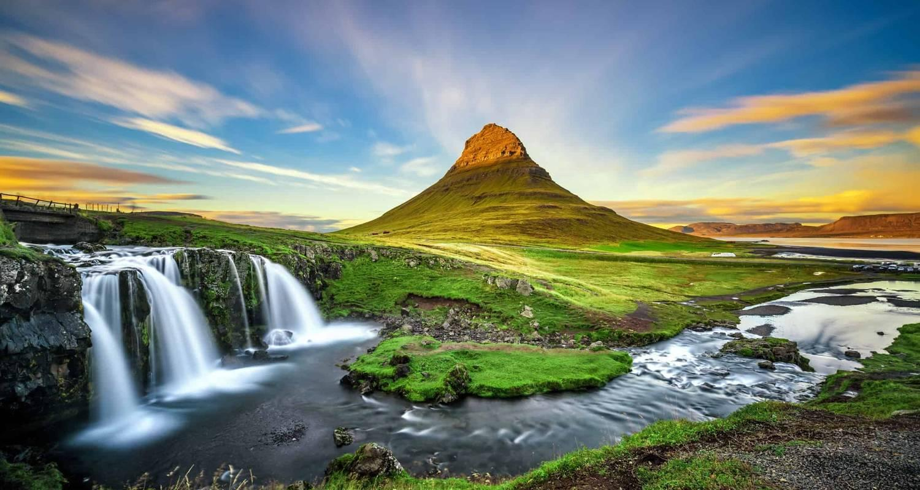

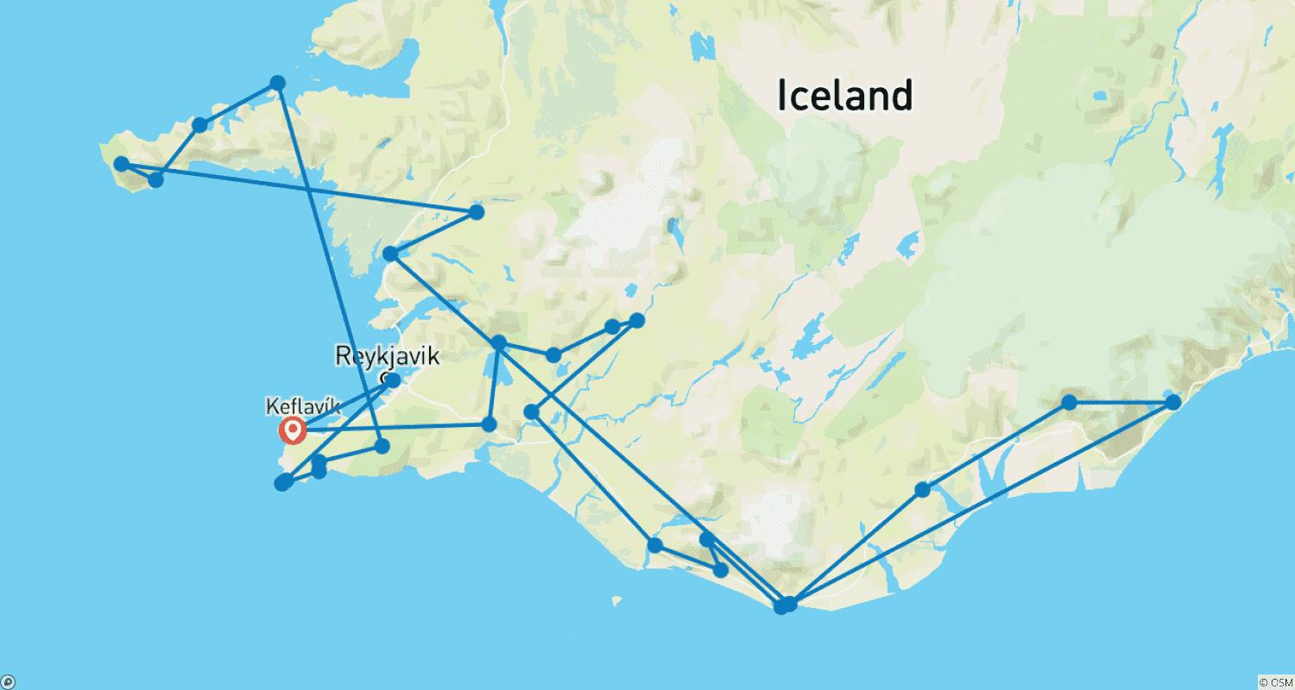

Tour ID: 173469  
Tour Name: 10 day Self-drive tour | Fantastic Iceland

Tour destinations: ['Keflavik', 'Thingvellir National Park', 'Borgarnes', 'Arnarstapi', 'Djupalonssandur', 'Snaefellsjokull National Park', 'Stykkisholmur', 'Laugarbakki', 'Saudarkrokur', 'Siglufjordur', 'Akureyri', 'Myvatn', 'Husavik', 'Asbyrgi Canyon', 'Egilsstadir', 'Hofn', 'Kirkjubaejarklaustur', 'Vik', 'Hella', 'Gullfoss', 'Geysir', 'Hveragerdi', 'Reykjavik']

Tour destinations images:





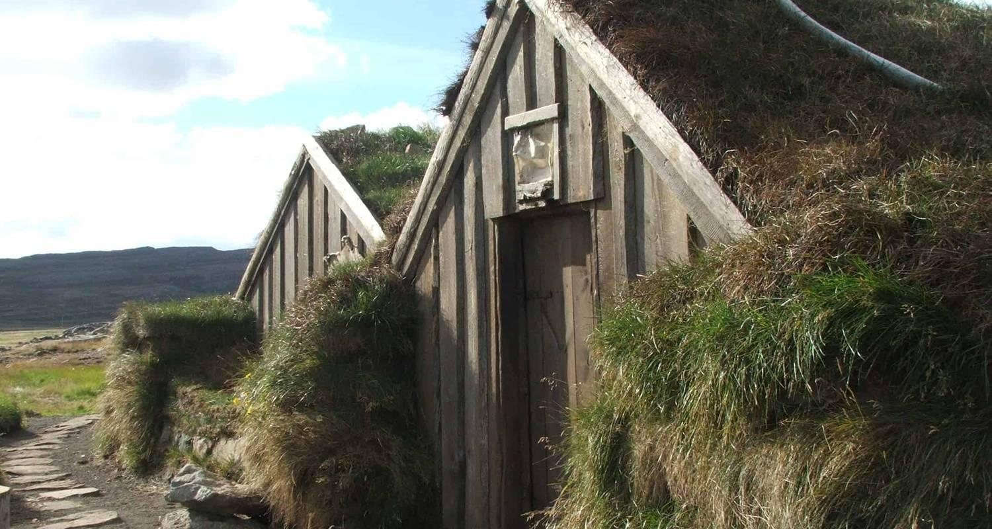

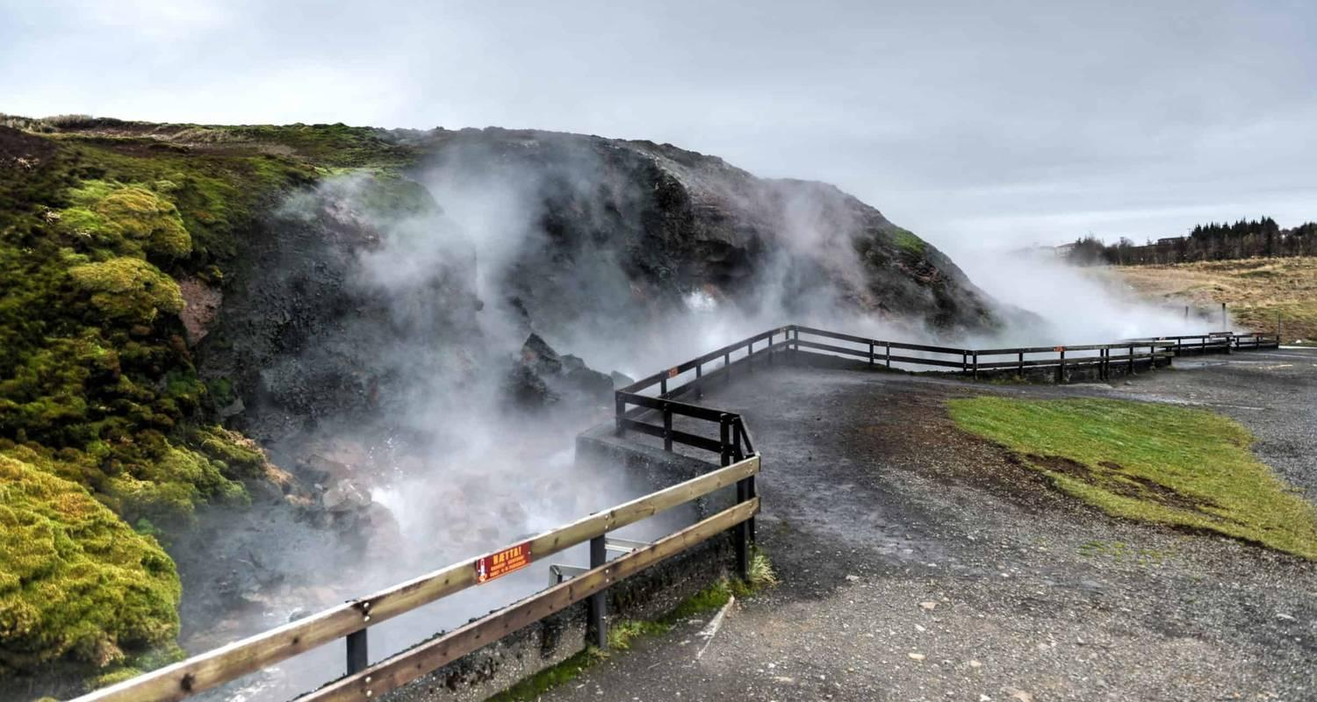

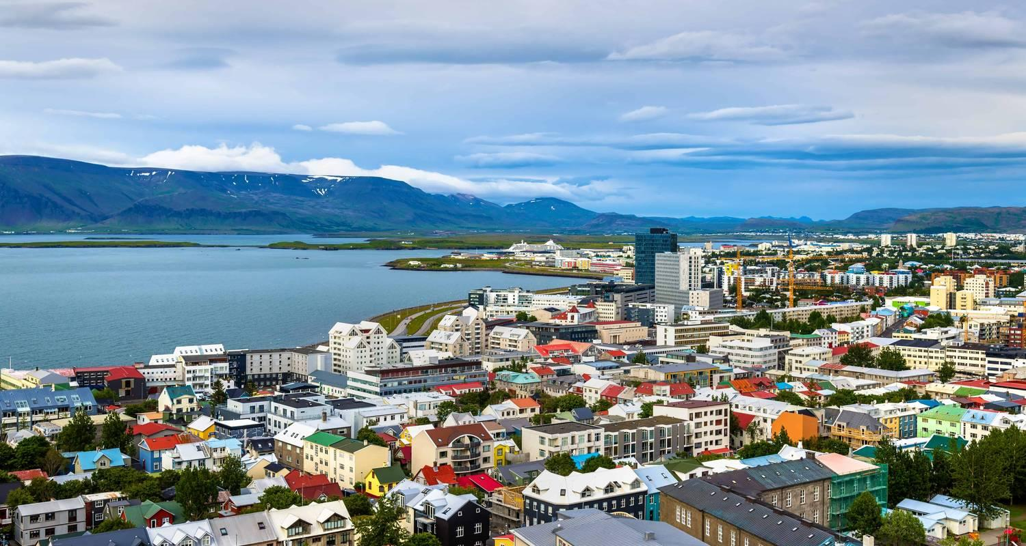

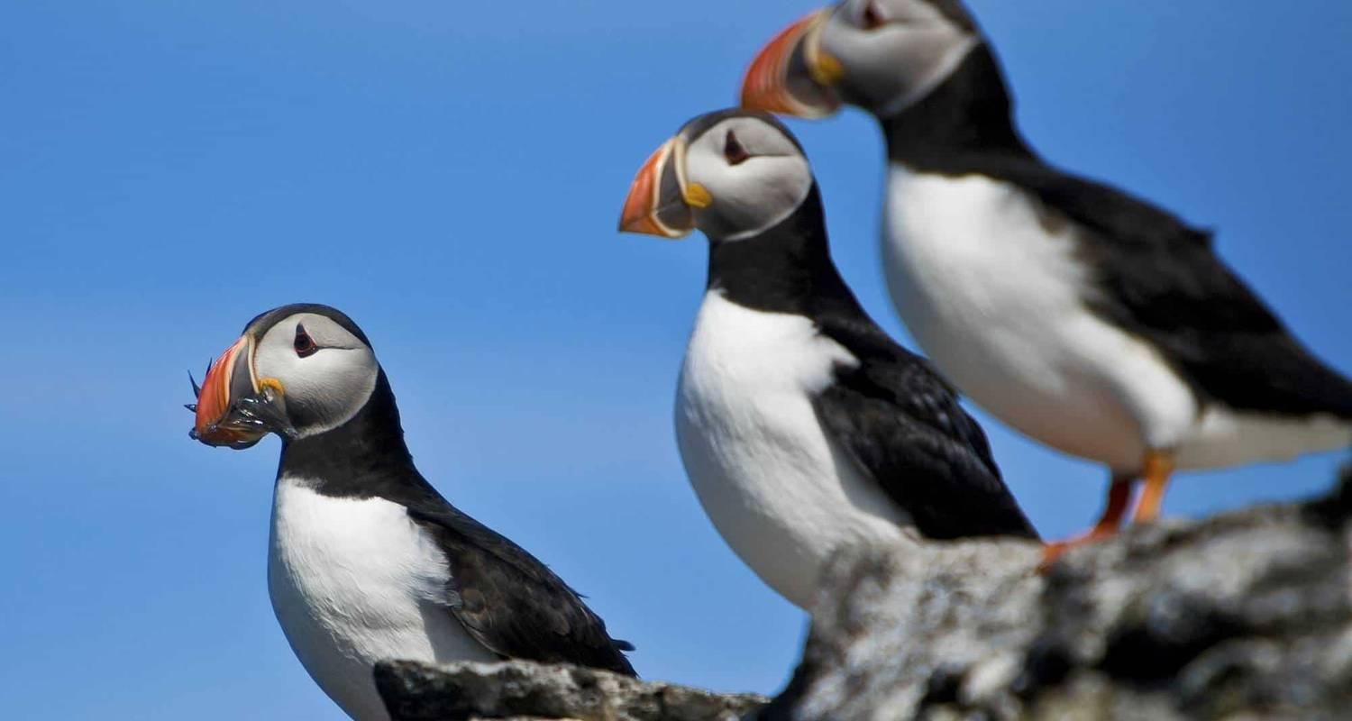

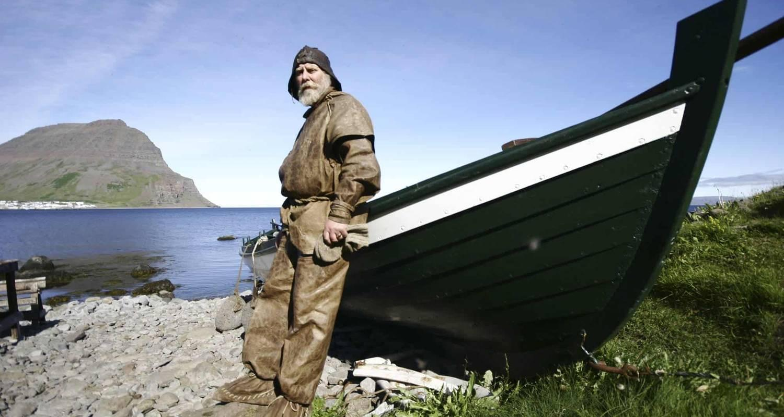

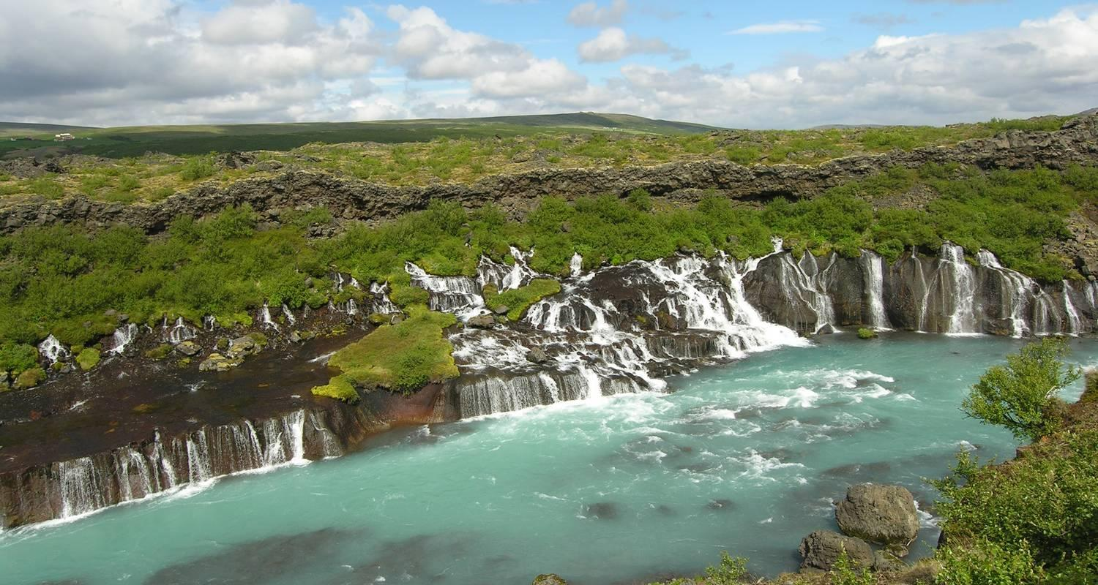

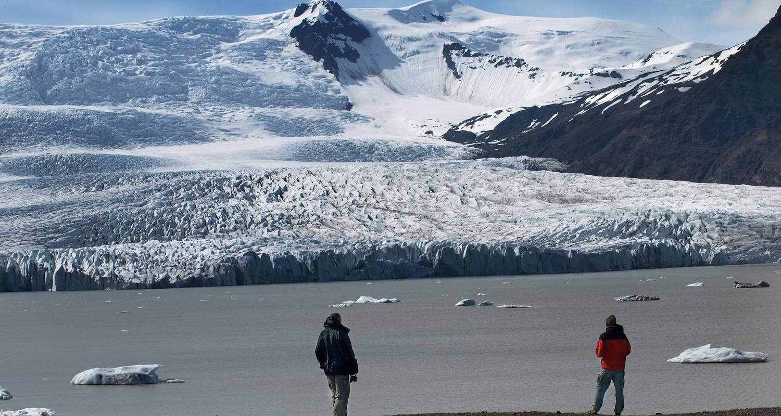

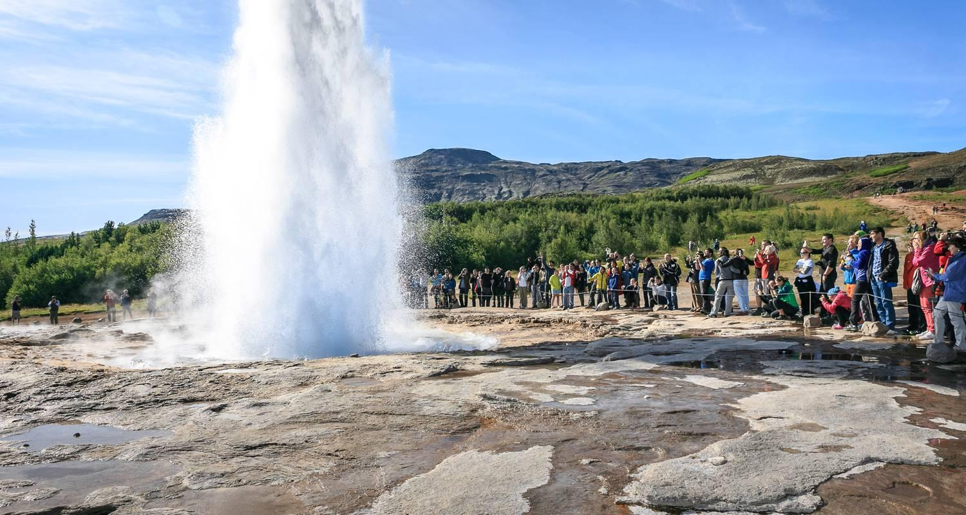

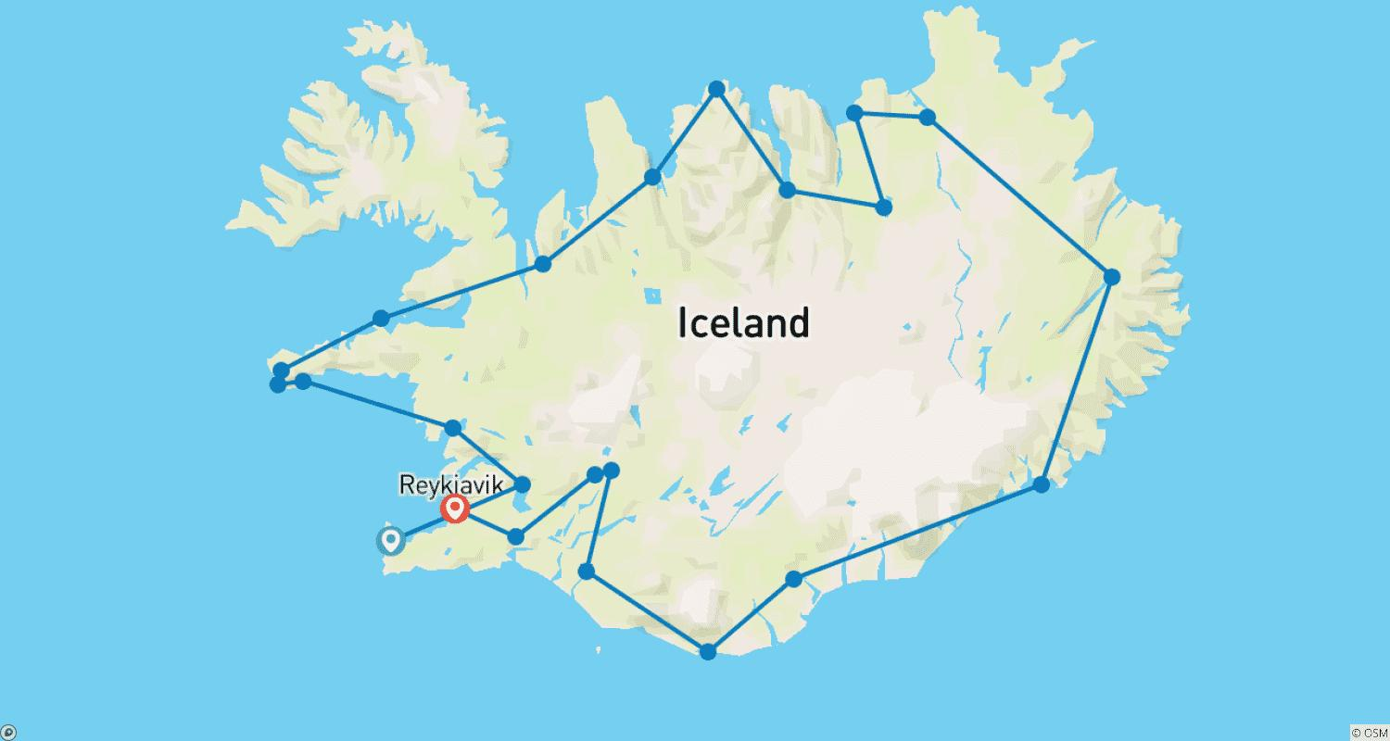

Tour ID: 180601  
Tour Name: Arctic Odyssey

Tour destinations: ['Longyearbyen', 'Ittoqqortoormiit', 'Reykjavik']

Tour destinations images:

